Get Creative Weekend
Saturday, 20th
10am – Flag Raising and Morning Stretches *w/Mascot @flagpole
11am – Wagon Ride *w/Mascot @office
12pm – No Brush Painting @rec. field
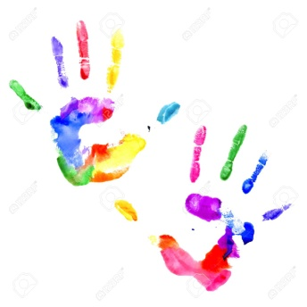
1pm – Make a Gumdrop Sculpture @clubhouse
2pm – Make Playdough @clubhouse
3pm – Freeze Dance Painting @basketball court
3-3:15pm Adult Swim @pool
4pm – Make Glass Paper @clubhouse
5pm – Wagon Ride *w/Mascot @office
5-5:15pm Adult Swim @pool
Sunday, 21st
10am – Flag Raising and Morning Stretches *w/ Mascot @flagpole
11am – Wagon Ride *w/Mascot @office
12pm – Rock Painting *sign up @clubhouse
1pm – Make a Flower Petal Suncatcher @clubhouse
2pm – Q-tip Painting @clubhouse
-All activities are subject to change and/or cancellation based off of attendance, weather, and other reasons deemed necessary.-
*P.S. Our furry friends Reagan Raccoon, Timber Fox and Woodford the Owl don’t like the heat, so they may not always join us.

