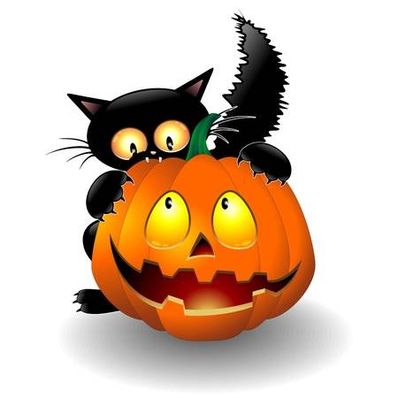
Halloween #1,#2,#3
Bring candy for trick or treaters!!
We will be on the lookout for the best decorated site on Friday and Saturday night so be sure your site is ready! Winner will be announced on
Sunday at the 11am Wagon Ride.
Saturday, Oct. 5th, 12th, 19th
10am – Flag Raising and Morning Stretches *w/Mascot @flagpole
11am – Wagon Ride *w/Mascot @office
12pm – Poke a Pumpkin @rec. field
1pm – Ghost Knockdown @rec. field
2pm – Mummy Wrap Race @rec. field
2pm, Oct. 19th only – Booze Cruise/Poker Run ($5 entry fee, 21+, wear your costume!)
3pm – Costume Contest @rec. field (2-5yrs, 6-12yrs, 13-18yrs, 19yrs+)
4pm – Halloween Costume and Golf Cart Parade @rec. field
(Decorate your golf carts for some added fun! Golf carts will follow slowly behind those walking.)
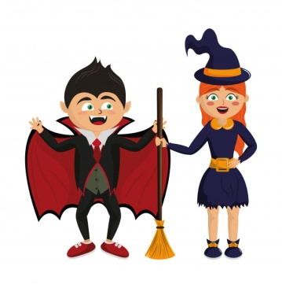
5pm – Wagon Ride *w/Mascot @office
6pm – Trick or Treating (campers will be walking from site to site, please limit your driving at this time!)
7pm-9pm Spook Walk @site 150A (weather permitting)
Sunday, Oct. 6th, 13th, 20th
10am – Flag Raising and Morning Stretches *w/Mascot @flagpole
11am – Wagon Ride *w/Mascot @office
12pm – Face the Cookie @clubhouse
1pm – Tarantula Toss @rec. field
2pm – Costume Relay @rec. field
Monday, Oct. 14th 11am –Wagon Ride @office

-All activities are subject to change and/or cancellation based off of attendance, weather, and other reasons deemed necessary.-
*Our furry friends Reagan Raccoon, Timber Fox and Woodford the Owl don’t like the heat or rain, so they may not always join us.

