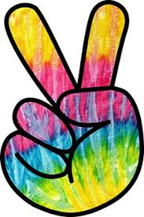
Hippie Weekend

Saturday, June 22
10am – Flag Raising and Morning Stretches w/mascot @flagpole
11am – Wagon Ride w/mascot @office
12pm – Make a Friendship Bracelet *Limit of 2 per person* @clubhouse
1pm – Tie-Dye Shirts *Sign up required* @clubhouse
2pm – Scavenger Hunt @pavilion
3pm – Funk Fresh Relay @rec. field
4pm – Pac-Man Tag
5pm – Wagon Ride w/mascot @office
Sunday, June 23
10am – Flag Raising and Morning Stretches w/mascot @flagpole
11am – Wagon Ride w/mascot @office
12pm – Make a Beaded Necklace *sign up* @clubhouse
1pm – Leisure Suit Relay @rec. field
2pm – Red Light, Green Light @rec. field

*All activities are subject to change and/or cancellation based off of attendance, weather, and other reasons deemed necessary.

