Saturday, July 11th
11am - Wagon Ride @office

12pm- Suds with Buds Soap and Bubble Party @rec. field

5pm - Wagon Ride @office
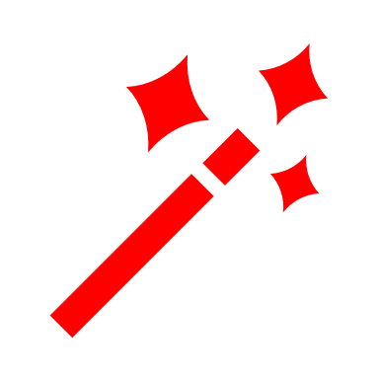

7pm - Magic Show and Face Painting with Jae P Illusions and Face Painting by Liz @pavilion
Bring lawn chairs or blankets for front row seating, or your golf cart for back row seating!
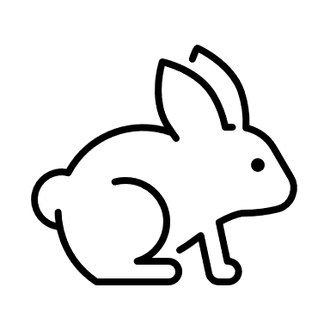

All activities are subject to last minute change or cancellation based on weather and attendance.

