Saturday, July 18th
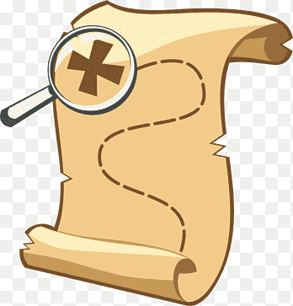
11am – Wagon Ride @office
1pm – Scavenger Hunt @pavilion
5pm – Wagon Ride @office
6:45pm – doTerra Essential Oil Make N Take Party @clubhouse
Check out our Facebook event page for more information!

Sunday, July 19th – 11am Wagon Ride @office

All activities are subject to last minute change or cancellation based on weather and attendance.

