With every season comes change, and with the recent COVID-19 outbreak and other campground changes, our Activity Schedule has recently been updated. Yes, we realize it is quite a bit smaller, and while we strive to provide a fun camping experience for all of our guests, please bear with us as we navigate the most recent events. We know and understand this has been a rough year for many.

July 4th & 5th- Fourth of July Weekend w/ Whiskey Bent

July 11th – Magic Show and Face Painting 7pm @pavilion

July 18th – Essential Oil Make N Take Party 6:45pm @clubhouse (find event details on Facebook)

July 25th- Christmas in July (site decorating contest!!)

September 5th-7th- Labor Day Weekend w/ Forced Country

October 3rd- Halloween #1

October 10th- Halloween #2 (Columbus Day Weekend)

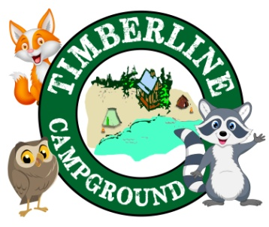October 17th- Halloween #3

Wagon Rides every Saturday 11am & 5pm! (weather permitting)

Check out our Facebook page, and website for event details!