MEMBERSHIP
Chairman - Sharon Bunton
18558 Pondview Dr.
Foley, Ala 36535
Aladistrict33@yahoo.com
817-296-0984

Southern Division – The Bison
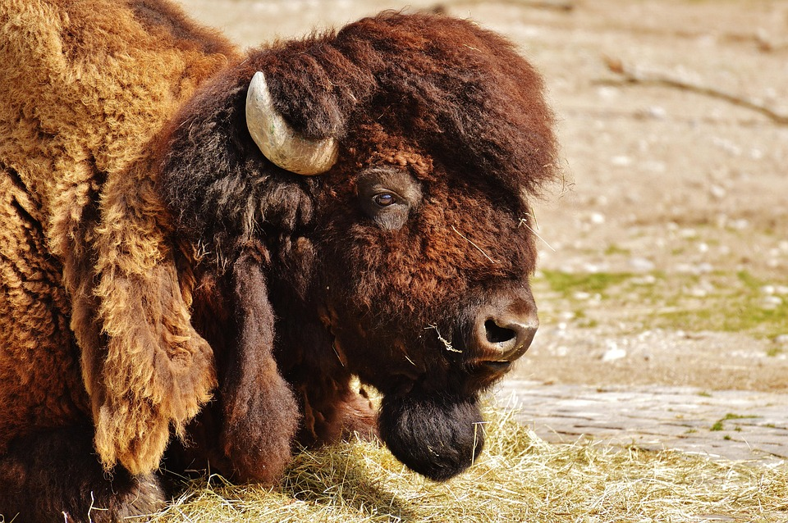
Strength, Resilience, Abundance, Bravery

