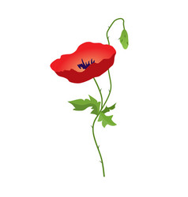

AMERICAN LEGION AUXILIARY - DEPARTMENT OF ALABAMA PO Box 606 -MONTGOMERY, AL 36101
OFFICE USE ONLY
emailed
Poppies sent
Poppy Order Form
Date
POPPIES ARE HANDMADE BY VETERANS.
PLEASE ALLOW A MINIMUM OF 2 WEEKS FOR PROCESSNG.
Due date required — if no date listed, poppies will be shipped ASAP.
We would like our poppies by
Month Day Year
Send to PLEASE PRINT LEGIBLY
Street Address

City/State/Zip Phone #

Email Address_______________________________________________ PLEASE PRINT LEGIBLY
PLEASE NOTE
Mistakes happen; therefore, check your order immediately upon arrival to make sure you have the number of poppies you paid for.
Adjustments will only be made within 2 weeks of delivery.

Poppy Prices and Postage Chart listed below.
Quantity: ________
Postage: __________
TOTAL remittance.
Check payable to: ALA-Dept of ALABAMA
Mail to: ALA-ALABAMA, PO Box 606. Montgomery, Alabama 36101

Small Poppy Prices Postage
Quantity (sold in bundles of 25) # of Poppies Postage
100 - $15.00 800 - $120.00 1-1000 $20.00
200 - $30.00 900 - $135.00 1001-2500 $23.00
300 - $45.00 1000 - $150.00 2501-5000 $27.00
400 - $60.00 1500 - $225.00 5001-9999 $38.00
500 - $75.00 2000 - $300.00 10,000 + Actual Cost Via USPS
600 - $90.00 2500 - $375.00 (invoiced at time of delivery)
700 - $105.00 3000 - $450.00

In purchasing this item, you acknowledge that 100% of the proceeds of poppy sales will go towards the welfare of veterans, active military personnel, and their families where financial or medical need is evident.

