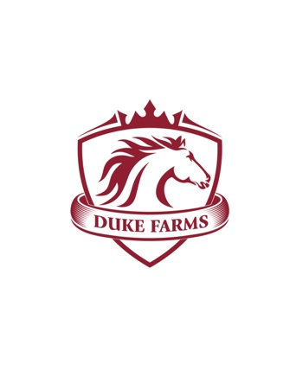
The goal for Duke Farm kids camp is for youngsters to safely learn good horsemanship and animal husbandry while having a great time on a family-oriented farm. Activities and programs also teach responsibility, cooperation, courage and self-esteem. New friends, positive values, personal growth, great adventures, and OUTRAGEOUS FUN are the foundations of the Duke Farm experience! This program is designed to provide instruction which will enable all students to gain confidence and precision in working with horses and other animals under a wide range of conditions. This camp focuses on adventures for all ages with emphasis on having a well-rounded and fun camp experience.
Please fill out this registration form and contact us with any questions!
Payment is required to hold a spot and cancellation policy is on page 2.
Email: info@DUKEFARMONLINE.COM Phone: 419-410-7193
Call for credit card payment or make checks payable to: DUKE FARM
Mail: 44 SAMARIA RD. TEMPERANCE, MI 48182
Child Participant’s Name and Age:

Parent/ Guardian Name:
____________________________________________________________________________
Contact Email: Contact Phone:
____________________________________________________________________________
Child Participant's Riding/Horse Experience or Notes:
____________________________________________________________________________
PLEASE CHECK ALL THAT APPLY TO YOUR CHILD:
______________________________________ AGE _________________________________
❏ Has never ridden horses before
❏ Has attended Horse Camp at Duke Farm
❏ Has attended horse camp at another facility______________________________________
❏ Has taken riding lessons with ___________________________ how often _____________
❏ Rides or cares for a family or friend’s horse
❏ Has a background riding (English, Western, Trails, 4-H, etc.) ________________________

Duke Farm Release and Hold Harmless Agreement: Address: 44 West Samaria Rd. Temperance, MI 48182
I _______________________________(Parent/Guardian), the undersigned, have read and understand, and freely and voluntarily enter into this Release and Hold Harmless Agreement with Duke Farm. I understand that this Agreement is a waiver of any and all liability.
I understand and agree there are potential dangers in mounting, riding, walking, exercising, jumping, and feeding horse[s] including but not limited to interactions and contact with other horses. I further understand that engaging in such activities presumes certain risk of injury and may result in injury or death.
I understand and agree Roy and Deborah Duke of Duke Farm shall not have any responsibility, liability or expenses for injury or medical treatment resulting in my participation in equine activities, and that the Farm will not provide any compensation for any injury or death I, the equine, or the Child/Rider named herein below may suffer while riding on the homeowner’s private land or in homeowner’s private riding arena. I hereby waive, release and forever discharge all rights and claims for damages that may occur to me, a horse, or anyone under my supervision, arising out of or in any way connected with my participation to ride voluntarily at or on the homeowner’s private property.
I affirm that on my own initiative, I voluntarily choose to assume all risk involved in equine activities. Dated_____________ Name of Child/Rider Print]______________________________ Dated_____________ Name of Rider/Parent/Guardian [Print] ______________________________________ Signature of Rider/Parent/Guardian__________________________________________________________
Any Allergies, Diagnoses, Medication, or Challenges Relevant to an Outdoor Group Camp Experience?__________________________________________________________________
Emergency Contact Name and Phone #1:___________________________________________
Emergency Contact Name and Phone #2:___________________________________________
Do you consent to have Duke Farm staff authorize emergency medical treatment?
❏ Yes
❏ No
Do you give Duke Farm permission to use your child's photograph in future advertising?
❏ Yes
❏ No

