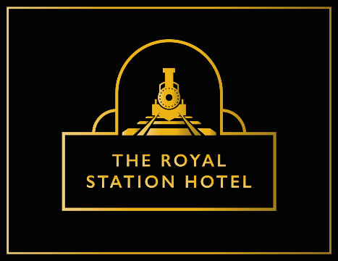

**Nibbles/Starters**

**Griddled Halloumi £6**

*Sticky Red Chilli Jam (v)*

**Honey Glazed Chipolatas (6) £6**

**Garlic & Parsley Butter Toasts (3) (v) £3**

**Mozzarella, Garlic & Parsley Butter Toasts (3) (v) £4**

**Vegetable & Vermicelli Spring Roll £9**

*Harissa Mayonnaise (ve)*

**Fiery Buffalo Chicken Wings £9**

*Roquefort mousse*

**Sweet & Spicy Braised Pork Ribs £10**

**Pancetta & Black Pudding Salad £11**

*Poached Egg & Honey Mustard Dressing*

**Mains**

**Steamed Steak Suet Pudding £17**

*Handcut Chips, Tenderstem Broccoli, Beef Stock Gravy.*

**Honey Glazed Horseshoe Gammon Steak £16.5**

*Pineapple Chutney, Fried Hen’s Egg, Roasted Cherry Tomatoes, Handcut Chips.*

**Beer Battered Haddock, £16.5**

*Handcut Chips, Marrowfat Mushy Peas, Tartare Sauce.*

**8oz Bacon Cheese Burger £16**

*Baby Gem Lettuce, Beef Tomato, Sticky Red Chilli Jam, Skin on Fries.*

**Wild Mushroom Risotto (v) or (ve) £16**

*Parmesan Shaving, Truffle oil.*

**Panko Chicken Katsu £17**

*Red Chilli, Lime & Coriander Basmati Rice*

*Pickled Cucumber.*

**Pan Seared Salmon Fillet £19**

*Crushed Parmesan Baby New Potatoes, Griddled Asparagus, Caper & Parsley Cream*

**Goats Cheese Salad £16.5**

*Sun blushed Tomatoes, Olives, Toasted Almonds, Balsamic*

**Beef Lasagne £15**

*Garlic Toasts*

**Steaks**

*Our steaks are served with roasted cherry on vine tomatoes, buttered roasted field mushrooms, beer battered onion rings, hand cut chips & watercress.*

**10oz Ribeye £28**

**Pepper & Brandy Sauce £2.5**

**Sides**

**Beef Dripping Beer Battered Onion Rings £4**

**Truffle, Parmesan & Chive Skin on Fries £5.5**

**Skin on Fries (v) £4.5**

**Mixed Green Vegetables £5**

**Sweets**

**Chocolate Orange Cheesecake £8**

*Vanilla Ice Cream*

**Steamed Zesty Lemon Sponge £7**

*Lemon Curd, Candied Lemon, Custard (v)*

**Sticky Toffee Pudding £7**

*Butterscotch Sauce, Vanilla Ice cream (v)*

**Strawberry & Raspberry Meringue £7**

*Vanilla Ice cream (v)*

**Cheese & Biscuits £11**

*Barbers, Roquefort, Lancashire, Brie, Sticky Red Chilli Jam, Grapes, Crackers & Salted Butter*

**English Lakes Ice Creams (v)**

Double Jersey, Strawberry, Chocolate, White Choc & Raspberry, Mint Choc Chip, Cappuccino

**1Scoop £3**

**2Scoop £4**

**3Scoop £5**