Capturing Complexity:

Impacts of a 6 week Workplace Mindfulness Training course on the mental wellbeing and retention of Further Education learners

‘The college sector has equality at its very heart’

Scottish Government 2018

‘I have more space in my brain now for to learn things, just because I’ve calmed it down by learning mindfulness’

Research Participant

EIS Action Research Report June 2018

Susan E. McAvoy

@learnrepsue

Standpoint… Story and Context

This piece may be written in a slightly different academic voice than you are accustomed to. I will often use a first person voice and intend to weave a narrative thread throughout a more traditional research report format. The narrative thread will connect this research study to a larger endeavour to place health and wellbeing at the heart of my professional practice.

The direct voice also speaks to a rejection of a positivist third person stance which necessitates the depersonalisation and exclusion of our essentially subjective human selves (Cohen *et al* 2007). Positivist research attempts to be value free whereas, my values are front and central to this research study.

They are also fundamental to the encompassing project of teaching mindfulness and personal development programmes offering strategies to increase confidence and decrease stress (Craig 2006). For me as a lecturer, social scientist and EIS Learning and Equalities Rep. it is all about equity. Levelling the playing field for Further Education (FE) learners often struggling to learn due to long term, chronic stress created by deprivation (Cozolino 2013, Hyland 2011).

Bringing my personal, social and spiritual values to the fore of the actual research and the reporting of it, feels authentic and as if I am speaking from the heart. This seems doubly apt as the research is on mindfulness or ‘heartfulness’ depending on translation (Kabat-Zinn 2011).

Mindfulness, for me is a lot about being present, acknowledging I am here in this moment. So, I will on occasion write as if I am here and you, the reader are too. Perhaps having a few mindful moments along the way as we explore if learning mindfulness impacts on the mental wellbeing and retention of learners…

Story: How we arrived here

Our narrative thread begins many years ago…

For over thirty years I have been a student and practitioner of complementary therapies, transpersonal psychology and meditation. In 1996 while still an Honours student, I developed and delivered a Complementary Therapies module at Abertay University which began my teaching and academic career. Through applying systems and complexity theories my previous research has explored areas such as; psychology and consciousness, Dundonian women, social class and community participation and more recently social and emotional skills and mindfulness in education.

When I moved from teaching in universities to the college sector in 2006, a clear insight for me was the difference in confidence levels between the two student groups. Low confidence levels of FE learners, often underpinned by hardships, difficulties and trauma, has been well documented (Hyland 2011). Motivated by that insight and also by positive learner feedback on pre-exam visualisation exercises in Sociology classes, in 2008/9 I developed a personal development course for Adult Returners to education. This programme included lessons on positive psychology (Seligman 2002), resilience (Craig 2017), metacognition (McGuinness 2005), Mindset (Dweck 2006) and meditation (Kabat-Zinn 2002) alongside academic writing and research skills. Based largely on positive learner feedback the course was awarded a SLIP (Sector Leading Innovative Practice) in 2009 by Education Scotland.

My career then moved increasingly towards staff and organisational development, where I sensed a need for professional learning around social and emotional skills so staff could maintain a balance in the face of increasing pastoral demands. As part of a postgraduate degree I conducted a small piece of research exploring emotions in teaching and learning (McAvoy, 2013). College staff spoke about feeling unsupported in terms of social and emotional skills while pastoral demands had increased dramatically over the last decade.

While qualifying as an EIS Learning Representative (LR) I again included the social, emotional and spiritual domains in a holistic approach to professional learning and coaching sessions. As a Reiki Teaching Master, from 2011 to 2014 I trained college staff in Level 1 Reiki which is a healing modality shown to reduce stress (Cuneo *et al.* 2011, Bukowski and Barardi 2015). I trained in mindfulness in 2013 to develop my own meditation practice but always with a view to teaching the skills to staff as a stress management tool. To further facilitate this aim, I trained to deliver the Workplace Mindfulness Training (WorkplaceMT) course which is aimed at leaders and employees in the workplace. This is the course being evaluated in the current research study.

Since 2016, EIS LR events and professional learning sessions offering social and emotional skills development have been consistently well attended and evaluated. It has become clear through emergent professional dialogues that there is a need for coping strategies for both practitioners and learners.

Context: Accepting our Present Reality

Another principle of mindfulness is acceptance (Kabat-Zinn 2012). This is not a passive mindset, but aims to see present reality as it really is… allowing clarity about how to respond and then act.

So let’s pause now, and assess the ‘big picture’ landscape relevant to this study.

Globally, mental, neurological and substance use disorders constitute 13% of the global disease burden and by 2020 between 15 and 30 million people will attempt to take their lives (Collins *et al* 2011, Whiteford *et al* 2015). Statistics show that mental health illness in the UK has steadily increased since the early 1990’s (NHS Digital 2017) and in Scotland incidences of depression have increased significantly since 2009 (Mental Health Foundation 2018).

Unsurprisingly, a key challenge for FE is the increase in learners experiencing mental ill health, often leading to negative impacts on retention and attainment (AoC 2017, Scottish Government 2017). This phenomenon is important to us as a sector as retention and attainment are the two main performance indicators (PI’s) used by the Scottish Funding Council to evaluate colleges (SFC, 2017). Retention is the percentage of learners who remain on their course. Retention is so important, the Scottish Government ‘have commenced a national college improvement programme to look in detail at individual college level solutions to raise attainment and improve retention’ (Scottish Government, 2018). D&A College is taking part in the programme. The NC5 Social Science course currently being researched here is participating, due to historically low retention rates. The WorkplaceMT course is of interest to the programme and the results of this research are awaited with interest (Gregory, 2018).

Data demonstrating a link between anxiety, depression and more serious mental health challenges and course withdrawals is not currently being gathered and collated by D&A College. However, through conversations with a range of staff at all levels, anecdotal evidence would indicate mental health issues as a recurring reason for withdrawals. D&A Colleges’ No 1 Priority Outcome in our current Regional Outcome Agreement is to ‘[r]emain one of the highest performing colleges nationally in the recruitment, retention, attainment and progression of our learners regardless of their backgrounds or entry levels’ (:7).

This is a real challenge as we shall see…

In 2015/16, 26% of college entrants in Higher Education (HE), and 32% of college entrants in FE, came from the 20% most deprived areas in Scotland (Scottish Government, 2017). Dundee City is the third most deprived area after Glasgow and Strathclyde. With a recent 2017 EIS survey finding 77% of teachers thought the mental ill health of learners had increased as a result of increased poverty and NHS Health Scotland (2017) stating that mental health problems are ‘strongly linked’ to social inequalities, we can clearly see the challenge.

D&A’s ROA (2017) states ‘The significant growth in support needs for learners with mental health and complex social/behavioural problems’ puts pressure on support services but also academic teaching staff’. This pressure is not new. Hyland (2011: 134) quotes Ecclestone and Hayes to make the point that in FE more emotional labour is needed as this is what makes FE ‘distinctive’.

When we consider that this landscape includes increasing public sector funding cuts (EIS 2018) and evidence showing that teachers are also increasing stressed (Mulholland *et.al.* 2013, NUT 2013, Ravalier *et al* 2017) we can accept that our present reality is challenging.

So what could be a mindful and skilful response? I would argue that exploring strategies to support our wellbeing such as mindfulness, is one.

Asking questions about wellbeing and learner retention (so closely linked with attainment) could be another. This research is aiming to do just that.

But why mindfulness and what is it?

‘[Mindfulness is] knowing what is happening, while it is happening, without preference.' (Nairn 2010: 5). Hulsheger *et al* propose four key characteristics: mindfulness involves an open awareness of inner states and experiences, information processing becomes pre-conceptual or non-judgemental, focus is on present moment experience and finally mindfulness is an inherent human capacity that varies situationally and individually (2013: 311).

My teaching practice is increasingly mindfulness based, delivering courses to children, young people and adults in schools, colleges and the workplace. There is a growing and robust research base indicating that Mindfulness Based Interventions (MBI’s) can increase mental wellbeing, physical health, cognitive performance and resilience while decreasing depression, anxiety and the negative impacts of stress (Kabat-Zinn 2012, Williams 2002, Davidson *et al* 2003, Hulsheger *et al* 2013, Buric and Farias 2017).There has been a notable increase in research with more than 500 peer-reviewed scientific journal papers being published every year(The Mindfulness Initiative 2015).

Evidence within educationis also beginning to accumulate, however it is not as robust or numerous ‘[t]he evidence base is there, but it’s fragile’ (Centre for Educational Neuroscience, 2017). Mindfulness research within the FE sector is scarcer (Hyland 2011, 2013) hence, part of the value of carrying out this research study. Research findings within HE however are promising and have relevance for FE. The Mindful Student Study studying the impact of a mindfulness course on studentresilience to stress, found ‘that provision of mindfulness training could be an effective component of a wider student mental health strategy’ (Galante *et al* 2017).

The Mindful Nation Report (2015) also offers a strong evidence base for exploring the benefits of mindfulness recommending that mindfulness be taught and practiced within education, particularly to support PSHE (Personal Social Health and Economic Education) lessons in England and Wales. Luckily in Scotland we have a number of policies that would support a similar focus on the holistic wellbeing of those in education. The Curriculum for Excellence explicitly names ‘thinking skills’ and ‘skills for health and wellbeing’ adding: ‘Through Curriculum for Excellence children and young people are entitled to a continuous focus on literacy, numeracy and health and wellbeing. These skills are essential if young people are to gain access to learning, to succeed in life and to pursue a healthy and active lifestyle (Scottish Government 2009). The Equality Act (2010) provides framing for good mental wellbeing in the workplace (TUC, 2013) and makes a strong business case with costs of mental ill health in Scotland to be around £10.7 billion for 2009/10 (Mental Health Foundation, 2016).

This research is asking if undertaking a mindfulness course would impact on the mental well-being and retention of learners in FE…

Research Design

The ontological and epistemological stance framing this research accepts that we are all interconnected in a complex network of relationships requiring mixed methodologies that can capture that complexity (Haggis 2008). Interactionist and constructivist perspectives should be favoured to allow the capture of ‘deliberate, intentional and agentic actions of participants’ (Cohen *et al* 2011). So, this research will blend a qualitative and quantitative approach, capturing both numerical data on retention and mental wellbeing *and* in-depth, ‘thick’ data on the lived experience of using mindfulness (Geertz 1973).

As an EIS Action Research Report submission, there is added element in our mixed methods approach. This research is not strictly Action Research (AR) (Ferrance 2000, McNiff and Whitehead 2012), however it includes important elements of AR such as including being ‘practioner based’, reflection on practice and the intention to make changes to teaching practice based on research findings (Cohen *et al*. 2011: 344). Indeed, Phelps and Graham (cited in Cohen *et al* 2010) argue there are links between action research and complexity theory (think: feedback loop systems). AR also requires feedback to feed forward and I will seek that from the group with a view to adapting and improving the course.

The transformative element of AR is important to me as a committed socialist, feminist and union activist. I believe that teaching mindfulness skills to students is potentially transformative in and of itself and is concerned with improving the ‘social conditions of existence’ as is AR (Cohen *et al* 2011: 345) echoing Rossi (2017) who argues that mindfulness can lift young people ‘up and out of generational poverty’.

So, I researched what I increasingly do in my teaching practice: deliver the 6 week WorkplaceMT course to a group of learners in FE.

The WorkplaceMT course emerged from the Oxford Mindfulness Centre (OMC) and is an evidence informed approach which has been evaluated, researched and refined over four years. It is based on the Mindfulness Based Cognitive Therapy (MBCT) course developed at OMC specifically for people with long-term recurring depression (Segal *et al* 2012). The robust standardised programme is specifically designed for the workplace ie. delivered in 1 hour over 6 weeks rather 2 hours over 8 weeks (The Mindfulness Exchange 2018, Penman 2015).

The research group was made up of self-selecting learners from my Tutor Group for which I have a pastoral role; outlined in D&A’s Group Tutor Guidelines and Remit (Appendix 1). The whole class attended an introductory mindfulness session where information about mindfulness, WorkplaceMT course and the research design were discussed (BERA 2014). The volunteers then completed an informed consent form including permission to be tape recorded during interviews (Appendix 2).

From a possible 23 learners, 10 volunteered and 9 completed. This was a diverse group with ages ranging from 17 to 48, a strong female to male bias (19:4) and complex support needs reflecting the literature highlighting the often difficult backgrounds of learners in FE (Hyland 2011, 2013). The course began mid-October and finished at the end of November 2017. WEMWBS questionnaires (Appendix 3) were completed pre and post-delivery of the WorkplaceMT course to quantify mental well-being. The WEMWBS is a validated scale for measuring mental well-being and covers states of happiness and positive psychological functioning. Mental well-being describes ‘positive states of being, thinking, behaving and feeling’ (Putz *et al.* 2012: 4).

Comparisons were also drawn between withdrawal rates for the 2015/16, 2016/17 NC5A Social Science cohorts and the research 2017/18 group who undertook WorkplaceMT. These methods offered a quantitative, ‘big picture’ view of mental wellbeing and retention for the research group.

Group and individual interviews gathered qualitative, ‘thick’ data from the group. A group interview was planned and carried out directly after the WorkplaceMT course had finished. 7 learners completed the course and took part in the group interview. 2 learners were absent for the last two weeks of the course due to ill health, however subsequently completed the WorkplaceMT with another D&A learners’ course. They were then interviewed individually at time that suited them.

Interviews are excellent for researching complex and sensitive issues, gaining deep understandings of the meaning of an issue (Cousins 2009). However, there is skill involved in interviewing, therefore training and experience will influence the outcomes. Knowing how to actively listen, ‘being aware of power imbalances and building a connection with the interviewee while remaining conscious of the boundaries of the research’ are key (*Ibid.:* 77).

For me these points are enhanced due to my Group Tutor role and by the fact that I am teaching them mindfulness when emotional issues are often discussed naturally. Luckily, mindfulness skills naturally enhance personal and social awareness (Roeser 2016), my own mindfulness skills were very much required during the research process to remain conscious of these factors.

Being curious & reflective about what we found

Coming back to the intentions of this research: were there any impacts on the wellbeing and or retention of the learners due to learning mindfulness?

Method 1: WEMWBS measuring mental wellbeing

The WEMWBS was administered pre and post WorkplaceMT course.

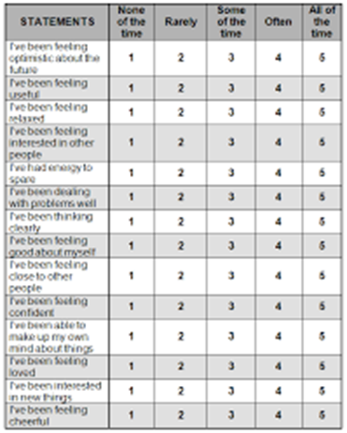The scale contains 14 questions with possible scores from 1- 5:

Maximum individual score is 70

Minimum is 14.

The maximum score for research group is 630 (9 x 70) minimum is 126 (9 x 14).

Graph 1: Individual WEMWBS Scores Pre & Post WorkplaceMT

Individually an increase from 3 – 8 points is ‘considered’ meaningful (Putz *et al*. 2012) and 7 out of the 9 learners had an increase of at least 3 – 8 WEMWBS points. One learner had a score of +1 and another had a negative score of -5. Interestingly, the latter learner was the only withdrawal from the course at the time of final analysis (03 April 2018). The raw data is available for viewing (Appendix 4).

These findings reflect similar results from evaluations of other practioner and learner WorkplaceMT courses by the author and also the supporting evidence discussed earlier (Hyland 2011, Galante *et al* 2017, Buric and Farias 2017). We also discussed how wellbeing is central to the learning process, perhaps when we glimpse the lived experience of learners, this link will be made clear.

Table 1: Group Wellbeing Data

|  |  |  |
| --- | --- | --- |
|  | **BEFORE MINDFULNESS** | **AFTER MINDFULNESS** |
| **GROUP MEAN** | 39 | 50 |
| **GROUP MEDIAN** | 39 | 49 |
| **GROUP WELLBEING COUNT** | 377 | 447 |

There was a 12% increase in the mental wellbeing of the research group overall again echoing multiple findings showing MBI’s increase social, emotional and mental wellbeing (Mental Health Foundation 2010, Goodman and Schorling 2012, Zivnuska *et al* 2016).

Method 2: Retention Comparison across time and by mindfulness training

Graph 2: Comparison of Retention Rates Across AY and Mindfulness Cohorts

Here we can clearly see that retention of the research group is higher than the previous cohorts. There may be extenuating variables such as these particular learners being more motivated learners (which is why they volunteered). However, as we shall see in the qualitative data, some learners were motivated by their mental health challenges. Historically these SCQF Level 5 Social Science cohorts have low retention, high withdrawals and high pastoral demands which could account for the steady high withdrawal rates, even increasing in 2017/18. When we frame this within the challenging landscape explored above, the increase in retention seen here is promising.

Method 3: Interviewing for meaning and depth

Emergent Themes World Cloud

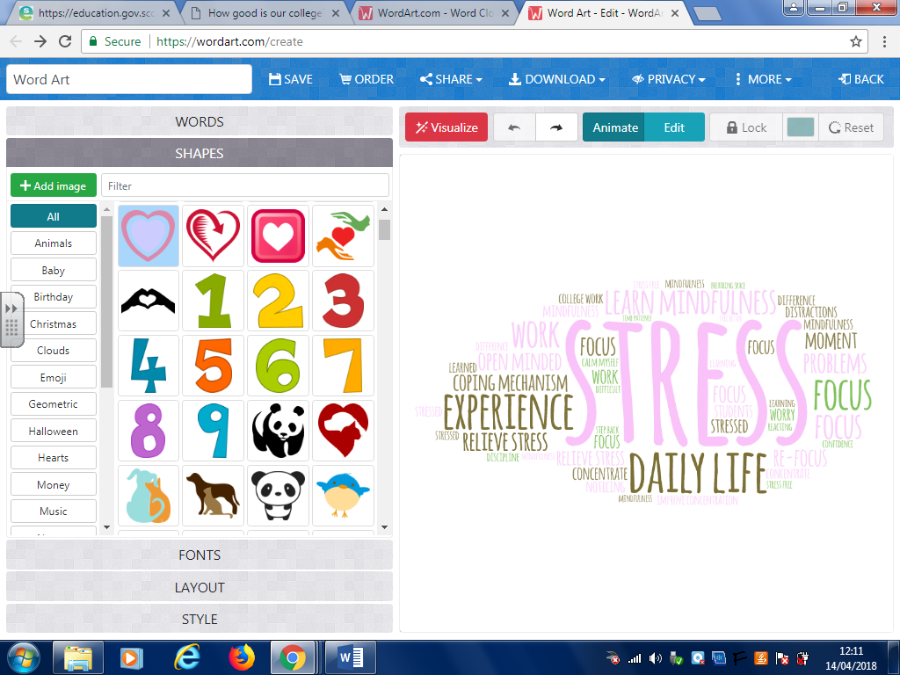

This image, containing key and recurring themes, gives a visual overview of emergent themes from the interviews. (WordArt 2018).

The interview schedule can be seen in full (Appendix 5) but briefly here:

*Why did you want to learn about mindfulness?*

*Have you found any benefits or otherwise from doing the mindfulness course in college?*

*What about benefits or otherwise outside college?*

*Would you recommend the course to other students?*

*How could the course be improved?*

*Is there anything else you’d like to add at this point?*

The word cloud illustrates that learners spoke about stress, learning, focus, concentrating and college work. When we delve deeper we find they were using mindfulness skills to relieve stress and increase concentration to more confidently tackle college work. Stressors from outside college were being noticed, and again, mindfulness skills were being used for calm and self-compassion.

So, themes for the qualitative analysis will be:

Stress, stress relief, coping mechanisms, retention

Learning, focusing, concentrating, college work

Mindfulness, mental well-being

Feedback for moving forward

Stress, stress relief, coping mechanisms

As we have seen, the rise in mental ill health is an issue for FE, education and society. It is then unsurprising that stress was a dominant theme in this data. Learners spoke about their experienceof stress and how mindfulness was modifying their stress. Naturally through the process of teaching mindfulness, the learners understand that mindfulness skills can be used to ‘relieve’ stress so we would expect this theme to emerge. However, it is of particular interest to gain insight into exactly how learners *apply* mindfulness skills to the learning process and the accompanying stressors.

When discussing reasons for doing the course, stress featured prominently from the beginning…

*‘I wanted to relieve stress and worry about daily life’*

*‘Yes, to relieve stress as well and improve concentration’*

*‘I wanted to learn mindfulness to help me have a coping mechanism for stress and situations’*

*‘To be more open minded about my problems and see other ways to tackle them’*

We then talked about any perceived benefits of mindfulness practice…

*‘A new concept and it’s such a great tool it’s not just about you being able to use when you need to use it and that’s what I’ve learned as well… it’s not about just being stress free all the time…it’s about being able to use it at the time when you’re stressed out… it’s got me through a lot in just the last wee while…I’m just so glad I got the opportunity’*

*‘…at work…that’s when I notice I’m not taking in information when I’m stressed…but it does help I’m noticing it more than I was before’*

*‘If I’m having a nervous morning I use it while I’m going to the bus stop, so that helps the day. I use it with my kids when they’re stressing me out…and they even see a difference’*

*‘…yes just from…not learning quicker or easier but not stressing myself out if I’m not getting something straight away…I can just sit back…even 30 seconds breathing space…just use that to get back into it’*

So, here we can see the mindfulness skills being used to deal with specific situations that the learners identify as stressful. In FE we understand that many of our learners have multiple stressors, poverty being just one of them. Having this thick data gives us a deeper appreciation that it is often the ‘small stuff’ creating stress and an opportunity to see exactly how mindfulness skills offer alternative responses (Carlson 1997).

Learning, focusing, concentrating, college work

The data concerning mindfulness practice, learning, concentration and focus was reviewed. What have the learners said in this regard?

‘*I found it helpful in...again dealing with distractions...being able to work with a lot of background noise would help a lot of other students to focus on their work as well by being able to take a minute’*

*‘I’ve used it to get through my work, which is great and I’ve also used it to calm myself and focus…I actually feel a big difference I’ve been able to focus on a bit of work whereas before I would be like ‘I’ll do it after’ but not now’*

*‘It helps me take a moment to myself and re-focus’*

*‘It also helps you get better at other skills as well…like your confidence when you’re writing and putting stuff down on paper, it really helps with that. Before I did this, when I was typing out something for college I was* *always unsure ‘oh maybe that’s not what they want’ whereas now I’ll be like ‘well if it’s not what they want, they’ll tell you’ so it’s totally swung the other way’*

*‘Yes I would recommend it for other students… I think it would be a good learning option for HNC and HND students to help them with stress and help them focus on work’*

*‘Because it helps you to open up your own mind and you can absorb a lot more information if you’re calm and you know what your focus is, you can get so much more done’*

With 100% of the group recommending the course for other learners, we can see that learning these skills was appreciated and valued. The science tell us exactly how mindfulness changes neural structure to facilitate cognitive processing, decision making, improved memory and of course, paying attention (Lazar 2012, Cozolino 2013). What is so fascinating and valuable, is hearing the learners’ lived experiences of these neural changes. These excerpts link the lived experience of wellbeing and the learning process.

Mindfulness, mental well-being

We have seen a 12% increase in the mental wellbeing of the group and 78% of learners showing a meaningful increase in their individual scores. The interviews did not directly address mental wellbeing, but a few did refer to this issue in their responses. Again we can grasp the specific processes, through which the increase in wellbeing may have come about.

*‘Because of my personal mental health issues I do have and always have had, I thought …try something new… give it a go and there’s no doubt about it it’s definitely helped with my mental health…and even when I feel a wee bitty down about certain things, I can always pick myself back up a lot quicker than what I used to be able to do…’*

*‘When I was off (college) I felt my mood go low again and I thought here go again, but I used this (mindfulness) and I didn’t get depressed again and that I just kept myself going, so it really does help’*

The next comment refers specifically to retention or getting oneself in to college.

*‘I liked doing it at the end of the week ‘cause it kind of set me up for the weekend and made it easier to come back to the college on the Monday’*

Author: ‘Can I ask you something else then…you say it made it easier to come back in to college…why was that?’

*‘…because I was nicer to myself and I started saying things like ‘if you’re late don’t worry cause you’ve not been late…you know rather than ‘oh god, what if I’m late!’ so… big difference that way’*

It is clear to me, as a mindfulness teacher, that the specific skills of noticing thoughts, noticing when they are critical or worrying and then deliberately shifting to more positive or rational thoughts in order to decrease stress have been applied beautifully here (Hanson R. 2013). Also, mindfulness offers an opportunity to pause and respond with awareness, before reacting from habitual patterns and instinctual drivers (Williams and Penman 2011, Immordino-Yang 2016).

*‘I think it’s given me the ability to stop and look at a situation before reacting to it…possibly in a negative way…’*

*‘It helps me to take a step back when things are difficult…like if someone is angry with me…I can see why they’re sort of upset around me or sad, rather than just rush over it.*

Finally, to speak to the transformative potential of mindfulness for learners:

*‘I’m constantly questioning – can I be this person that I hope to be? Usually in the past I would never think that I could…now I am at a stage where if I actually believe that if I use tools like mindfulness and learn new things that I can achieve anything I want to, I took me a while to realise that but I know in my heart that I can…definitely’*

Feedback for moving forward

When asked how the course could be improved and for any other comments, useful feedback emerged.

Encouragingly, 100% of the group agreed that all learners should get the opportunity to learn mindfulness.

*‘…yes I’d recommend it to others especially students or other people who are going in to high stress jobs like…help them just take a minute to themselves…’*

However, one learner felt that the time spent on practice was tedious and the advantages were not worth the effort required but agreed it was worth trying.

There were also suggestions for additions, such as more brain science, online materials, shorter sessions throughout the week and a number of learners felt that Friday afternoon was not conducive as they were tired.

In response to this feedback, and to feed forward; a bespoke mindfulness course for FE learners will now be developed. Learner also suggested mindfulness be more integrated across their curriculum. The literature suggests that a whole institution approach works best when adopting mindfulness as a strategy (The Mindfulness Initiative 2015, Chade-Meng Tan 2012) therefore practitioner mindfulness courses will be continue to be offered within the auspices of my EIS roles.

Conclusions: The sum of the parts

Let’s pause again and take stock of the story so far. A key question must be: how much complexity has been captured while exploring what impact learning mindfulness has for FE learners? By taking a holistic view of the complex relationships between individuals and their wider social milieu and thus adopting mixed methods, has this yielded complex insights? By placing this research study within a wider social and global landscape we recognised that individuals, institutions and societies are being challenged by rising levels of mental ill health. We then discovered that FE has particular challenges due to high levels of learners from areas of deprivation; deprivation being correlated with increased mental health challenges. Evidence that mindfulness positively effects wellbeing was seen to be robust and growing.

The findings were that learning mindfulness skills increased the mental wellbeing and retention of the group and the learners shared rich, experiential reports of applying the skills, allowing a more complex comprehension. We have big picture statistics framing the research, while experiential minutia illustrates how learners perceive, act and give meaning within the framing. The findings suggest that extending opportunities to learn mindfulness would assist D&A College in meeting its ‘No 1 Priority Outcome’. Professional learning opportunities for practitioners to learn mindfulness within FE and ideally wider education should be expanded. I would also suggest that these findings speak to the roots of the EIS Child Poverty Campaign along with the encouraging evidence suggesting that learning mindfulness skills can help move young people ‘up and out of poverty’: and that the ramifications of this be seriously and fully considered.

I would finally contend that this small piece of research has indeed captured some of the complexity around this topic. The narrative carries on and unfolds. As demands for mindfulness teaching and professional learning around social and emotional skills increase, I intend to step more deeply into this work and continue along my journey placing health and wellbeing at the heart of my professional practice.



Reference List

Association of Colleges (2017) “*AoC survey on students with mental health conditions in Further Education”* Available at: <https://www.aoc.co.uk/sites/default/files/AoC%20survey%20on%20students%20with%20mental%20health%20conditions%20in%20FE%20%20summary%20report%20January%202017.pdf> Accessed on: 16.06.18

British Educational Research Association (BERA) (2011) *Ethical Guidelines for Educational Research* [Online] Available at: <https://www.bera.ac.uk/wp-content/uploads/2014/02/BERA-Ethical-Guidelines-2011.pdf?noredirect=1> (Accessed on: 25 February 2018)

Buric, I., M. Farias, et al. (2017) “What is the molecular signature of mind–body interventions? A systematic review of gene expression changes induced by meditation and related practices” *Frontiers in Immunology* 8(670)

Bukowski E. Berardi D. (2015) “The use of self-Reiki for stress reduction and relaxation” *Journal of Integrative Medicine*, 2015; 13(5):336-340.

Centre for Educational Neuroscience (2018) “Mindfulness has a place in the classroom”, University College London, [Online] Available at: <http://www.educationalneuroscience.org.uk/resources/neuromyth-or-neurofact/mindfulness-has-a-place-in-the-classroom/> (Accessed on: 15 May 2018)

Capra F. (1982) *The Turning Point: Science, society and the rising culture*, London, Flamingo

Carlson R. (1997) *Don't sweat the small stuff and it's all small stuff: Simple ways to keep the little things from taking over your life*, New York, Hyperion

Chade-Meng Tan (2012) *Search Inside Yourself*, London, Harper Collins

Cohen L. Manion L. Morrison K. (2011) *Research Methods in Education, London*, Routledge

Collins P. Patel V. Joestl S. March D. Insel T. Daar A. (2011) “Grand challenges in global mental health”, Nature. Jul 6;475 (7354):27-30 [Online] Available at: <https://www.ncbi.nlm.nih.gov/pubmed/21734685> (Accessed on: 15 May 2018)

Cousins G. (2009) *Researching Learning in Higher Education: an introduction to contemporary methods and approaches*, Oxon, Routledge

Craig C. (2007) *Creating Confidence: A handbook for professionals working with young people*, Glasgow, Centre for Confidence and Well-being

Craig C. (2017) *Hiding in Plain Sight*, Paisley, CCWB Press

Cuneo C. Curtis-Cooper M. Drew C. Naoum-Heffernan C. Sherman T. Walz C. Weinberg J., “The Effect of Reiki on Work-Related Stress of the Registered Nurse, *Journal of Holistic Nursing”*, American Holistic Nurses Association, Volume 29 Number 1, March 2011 33-43

Davidson R. Kabat-Zinn J. Schumacher J. Rosenkranz M. Muller D. Santorelli S. Urbanowski F. Harrington A. Bonus K, Sheridan J. (2003) “Alterations in brain and immune function produced by mindfulness meditation”, *Psychosomatic Medicine*, Jul-Aug;65(4):564-70

Dundee & Angus College (2017) Scottish Funding Council and Dundee and Angus Regional College Outcome Agreement 2017-20, Available at: <https://dundeeandangus.ac.uk/about-us/regional-outcome-agreement/> (Accessed on: 11 April 2018)

Dweck C. (2006) *Mindset: How you can fulfil your potential*, USA, Ballantine Books

Ferrance E. (2000) *Themes in Education: Action Research*, Providence, Brown University

Galante J. Dufour G. Vainre M. Wagner A. Stochl J. (2017) “A mindfulness-based intervention to increase resilience to stress in university students (the Mindful Student Study): A pragmatic randomised controlled trial”, *The Lancet Public Health*, Vol 3, No. 2, December

Geertz C. (1973) *The Interpretation of Cultures*, New York, Basic Books

Goodman M. Schorling J. (2012) “A Mindfulness Course Decreases Burnout and Improves Well-Being among Healthcare Providers”, *The International Journal of Psychiatry in Medicine*, Volume: 43 issue: 2, June 15 :119-128

Gregory S. (2018) Conversation with Susan McAvoy, 25 April

Hyland T. (2011) *Mindfulness and Learning: Celebrating the Affective Dimension of Education*, UK, Springer

Hyland T. (2013) Moral Education, Mindfulness, and Social Engagement Fostering Social Capital Through Therapeutic Buddhist Practice, SAGE Open Journal, Volume: 3 issue: 4, October 22 2013 [Online] Available at: <http://journals.sagepub.com/doi/full/10.1177/2158244013509253> (Accessed on: 18 April 2018)

Hülsheger U. Alberts H. Feinholdt A. Lang J. (2013) Benefits of mindfulness at work: the role of mindfulness in emotion regulation, emotional exhaustion, and job satisfaction, *Journal of Applied Psychology*, March: 98(2):310-25

Immordino-Yang M. (2016) *Emotions, Learning, and the Brain: Exploring the educational implications of affective neuroscience*, New York, W.W. Norton & Company

Kabat-Zinn J. (2011) Heartfulness, *YouTube*, 23 September, Available at: <https://www.youtube.com/watch?v=6aaJtBKwK9U>

Kabat-Zinn J. (2012) Full Catastrophe Living: How to cope with stress, pain and illness using mindfulness meditation, 15th edn. London, Piatkus

McAteer M. (2013) *Action Research in Education,* London, BERA/Sage

McAvoy S. (2013) *Reflection on Emotion: A personal and professional development workshop at D&A College, Unpublished Research Study*, Dundee University

McGuinness C. (2005) 'Teaching Thinking: Theory and practice.' *Pedagogy-Learning for Teaching*, BJEP Monograph Series II, 3, 107–126

McNiff J. Whitehead J. (2011) *All you need to know about Action Research*, 2nd edn. London, Sage Publications Ltd.

Mental Health Foundation (2018) Mental Health Statistics: Poverty, Available at: <https://www.mentalhealth.org.uk/statistics/mental-health-statistics-poverty> Accessed on: (25 May 2018)

Mindfulness all Party Parliamentary Group (2015) Mindful Nation Report, The Mindfulness Initiative, Available at: <http://themindfulnessinitiative.org.uk/images/reports/Mindfulness-APPG-Report_Mindful-Nation-UK_Oct2015.pdf> (Accessed on: 12 April 2018)

Mulholland R. McKinlay A. Sproule J. (2013) Teacher Interrupted: Work stress, strain, and teaching role, SAGE Open Journals, [Online] Available at: <http://journals.sagepub.com/doi/full/10.1177/2158244013500965> (Accessed on: 12 April 2018)

NHS Digital (2017) Mental Health Bulletin: 2016-17 Annual Report, Available at: <https://digital.nhs.uk/data-and-information/publications/statistical/mental-health-bulletin/mental-health-bulletin-2016-17-annual-report> (Accessed on: 21 April 2018)

National Union of Teachers (2013) Teacher Stress NUT Guidance to Divisions and Associations [Online] Available at: <https://www.teachers.org.uk/files/TACKLING-STRESS-0713.doc> (Accessed on: 15 May 2018)

Penman D. (2015) *Mindfulness for Creativity: Adapt, create and thrive in a frantic world*, London, Piatkus

Newby P. (2014) *Research Methods for Education*, London, Routledge

Penman D. (2015) *Mindfulness for creativity: Adapt, create and thrive in a frantic world*, London, Piatkus

Putz R. O’Hara K. Taggart F. Stewart-Brown S. (2012) *Using WEMWBS to measure the impact of your work on mental wellbeing: A practice-based user guide*, Coventry Wellbeing Project [Online] Available at: <https://www.corc.uk.net/media/1244/wemwbs_practitioneruserguide.pdf> (Accessed on: 20 May 2018)

Ravalier J. Walsh J. (2017) Scotland’s Teachers: Working Conditions and Wellbeing, EIS [Online] Available at: <https://www.eis.org.uk/Content/images/Employ%20Relations/WorkingConditionsReport.pdf> (Accessed on: 19 June 2018)

Roeser K. (2016) Mindfulness and Social Emotional Learning (SEL): A Conceptual Framework ‘in’ Schonert-Reichl K., Roeser R. (eds) *Handbook of Mindfulness in Education*. Mindfulness in Behavioral Health, New York, Springer

Rossi A.M. (2015) Why Aren't We Teaching You Mindfulness | AnneMarie Rossi TEDxYouth@MileHigh, *YouTube*, 21 May, Available at: <https://www.youtube.com/watch?v=-yJPcdiLEkI> (Accessed on: 18 June 2018)

Rossi A.M. (2017) *First, Just Breathe: A guide to having slightly less regret in your life*, Colorado, AnneMarie Rossi

Seligman M. (2002) *Authentic Happiness: Using the New Positive Psychology to Realise your Potential for Lasting Fulfilment*, New York, Simon and Schuster

Scottish Funding Council (2018) Appendix A: An explanation of our performance indicators Available at: <http://www.sfc.ac.uk/web/FILES/statisticalpublications_sfcst022018/SFCAN022018_Sector_PIs_Technical_Appendix_2016-17.pdf> Accessed on: 17.06.18

Scottish Government (2009) Curriculum for Excellence: Building the Curriculum 4: Skills for Learning, Skills for Life and Skills for Work Available at: <http://www.gov.scot/Publications/2009/10/16155220/7> Accessed on: 16.06.18

Scottish Government (2015) Commission on Widening Access Interim Report, Available at: <http://www.gov.scot/Publications/2015/11/9302/9> (Accessed on: 21 April 2018)

Scottish Government (2017) Mental Health Strategy 2017 – 2027 Available at: <http://www.gov.scot/Publications/2017/03/1750/5> (Accessed on: 16 May 2018)

Scottish Government (2018) Scotland’s Colleges: Delivering for All, Available at: <https://beta.gov.scot/publications/scotlands-colleges-delivering/pages/1/> (Accessed on: 16 May 2018)

The Educational Institute of Scotland (2017) Face up to Child Poverty Survey, Available at: <http://www.eis.org.uk/Child-Poverty/ChildPovSurvey> (Accessed on: 25 May 2018)

The Mindfulness Exchange (2018) Available at: <http://workplacemt.com/home> (Accessed on: 15 May 2018)

Vogel S. Schwabe L. (2016) “Learning and memory under stress: implications for the classroom”, *Science of Learning*, Volume 1, Article number: 16011 Available at: <https://www.nature.com/articles/npjscilearn201611> (Accessed on: 15.05., 2018

Whiteford H. Ferrari A. Degenhardt L. Feigin V. Vos T. (2015) “The global burden of mental, neurological and substance use disorders: an analysis from the Global Burden of Disease Study 2010” *PLOS One*. 2015 Feb 6;10(2) [Online] Available at: <https://www.ncbi.nlm.nih.gov/pubmed/25658103> (Accessed on: 11 April 2018)

WordArt (2018) Word Cloud Art Creator, Available at: <https://wordart.com/> (Accessed on: 23 April 2018)

Zindel V. Segal J. M. Williams (2012) *Mindfulness-Based Cognitive Therapy for Depression*, USA, The Guilford Press

Zivnuska S. Kacmar K. Ferguson M. Carlson D. (2016) "Mindfulness at work: resource accumulation, well-being, and attitudes*", Career Development International*, Vol. 21 Issue: 2, pp.106-124 [Online] Available at: <https://www.emeraldinsight.com/doi/full/10.1108/CDI-06-2015-0086?fullSc=1&> (Accessed on: 14 May 2018)

Appendix 1: D&A College Group Tutor Guidelines and Remit

**Guidelines for Group Tutors**

Group Tutors have responsibility for a designated group of learners. They are the first port of call for these learners and they provide them with support and guidance throughout their course at College.

Group tutors are supported by course teams, Course Leaders, Academic Heads and Directors of Curriculum and by the Leading Learning Academy.

**The following support is provided to group tutors:**

• Group Tutor Remit

• Set of online resources, including College devised materials and links to external information and sources of reference

• Information on the relevant College based support services and on the processes and mechanisms in place

• Programme of professional development workshops

• Regular focus groups / surveys and other opportunities for feedback and reflection

• Opportunity to complete an SQA unit

• (Plan and Prepare the Learner Experience - Guidance and Support. **Credit points and level**: 2 Higher National Unit credits at SCQF level 9 (16 SCQF credit points at SCQF level 9)

**The time allocation for Group Tutor duties** is one hour per week for each allocated group.

It is envisaged that the first input from the Group Tutor would take place as part of the **Induction process**.

Wherever possible each Group Tutor should only be allocated **one** group.

**Group Tutor Remit**

The Group Tutor within Dundee and Angus College is a recognised, key role in supporting learners, building positive relationships and helping learners achieve their potential and realise success in learning.1 The role is a supportive one and entails a significant pastoral element, so for these reasons a specific Group Tutor CPD package is provided via the LLA.

1 The 2014 Learner Survey clearly demonstrated how many of our learners value this relationship, with ‘Group Tutor’ scoring the highest in terms of satisfaction.

**The Group Tutor role is supported by a number of teams in the College and therefore it is important Group Tutors are confident signposting support and resources.**

**The Group Tutor working one-to-one with learners should:**

• Set goals with students, identifying needs and having an awareness of the stages of support for their group/s (pre-entry, induction, during study, exit and progression), providing appropriate guidance and support along with signposting.

o Methods include monitoring absence and other behaviours, as well as maintaining regular communication. Positive relationship building is an essential element.

• Work with each student to build a **Personal Development Plan** which captures academic attainment, personal development, progression and wider achievement.

**The Group Tutor collaborating with key College staff should:**

• Work closely with **Course Leaders** and **Tutor Group programme lecturers**, communicating effectively to discuss attendance, positive and critical feedback etc.

• Signpost and communicate effectively with the Administration and Student Services teams, demonstrating appropriate first line knowledge of their functions.

• Participate in the Group Tutor CPD provided by the LLA on a rolling basis.

**The Group Tutor signposting to specialists should:**

• Have an understanding of the **boundaries** of the Group Tutor’s professional role.

o The point at which a decision naturally comes to either take on further responsibility with regards to an issue, or not feeling adequately trained to do so is usually the point at which Group Tutors must **signpost**.

o Be aware of the role of the **Student Services** team and the mechanisms for referring for pastoral support.

• Identify learners' Learning & Teaching needs and signpost to Student Services as required (i.e. Dyslexia assessment etc.)

**Guidance and Support** is one of the *Professional Standards for Lecturer’s in Scotland’s Colleges (2012)* and is therefore part of every lecturer’s professional role.

For further advice on what constitutes the professional role, explore the standards here.

Appendix 2: Ethical Consent Form

CONSENT FORM

Measuring the impact of a 6 week mindfulness training course on the mental wellbeing and retention rates of Further Education College learners

This research is aiming to measure the impact of a 6 week mindfulness course on mental wellbeing and retention rates of learners in FE over an academic year.

If you take part in the study, you will undertake a 6 week Workplace Mindfulness training course as part of your curriculum. You will complete a Warwick-Edinburgh mental Wellbeing Scale to measure mental wellbeing pre and post the 6 week course. You will also take part in a group interview in order to gather further in-depth qualitative data. Withdrawal rates of your cohort will be compared with statistics for earlier cohorts (2015/16 and 2016/17)

By signing below you are indicating that you have read and understood the Participant Information Sheet and that you agree to take part in this research study.

_________________________________ _________________

Participant’s signature Date

_________________________________

Participant’s name

_________________________________ _________________

Signature of person obtaining consent Date

_______________________________

Name of person obtaining consent

“I agree to the use of anonymous extracts from my interview

in conference papers and academic publications” YES NO

“I agree to the audio recording of the interview” YES NO

Appendix 3: Warwick Edinburgh Mental Wellbeing Scale



Appendix 4: WEMWBS Raw Data

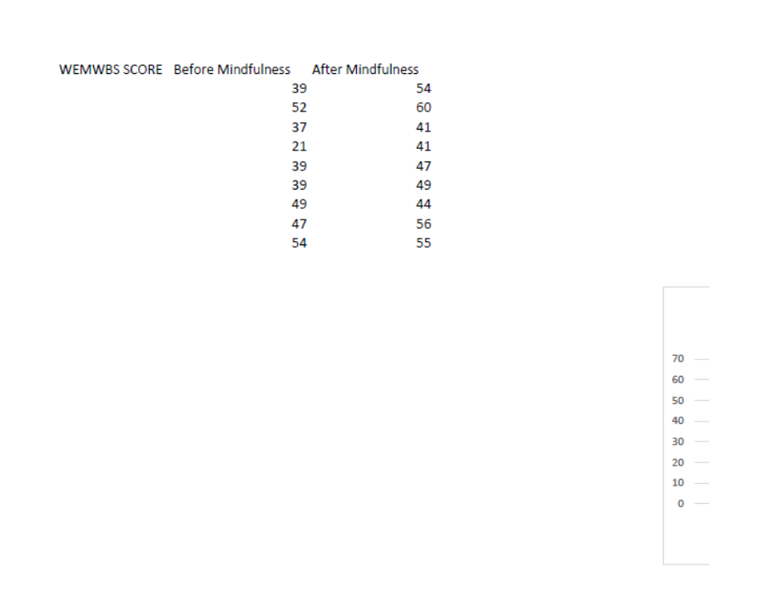

Appendix 5: Interview Schedule Group Interview WorkplaceMT NC5A Course

1. Have you enjoyed doing the mindfulness course?

2. Can you tell me a little bit about the reasons why you wanted to do the course?

3. Have you found any benefits or otherwise in college from learning mindfulness?

4. Have you found any benefits or otherwise outside college from learning mindfulness?

5. Would you recommend the course to other students?

6. Is there anything else you would like to add at this point? For example, how the course could be improved or anything else that could be better (timing, place) for students?