How to send Reiki at Level 1

There are 3 levels of training in Reiki:

Level 1 using Reiki to treat yourself and others with physical hands on healing

Level 2 where you are given symbols to send Reiki energy over time & space

Level 3 this is where you are given the Master Symbols and can teach others all 3 levels of Reiki

At the end of my Reiki 1 classes I give a quick explanation and demonstration of how to send Reiki at level 1.

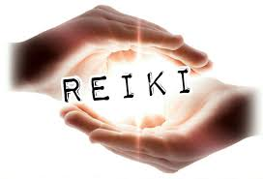

Here it is…

1. Make sure you are comfortable with a wrap and some water nearby. Rest your hand on a cushion or 2 if that is more comfortable when it comes to the sending.
2. Centre yourself with 5 minutes or so of Gassho or other mindfulness meditation
3. Bring to mind what you want to send Reiki to. This could be a situation (ie. Reiki Sharing Group, a future or past event) a person or an animal or anything else you can think of.
4. 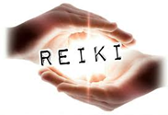Imagine you can place the situation/person in the palm of your non-dominant hand (I’m right handed so this is my left hand).
5. You can also write down the name of the person or situation on a piece of paper and place that in your hand. Or a photograph of the person, animal or situation.
6. Hold your other hand over this and imagine a beam of Reiki being sent to the situation/person in your hand. Just like this image… 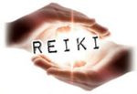
7. See if you can feel the Reiki in your hands – like heat or pulsing or even coolness. Or a sense of the energy flowing to the situation or person.
8. Send for around 15 minutes or so – this can be longer or shorter. You can continue to visualise Reiki energy flowing to the situation/person or some other visualisation. But it won’t stop Reiki flowing if your mind wanders so don’t worry – just notice and bring it back to focusing and noticing the flow of Reiki energy.
9. When you are finished just gently close your palms together to close off the energy and do a wee sweep of your palm or a blow to clear.
10. Take a moment to sit and notice how you feel …and that’s it…😊

