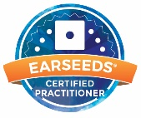

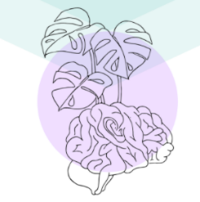
Growing Our Mindset, LLC
Frequently Asked Questions About Auriculotherapy
What is Auriculotherapy?  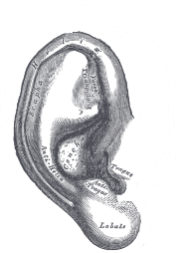  Auriculotherapy is a form of acupressure done on the visible outer part of the ear called the auricle or auricula.  What is an Ear Seed?  Ear seeds are tiny acupressure devices. The seeds are typically a vaccaria seed, though they can also be made of metal or ceramic beads. These seeds (or beads) are placed on adhesive tape, which you can put directly on your ears.  Why does my ear hurt after application?  The more severe pain your body is in your ears will recognize that and be sensitive in the correlating spot on the ear. Listen to your body and work with it. If it is too much pain in the ear avoid overly stimulating the point or take them off and give it a break.  Just don’t give up too soon. As the pain in your body reduces, the pain in the ears will dissipate too.  How long do the benefits of Auriculotherapy last?  The range of response to an ear seed session are quite varied, but it is common for a person with severe pain\tension to notice reduction in their symptoms with the very first session. Occasionally the benefits begin to subside after a few days until the next treatment. With each session the degree residual pain reduces extending the time of relief between each treatment session.  What kind of training does an Auriculotherapy practitioner have?  Training and Education vary per provider. Sarah Arntt, owner of Growing Our Mindset, LLC is a certified ear seed practitioner through the Ear Seeds Academy. She is, also, certified Acu-Detox Specialist through the National Acupuncture Detoxification Association. Along with being a Certified Addiction Specialist registered with the State of Colorado. She holds a Bachelor of Science in Psychology along with a Certification for Nursing Assistant. | How many treatment sessions are needed to help?  There is no set number of session for any condition. But the more severe the conditions it can take 3-5 for a moderate reduction in symptoms. As the symptoms are controlled, we can work into what is called a maintenance phase of monthly-quarterly visits to maintain the progress made.  How long is a typical session?  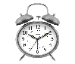  The first session can take 30-45 minutes for an intake discussion and treatment plan. Corresponding sessions are typically 20 min.  This Photo by Unknown Author is licensed under CC BY-NC  How long should I leave the ears seeds on?  Ear seeds can remain in place 4-6 days. It is highly recommended to remove the seeds at least 8 hours prior to next treatment session to give the skin and nerve points a break.  What is “stimulation” of the ear seeds?  Stimulating the ear seeds is as simple as pushing on the points or rubbing the ear. This will continue to activate the nerve points under the seed where acupressure is taking place. This sends signals to the body to heal.  Can other therapeutic modalities be used while having ear seeds?  Yes, for example if massage therapy is a part of your regular self-care routine, please continue with that therapy as well.  If you are interested in other modalities consult with that practitioner to ensure the two do not create conflicting energies in your body.  Should I stop taking my medications if I feel better?  NO, please never stop taking any medications without first consulting your medical provider. Auriculotherapy should never take the place of regular medical care.  How can you tell what points are where on the ear?  The structure of the ear can be viewed as if it is an inverted fetus. The different sections of the ear correlate with different parts of the body.  