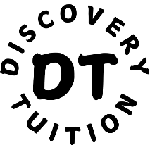
Discovery Tuition
Consent form for photo, video and audio
This form is a record of consent for any photographs/video/audio footage depicting your child for the purposes of Discovery Tuition, its products, services, work and values to help us encourage a wider awareness and understanding.
Name of Child:

Parent/Guardian/Carer Name:

Contact Number:

Home Address:

Email Address:

I understand that the photographs/video/audio will be retained in line with Discovery Tuition’s Terms and Conditions and managed in line with Discovery Tuition’s Privacy policy.
I understand I can ask for the photographs/video/audio my child appear in to be removed at any time by contacting Discovery Tuition. Although these will be removed upon request, I understand it will not be possible to remove photographs which have already been published.
I know I will not be paid for allowing the photographs/video/audio to be taken or used. I am giving permission freely. I have no interest in the copyright, nor of any moral rights, in the same.
I understand that should I have any questions I will contact Discovery Tuition by e-mail.
Please read and tick the accordingly to give your consent:
Yes / No ● I hereby consent to Discovery Tuition using photographs/video/audio
recordings of my child’s work for publicity purposes including social media and website imagery.
Yes / No ● I hereby consent to Discovery Tuition using photographs/video/audio
recordings of my child for publicity purposes including social media and website imagery.

Signed: ___________________________ Date:_________________
Printed Name: ____________________________________________________
(Parent/Guardian/Carer)

