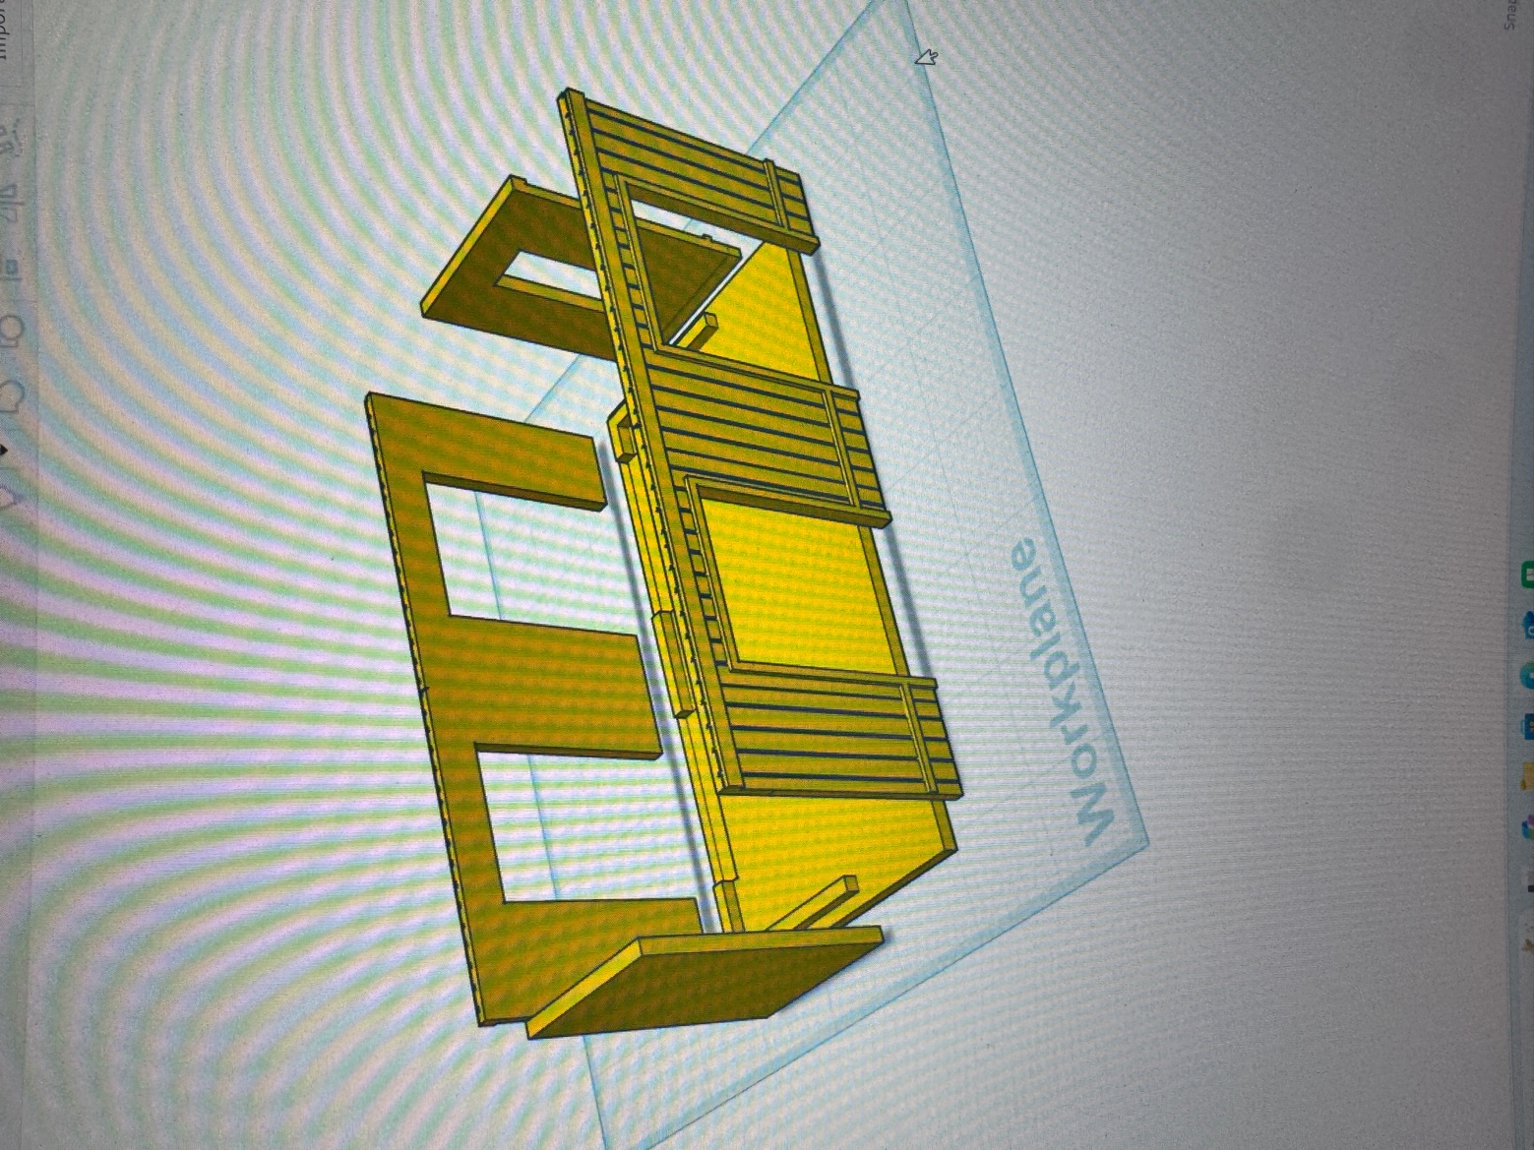

Start building the bottom sections first. You have (4) to build, (2) with solid sides and (2) with windows.

1. Use the Grey Bases, and glue the side pieces flush and to the INSIDE of the front and back walls. Once you have all the lower sections complete, set aside and let dry.

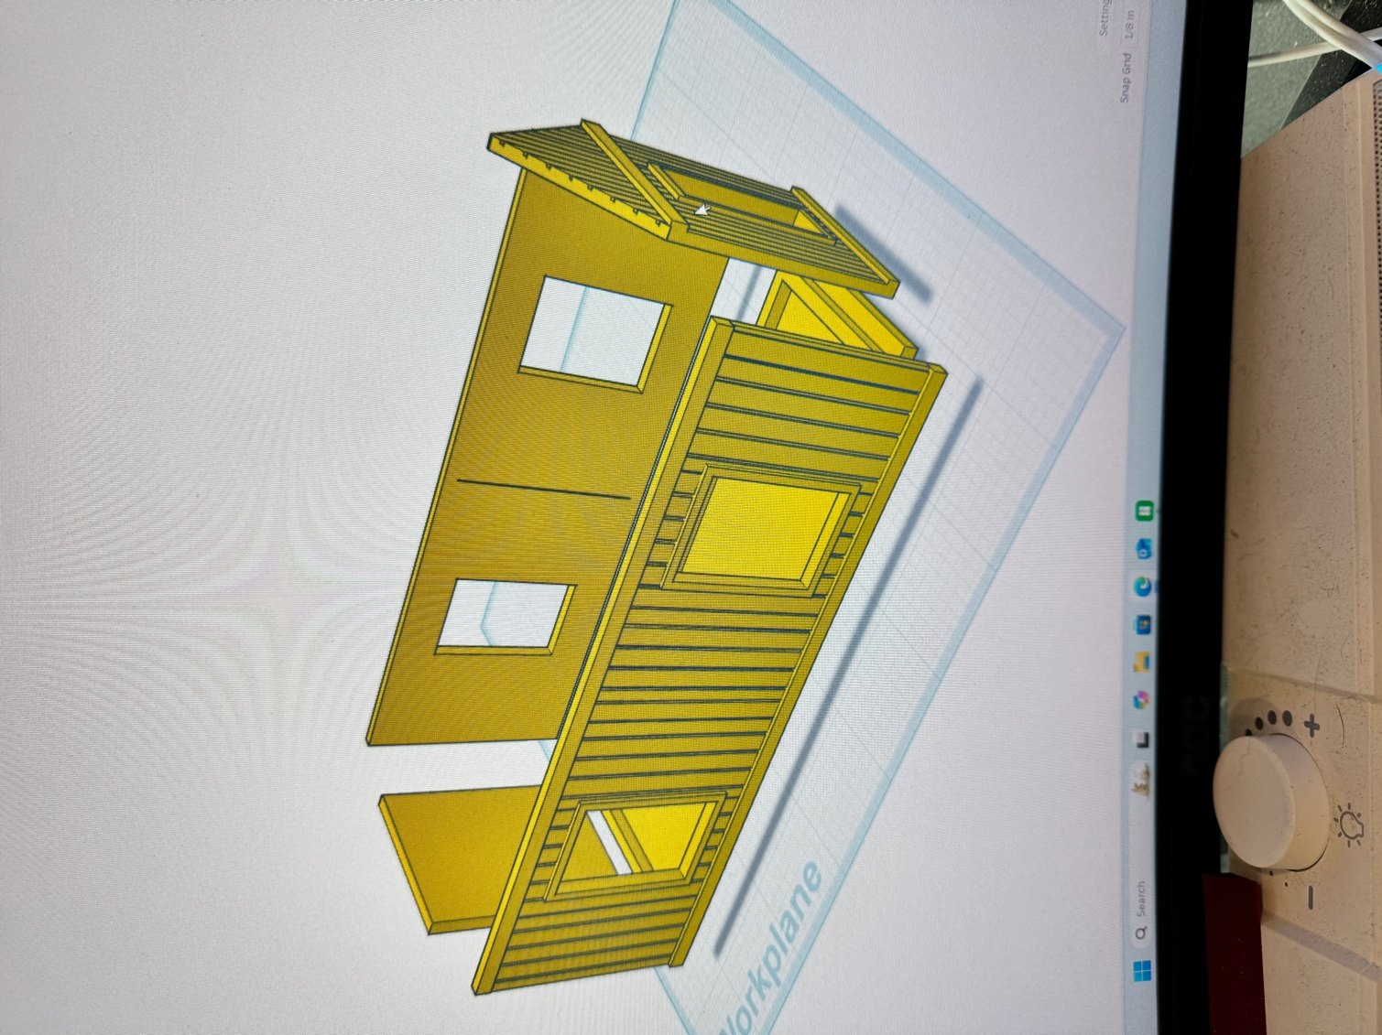

Start building the top sections using the yellow bases, you have (2) with peaked ends with windows, (1) solid and (1) with the overhang office. Glue the sides flush and to the INSIDE of the Front and back walls.

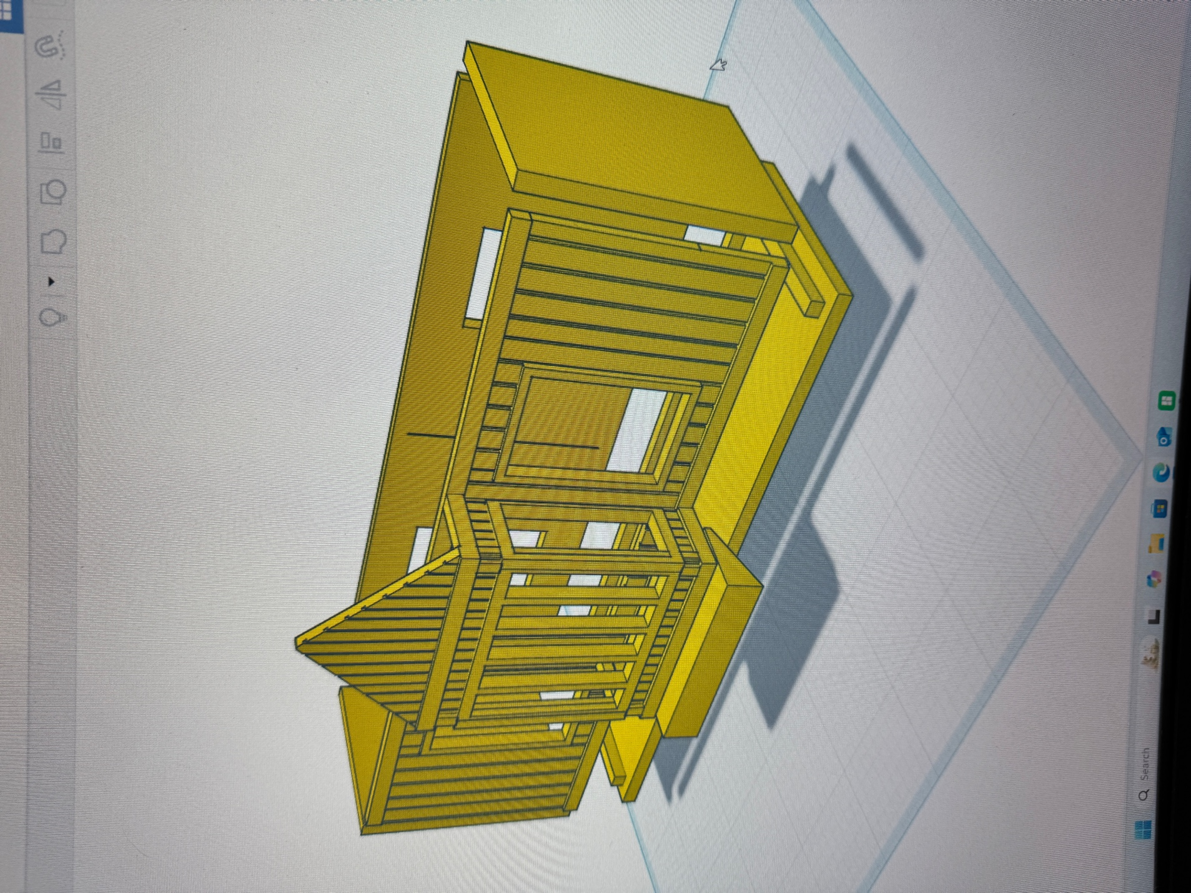
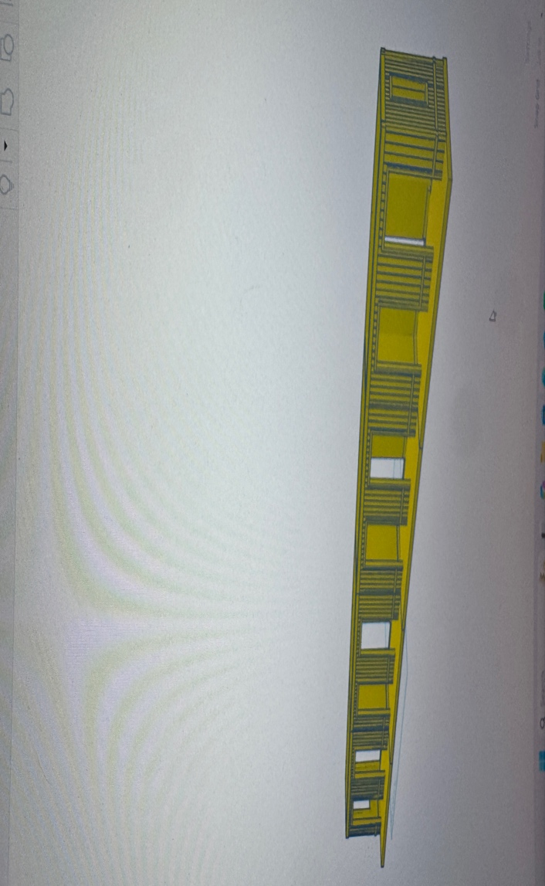

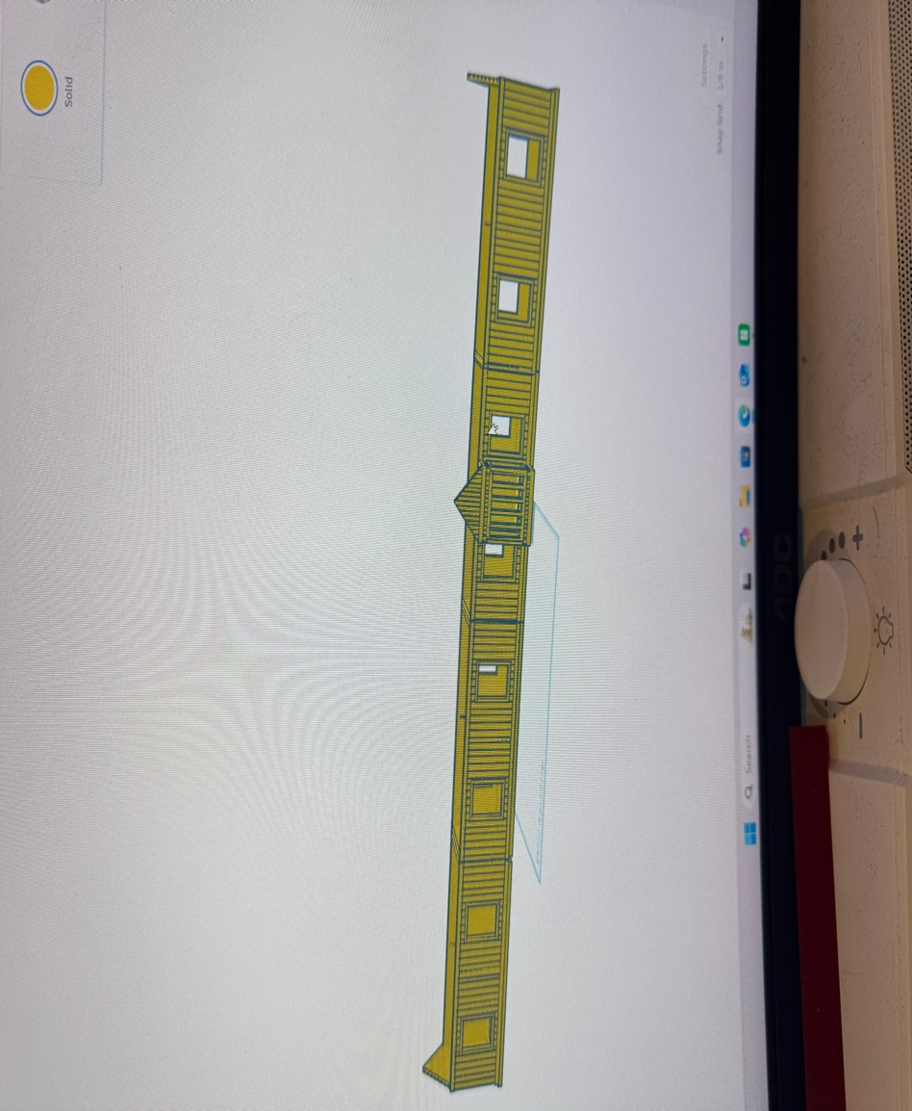

Completed sections.

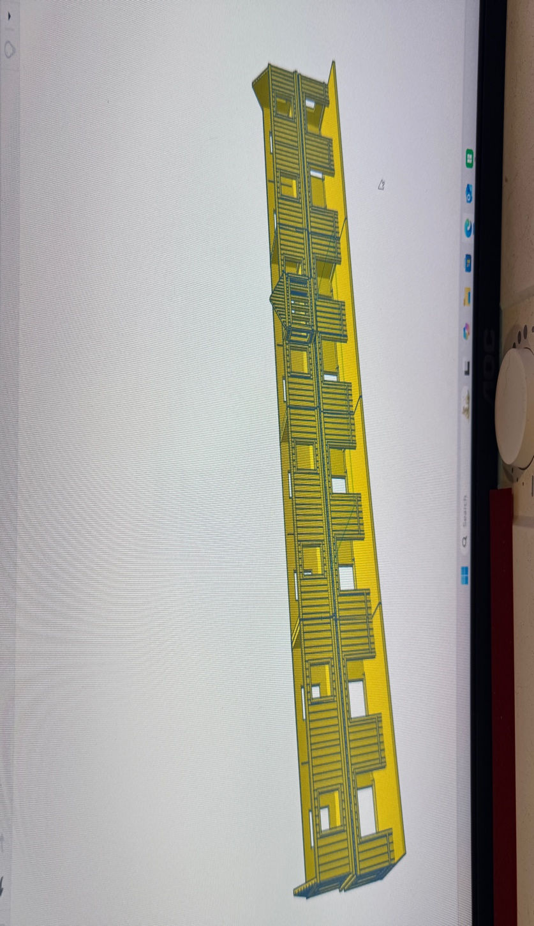

Glue the bottom and top sections together.

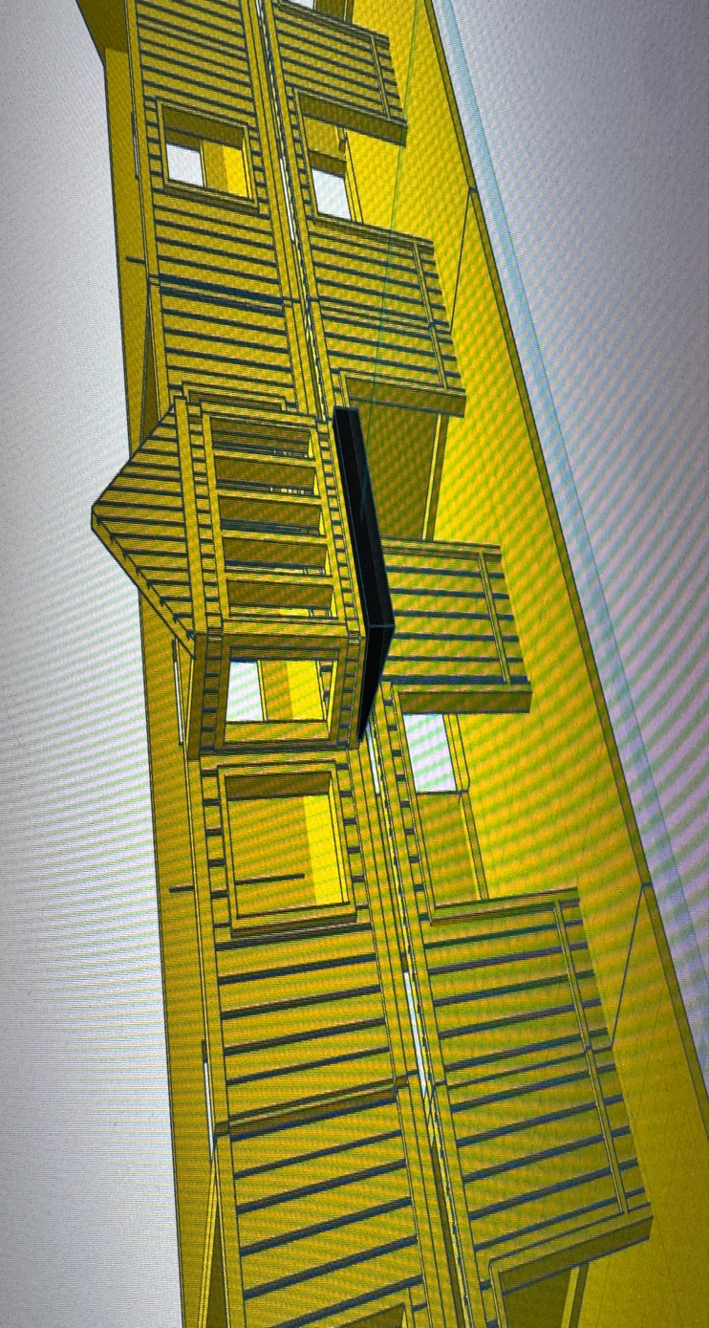

Glue the yellow Rectangle piece flush to the bottom of the overhang. This will be the angle guides for the grey overhang roofs.

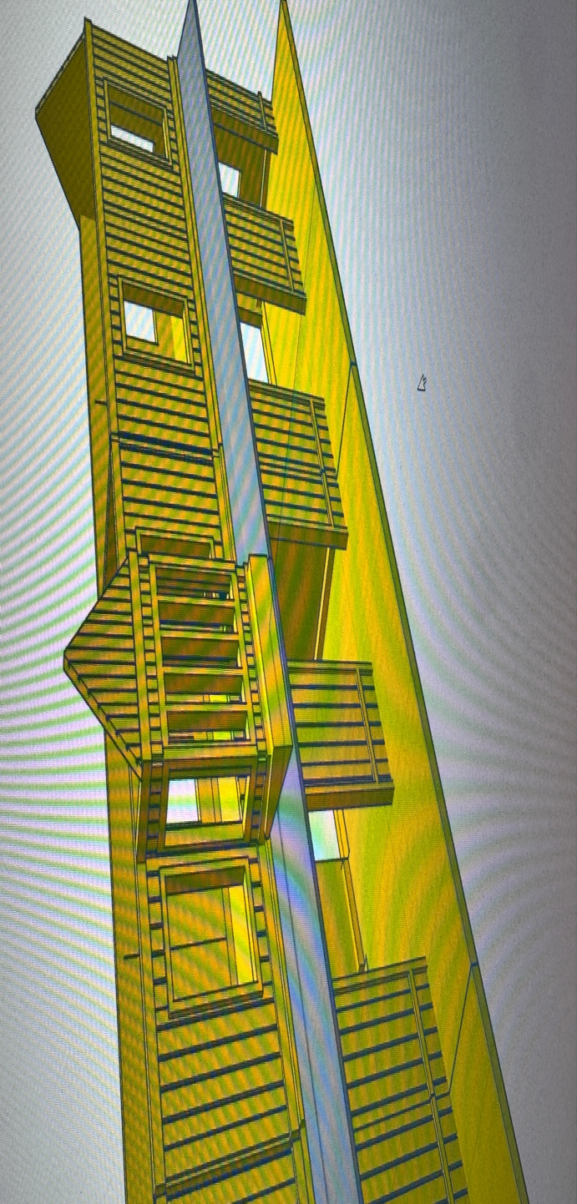

Glue the grey overhang roof to the building.

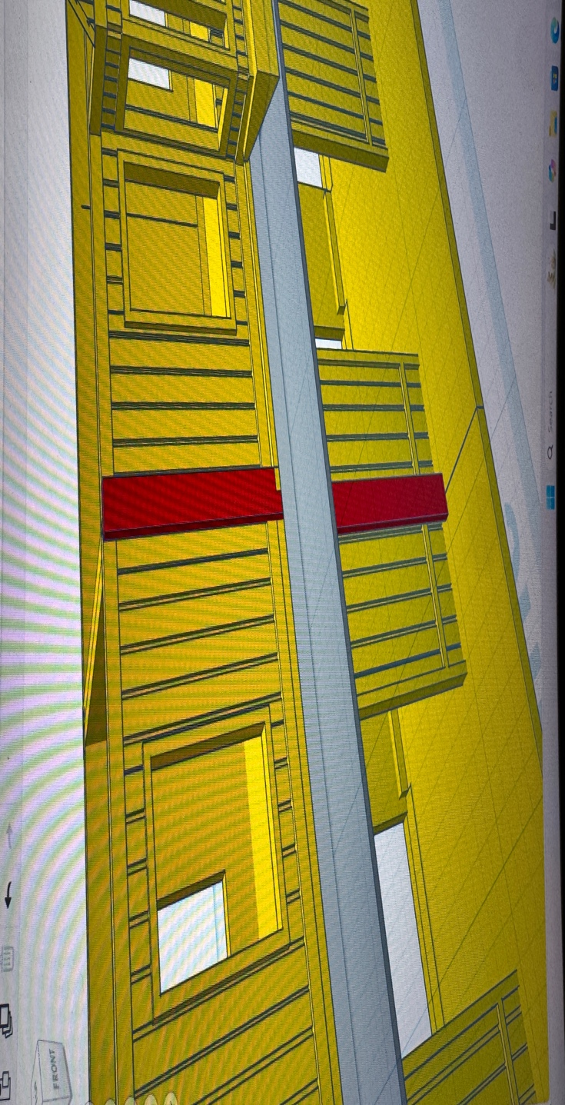

Use the included yellow sticks to fill the gaps between the building sections.

Finishing off.

1. Glue the little white angles to the bottom of the grey overhang roofs at your preferred location.

2. Glue the respective roof sections.

3. Glue signs on each end.

4. Glue or place accessories.

