Thanks for your support!

Since these Kits are limited and hard to find, I decided to create my own and offer them for sale at a reasonable price.

You can see the cars and buildings I design and sell running on my layout on my YouTube Channel listed below, as I print and test them on my layout before I release them to the public.

Please go over the KIT, if anything arrives broken let me know and I will replace it free of charge, 100% Satisfaction and positive feedback is our goal.

Webstore– www.flrailroaddog.com

Youtube - @FL Railroaddog

Etsy store - <https://flrailroaddog.etsy.com>

I clean the models before I ship them out, but I recommend going through the pieces to make sure all the fillers have been removed.

1. Start with the porch, glue the support beams to the roof, if needed trim the ends of the beams with a hobby knife or file until they fit snug into the holes. Do not let them extrude past the floor.

2. Once dry, glue the top railings, ensuring that the long ends go down. Set aside.

3. Notice that the front wall sits on top of the porch base, even with the back. Glue and let dry.

4. Glue both side walls to the front wall on the inside. The space on top is where the roof will sit.

5. Glue the Back Wall to the outside of both ends. Let dry.

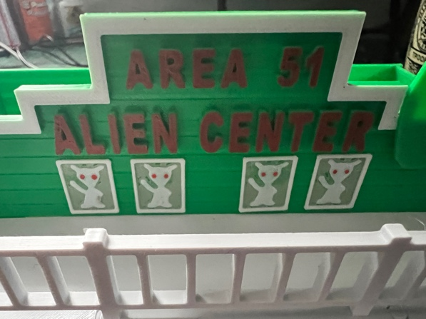

6. Glue the 4 Alien boxes to the front wall as shown above.

7. Glue the big alien face to the front wall.

8. Glue or just set the roof on to the structure.

Your Done!