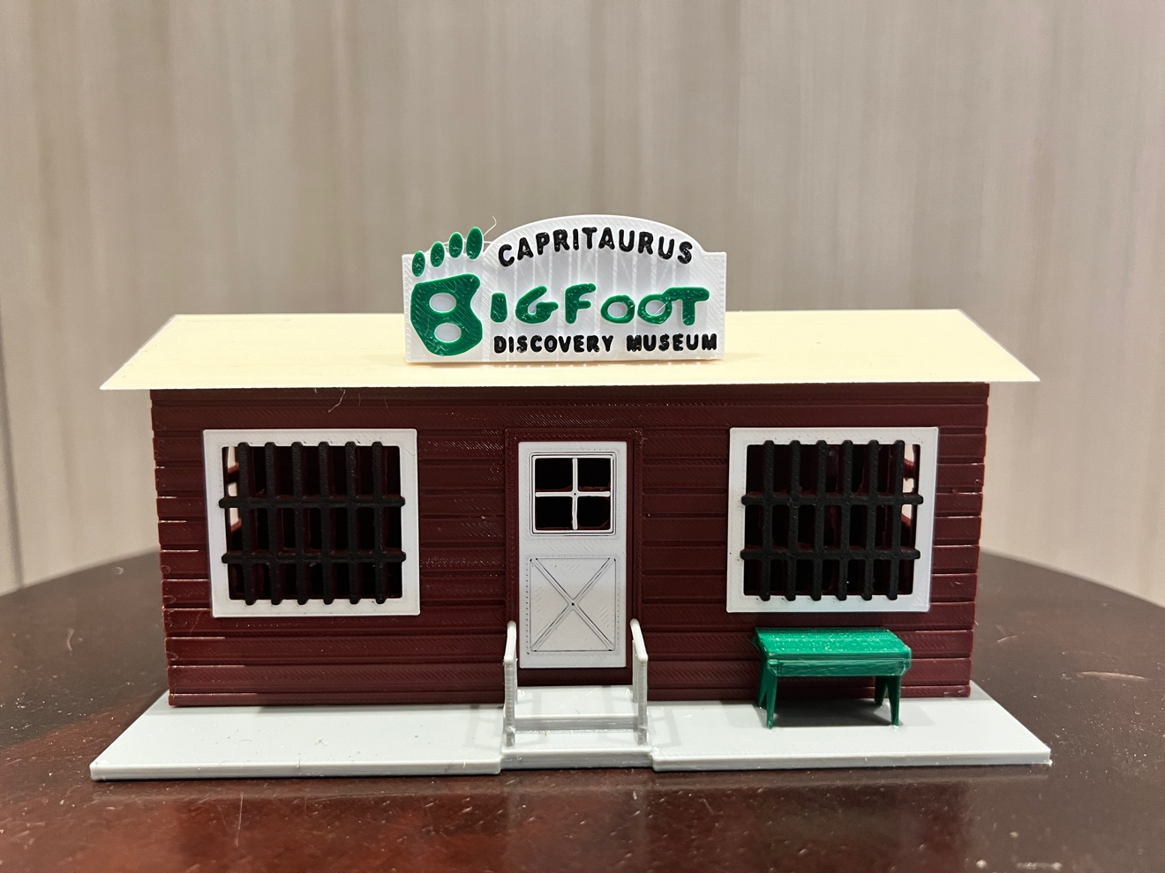

Thanks for your support!

Since these Kits are limited and hard to find, I decided to create my own and offer them for sale at a reasonable price.

You can see the cars and buildings I design and sell running on my layout on my YouTube Channel listed below, as I print and test them on my layout before I release them to the public.

Please go over the KIT, if anything arrives broken let me know and I will replace it free of charge, 100% Satisfaction and positive feedback is our goal.

Webpage – https://flrailroaddog.com
Youtube - @FL Railroaddog
Etsy store - https://flrailroaddog.etsy.com

STRUCTURE

1. I clean the models before I ship them out, but I recommend going through the pieces to make sure all the fillers have been removed.

2. Assemble the structure with the side walls glued to the inside of the front and rear wall.

3. Glue the roof centered with a lip extruding on both sides.

4. Glue the Sign centered on the roof.

5. Glue the structure centered on the stairs.

6. 2 Benches are included so you can place them where you prefer.

7. You are Done!

