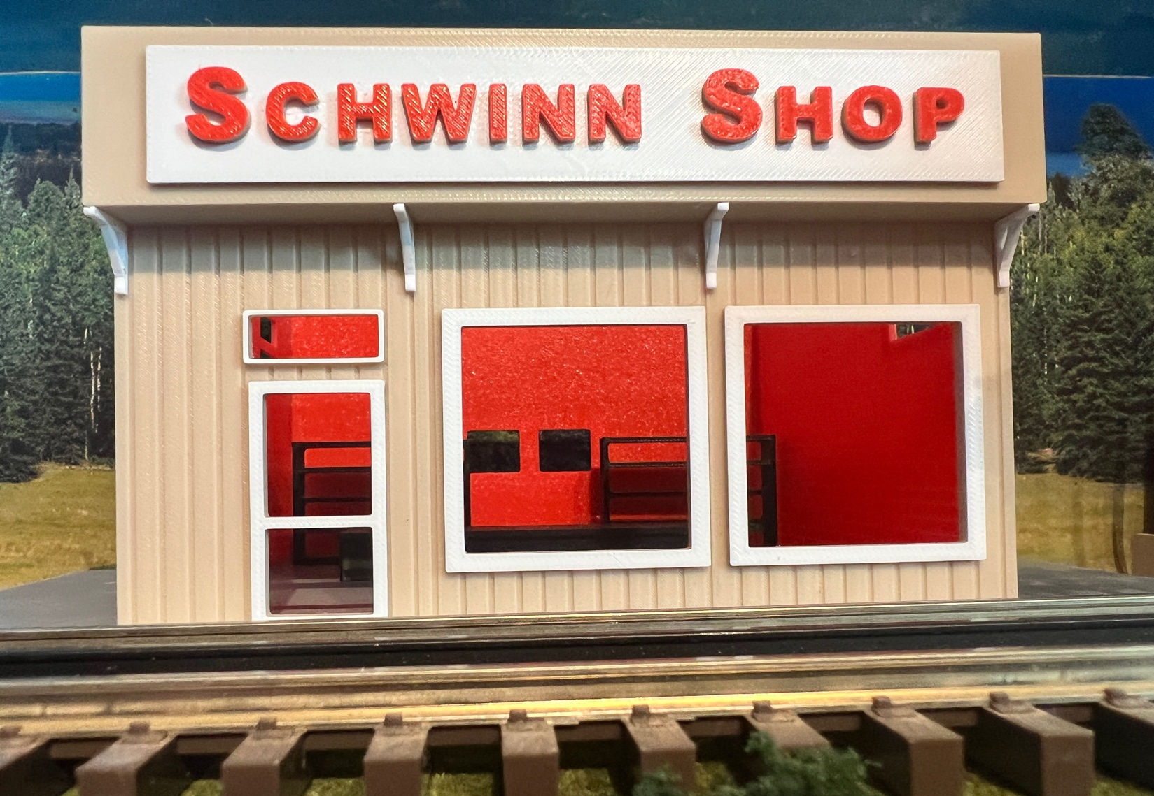
Thanks for your support!

Since these Kits are limited and hard to find, I decided to create my own and offer them for sale at a reasonable price.

You can see the cars and buildings I design and sell running on my layout on my YouTube Channel listed below, as I print and test them on my layout before I release them to the public.

Please go over the KIT, if anything arrives broken let me know and I will replace it free of charge, 100% Satisfaction and positive feedback is our goal.

Webpage – https://flrailroaddog.com
Youtube - @FL Railroaddog
Etsy store - https://flrailroaddog.etsy.com

STRUCTURE

1. I clean the models before I ship them out, but I recommend going through the pieces to make sure all the fillers have been removed.

2. Glue the back wall and front wall to the side walls, with the back and front walls flush to the outside of the side walls.

3. Glue the structure to the base.

4. Glue the white roof supports to the front wall and sign support.

5. Glue the roof.

Your Done!

