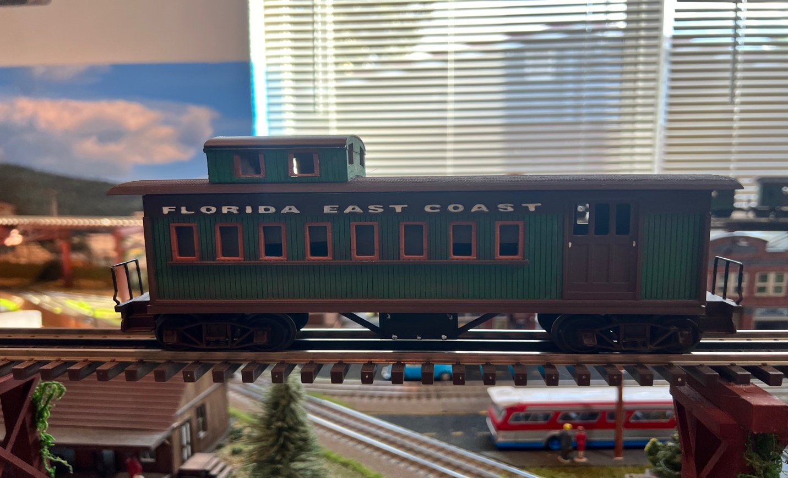

I wanted 36’ Wood Sided Coaches and a Caboose to match my MTH 36’ Reefer and boxcars, unfortunately they are not made and probably never will, so I decided to create my own.

The Caboose is built exactly like the passenger cars, hence the instructions, with the only difference being the window inserts and the top capola (no window inserts for this). Window inserts are optional if you want to paint them a different color like I did on mine.

Take your time putting these items together, and with a lot of attention to detail, you can create a beautiful piece of rolling stock for your model railroad.

Thanks, and Happy Railroading

Jorge

YouTube Channel – FLRailroaddog
TinkerCad – FL Railroaddog
Email – flrailroaddog@gmail.com

