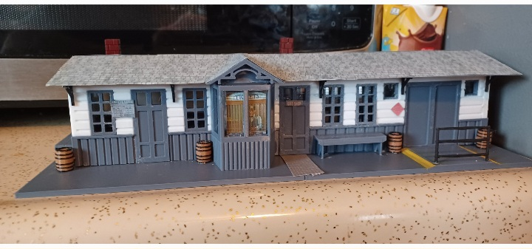

Thanks for your support!

Since these Kits are limited and hard to find, I decided to create my own and offer them for sale at a reasonable price.

You can see the cars and buildings I design and sell running on my layout on my YouTube Channel listed below, as I print and test them on my layout before I release them to the public.

Please go over the KIT, if anything arrives broken let me know and I will replace it free of charge, 100% Satisfaction and positive feedback is our goal.

Website- www.flrailroaddog.com
Youtube - @FL Railroaddog
Etsy store - https://flrailroaddog.etsy.com

You will notice that the lower structure and the upper structure are in multiple pieces. This is done for color printing and the large size of this building. Do not be discouraged follow the below steps and it will assemble easily.

1. Locate all the windows and doors, these will be your guide for lining up the bottom and the top structure. Glue the door and windows to the Top portion of the structure (WHITE).

2. Locate and glue the bottom portion of the structure and match them up to the top white portion, using the doors as a guide.

3. Locate the ticket building and glue to the structure.

4. Locate both halves of the base and glue together.

5. Glue the structure to the base.

6. Locate and glue both halves of the roof together, and glue to the structure.

7. Locate and glue the roof decorated trim pieces to the ends of the roof and the end of the ticket office.

8. Locate and glue the black (L) angles to the bottom of the roof and to the side of the structure.

9. Locate and glue the Cass signs to each end of the building.

10. Locate and glue the benches to the desired area.

Your Done!

