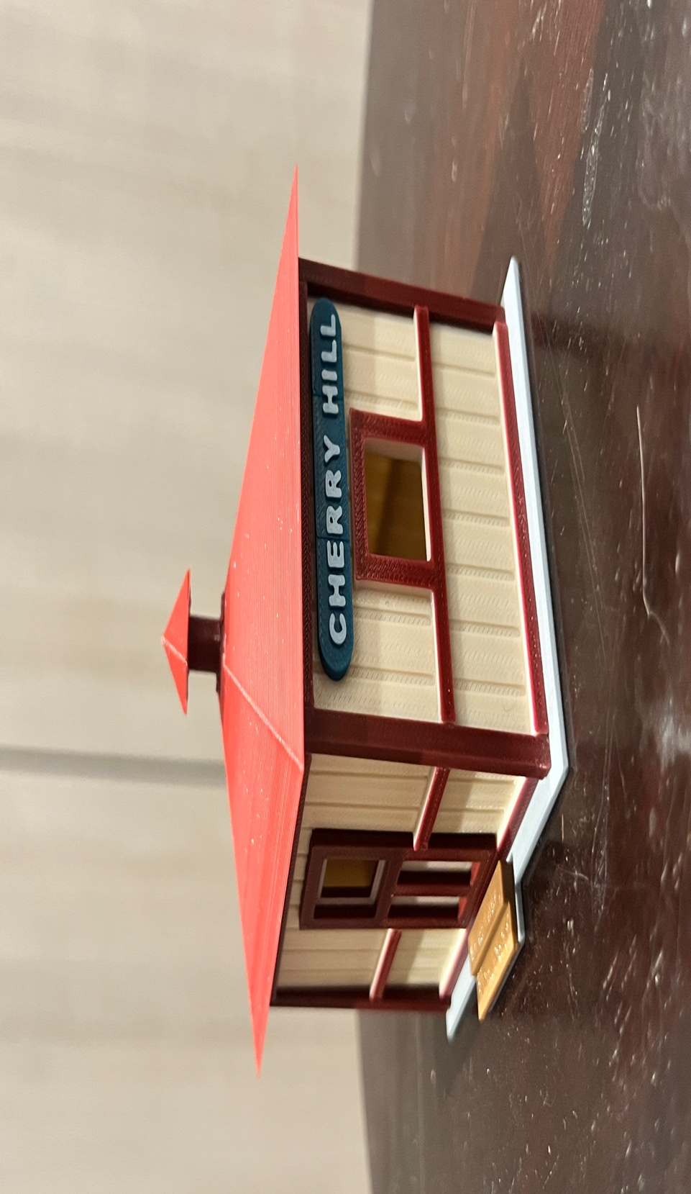
Thanks for your support!

Since these Kits are limited and hard to find, I decided to create my own and offer them for sale at a reasonable price.

You can see the cars and buildings I design and sell running on my layout on my YouTube Channel listed below, as I print and test them on my layout before I release them to the public.

Please go over the KIT, if anything arrives broken let me know and I will replace it free of charge, 100% Satisfaction and positive feedback is our goal.

Ebay – www.flrailroaddog.com
Youtube - @FL Railroaddog
Etsy store - https://flrailroaddog.etsy.com

I clean the models before I ship them out, but I recommend going through the pieces to make sure all the fillers have been removed.

This KIT comes pre-printed in Cream, Burgundy, White and Black, with the Groff’s Signs already printed in their respective colors, saving the time used to fine paint them.

As you can see, I have designed this building to be completed with ease and very little effort
.
I use a hot glue gun to glue my models, that way they are easy to take apart and store. A small amount at each corner should be just fine. For a permanent structure I use Gorilla Super Glue liquid not gel.

If you take your time, you can create a beautiful piece.

As always, your satisfaction is of outmost important, if anything arrives broken, let me know and I will ship out a replacement free of charge.

If you have any suggestions and or ideas to improve the KIT let me know.

Happy Railroading,

Jorge

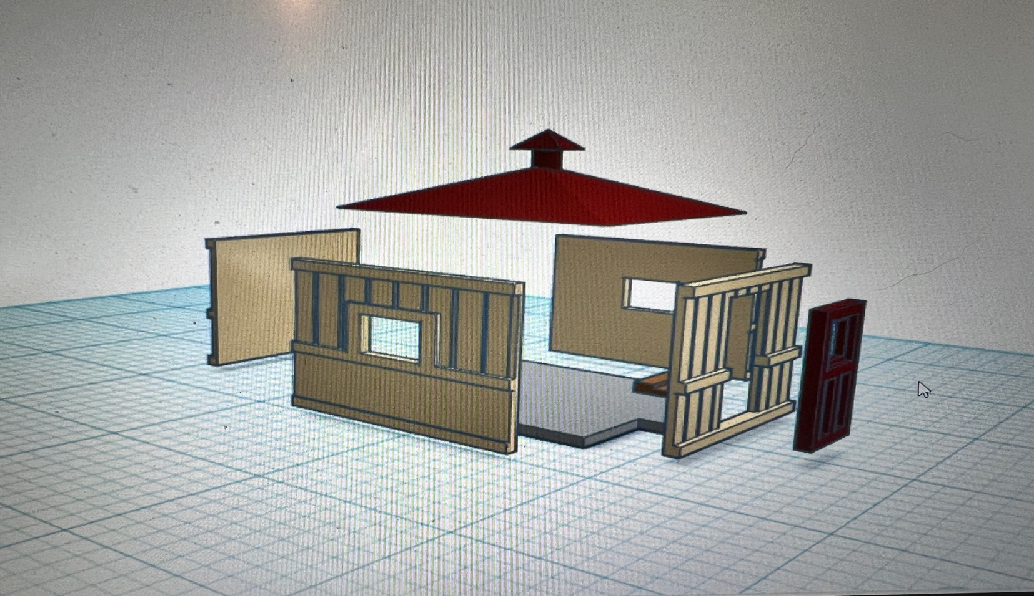

1. Glue the back wall to the side walls, with the back wall flush to the outside of the side walls.

2. Glue the structure to the base.

3. Glue or snap in Door.

4. Glue the brown stairs to the base

5. Glue the roof, ensuring that it is even on both sides.

Your Done!

