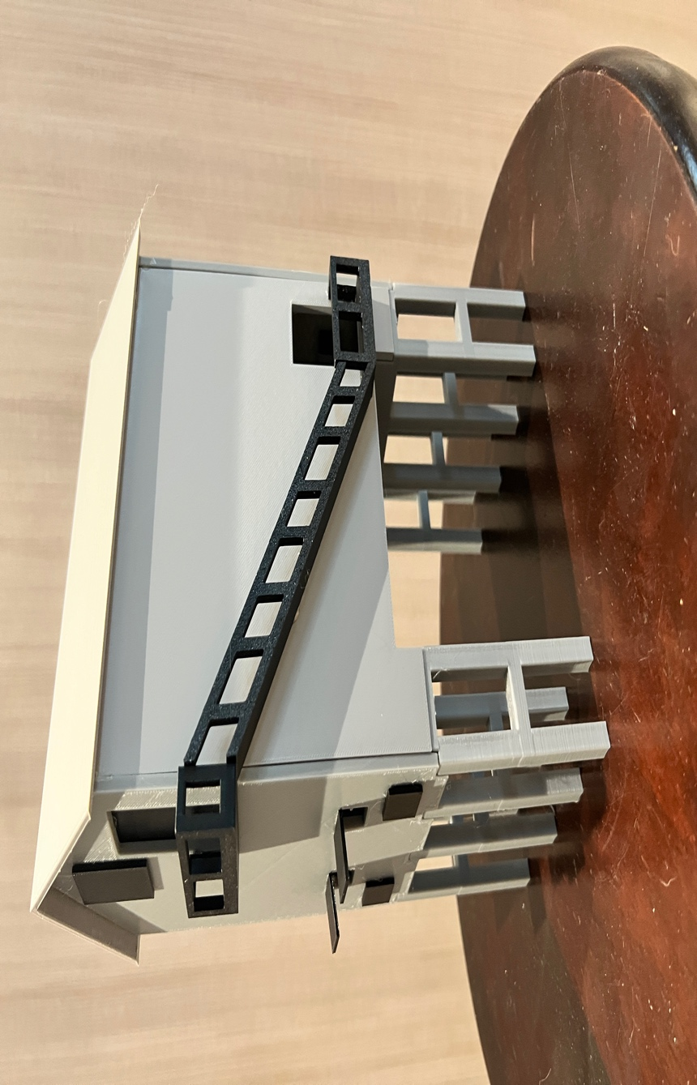

Thanks for your support!

Since these buildings have never been made or ever will, I decided to create my own and offer them for sale at a reasonable price.

You can see the all my designs on my layout on my YouTube Channel listed below, as I print and test them on my layout before I release them to the public.

Youtube - @FL Railroaddog
Etsy store - https://flrailroaddog.etsy.com
www.flrailroaddog.com

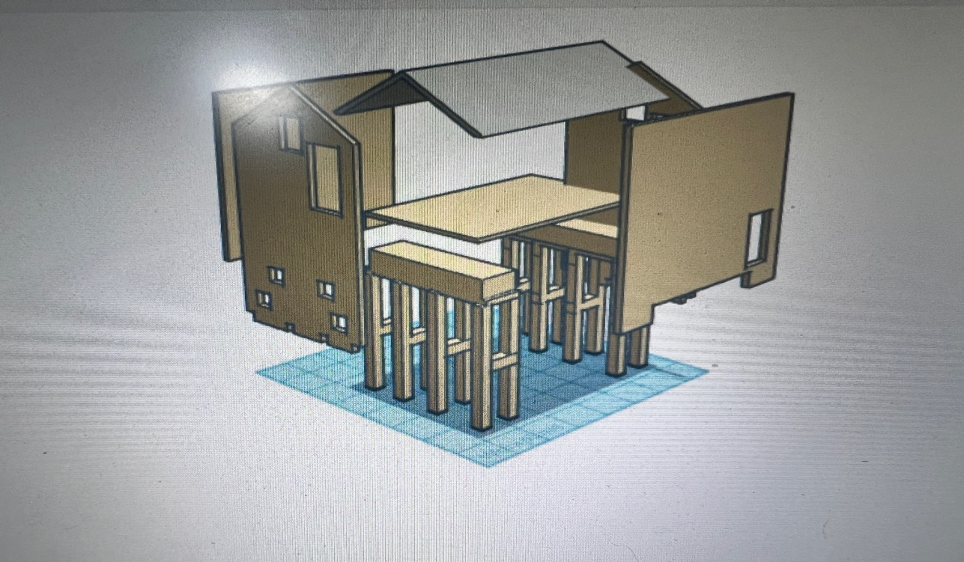

I clean the models before I ship them out, but I recommend going through the pieces to make sure all the fillers have been removed.

Paint all the pieces separately, I recommend a coat of GREY AUTOMOTIVE FILLER PRIMER, this will ensure the paint catches better and small imperfections are filled.

I then paint all the pieces to the colors I need.

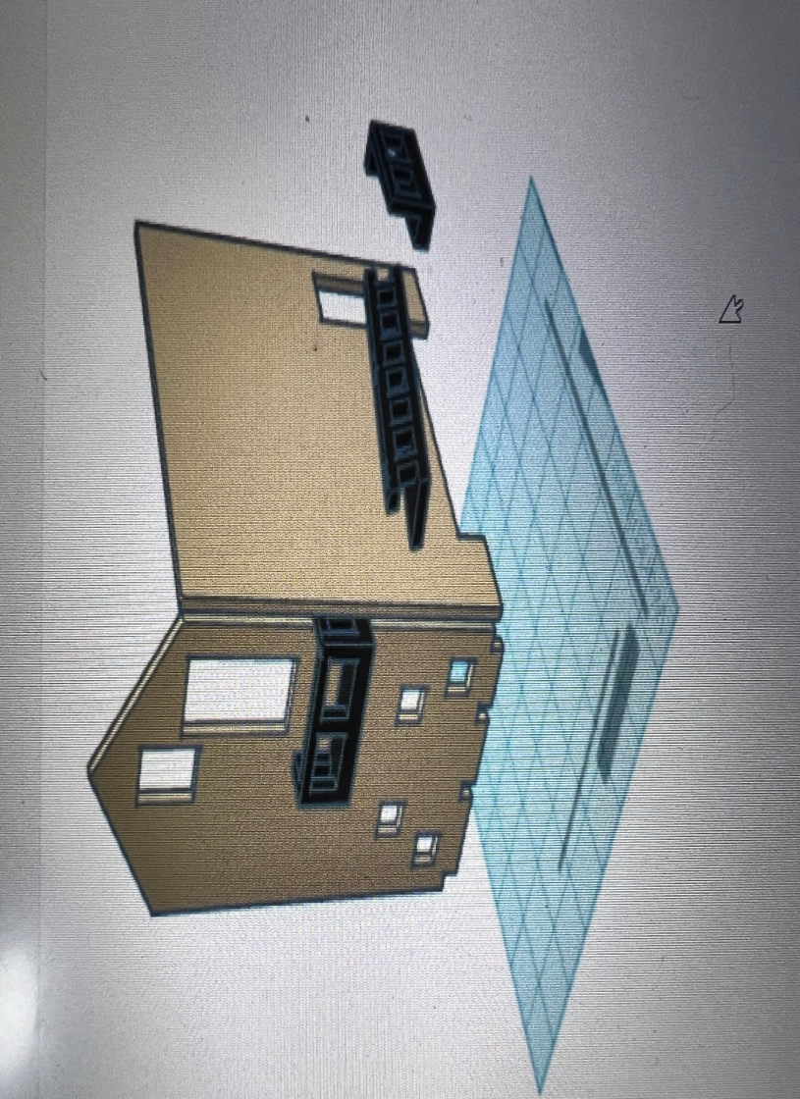

1. Glue and slide the sidewalls on to the slots on the base.

2. Glue the inner floor to the base, ensuring that it its square.

3. Glue the front and rear walls flush to the side walls and bottom slots on the base.

4. Glue the Stairs, ensuring a correct alignment between the top and bottom.

6. Glue the doors to the inside the building.

7. Glue the Shute doors flush or slightly ajar.

8. Glue the Roof. (PLEASE NOTE!!, the roof might seem to be too big, it is not!, I made it this way for a tighter fit, please glue and tape it on and it will fit perfectly and fill any gaps.

I hot glue the items pictured since I take them apart later for storage. If you want a permanent structure, I recommend Gorilla Super Glue in liquid form.

If you take your time, you can create a beautiful piece.

Happy Railroading,

Jorge

