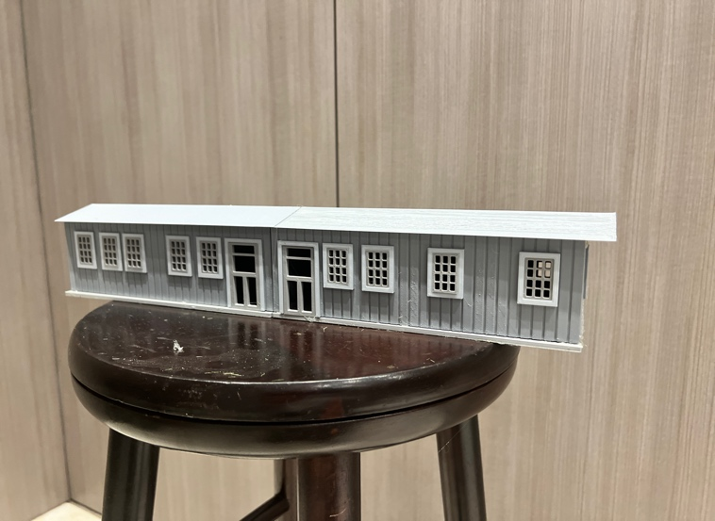
Thanks for your support!

Since these Kits are limited and hard to find, I decided to create my own and offer them for sale at a reasonable price.

You can see the cars and buildings I design and sell running on my layout on my YouTube Channel listed below, as I print and test them on my layout before I release them to the public.

Please go over the KIT, if anything arrives broken let me know and I will replace it free of charge, 100% Satisfaction and positive feedback is our goal.

Please DO NOT go by the building above, as it was the prototype and I upgraded it to a certain degree, better roof design, fixed windows and other upgrades.

Webpage – https://flrailroaddog.com
Youtube - @FL Railroaddog
Etsy store - https://flrailroaddog.etsy.com

STRUCTURE

1. I clean the models before I ship them out, but I recommend going through the pieces to make sure all the fillers have been removed.

2. Locate the 2 L shaped bases and glue them together, with the wide part side by side, the wide portion is the base for the bathroom area.

3. Located and glue the front and backwalls to the sidewalls. Do this to both buildings. I made the front wall thicker for better support.

4. Glue both buildings together, making sure the doors go closest to eachother, then glue the buildings to the base.

5. Glue the 4 roof sections to the building.

6. Glue the bathroom sides and front together. Then glue this structure to the main building, centered.

7. Glue the bathroom roof.

8. Orientate and glue the front steps.

9. I included 2 benches if you want to use them.

Your Done!

