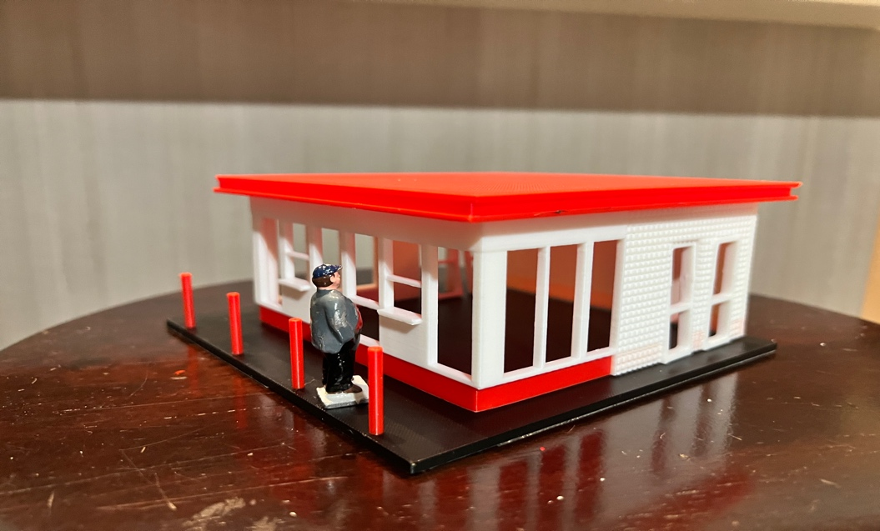

Thanks for your support!

Since these Kits have never been made or ever will, I decided to create my own and offer them for sale at a reasonable price.

You can see the cars and buildings I design and sell running on my layout on my YouTube Channel listed below, as I print and test them on my layout before I release them to the public.

Please go over the KIT, if anything arrives broken let me know and I will replace it free of charge, 100% Satisfaction and positive feedback is our goal.

Ebay – www.flrailroaddog.com
Youtube - @FL Railroaddog
Etsy store - https://flrailroaddog.etsy.com

As always, your satisfaction is of outmost important, if anything arrives broken, let me know and I will ship out a replacement free of charge.

If you have any suggestions and or ideas to improve the KIT let me know.

Happy Railroading,

Jorge

