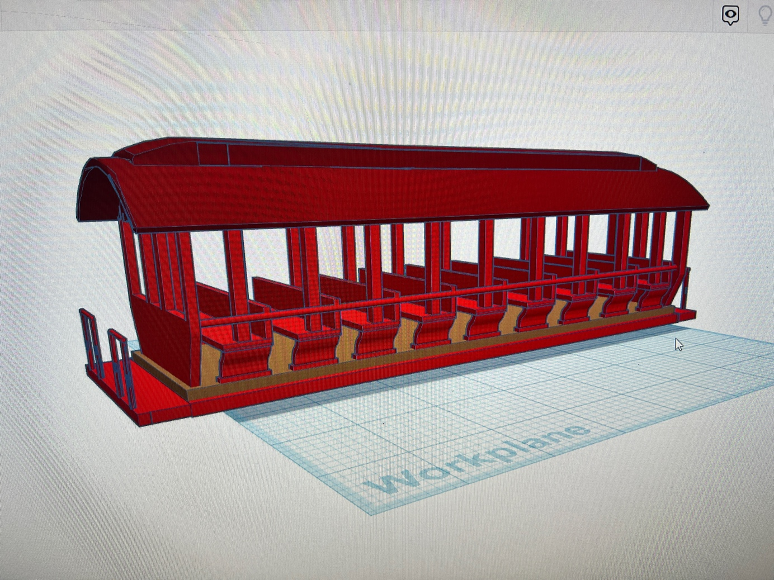

Thanks for your support!

Since these Amusement Park Cars have never been made or ever will, I decided to create my own and offer them for sale at a reasonable price.

You can see the cars I design and sell running on my layout on my YouTube Channel listed below, as I print and test them on my layout before I release them to the public.

Please go over the KIT, if anything arrives broken let me know and I will replace it free of charge, 100% Satisfaction and positive feedback is our goal.

Youtube - @FL Railroaddog
Etsy store - https://flrailroaddog.etsy.com

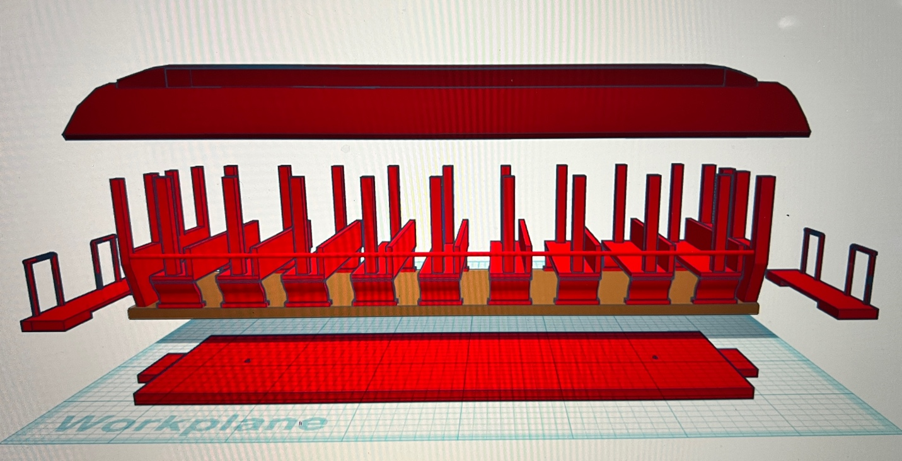

I clean the models before I ship them out, but I recommend going through the pieces to make sure all the fillers have been removed.

Paint all the pieces separately, I recommend a coat of GREY AUTOMOTIVE FILLER PRIMER, this will ensure the paint catches better and small imperfections are filled.

I then paint all the pieces to the colors I need.

I use either Lionel or MTH 3 rail trucks with wheels. I counter sink the screw so as it is slightly below the base.

I then hot glue the floor w/ seats to the Base, placing a small amount of hot glue in the corners and center. This allows the base to be removed in the future if the trucks and wheels need to be replaced or repaired.

I then complete the model by gluing the roof. If you take your time, you can create a beautiful piece.
Happy Railroading, Jorge

