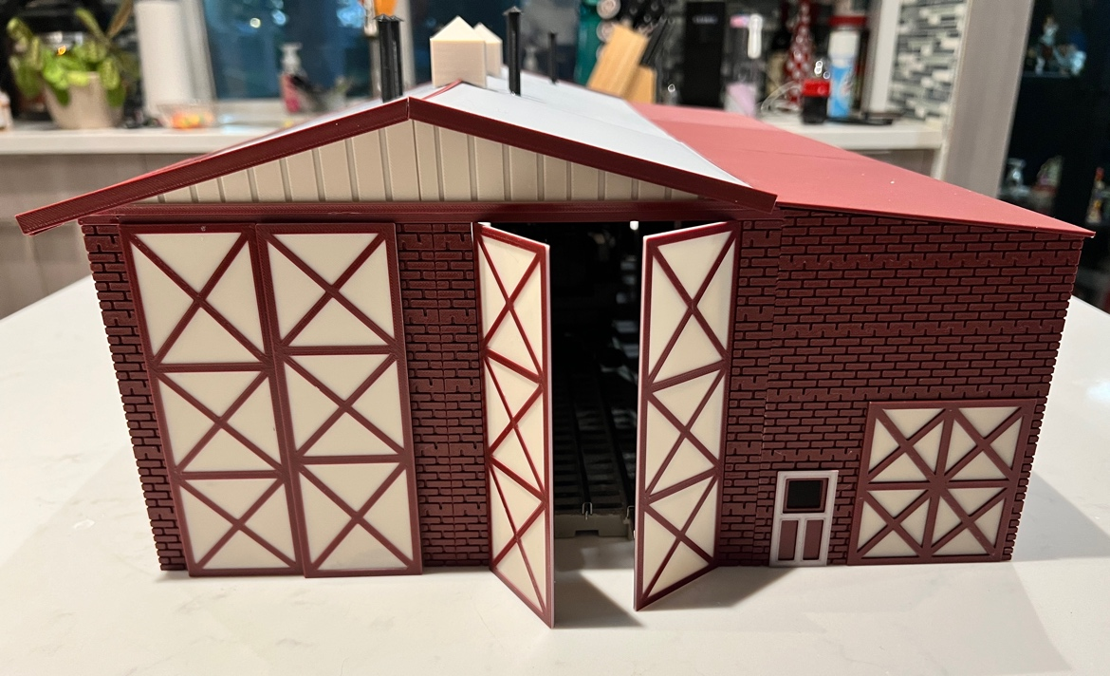

Thanks for your support!

Since these Kits are limited and hard to find, I decided to create my own and offer them for sale at a reasonable price.

You can see the cars and buildings I design and sell running on my layout on my YouTube Channel listed below, as I print and test them on my layout before I release them to the public.

Please go over the KIT, if anything arrives broken let me know and I will replace it free of charge, 100% Satisfaction and positive feedback is our goal.

www.flrailroaddog.com
Youtube - @FL Railroaddog

I clean the models before I ship them out, but I recommend going through the pieces to make sure all the fillers have been removed.

If you take your time, you can create a beautiful piece.

If you have any suggestions and or ideas to improve the KIT let me know.

Happy Railroading,
(A) 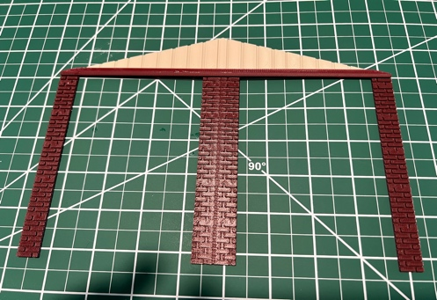 (B) 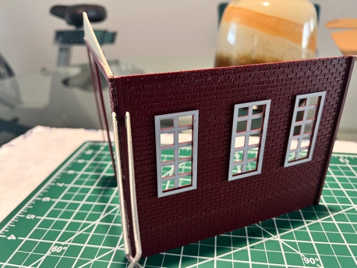 (C) 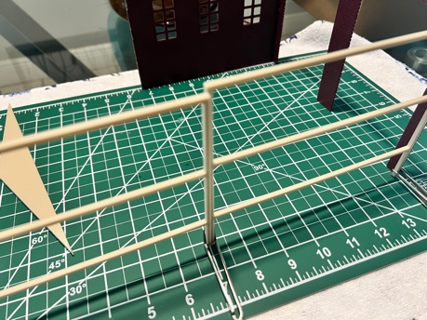

1. Locate the (2) front bay openings and the (2) roof supports with the ribbed fronts. Glue them flush to the top. Pic (A)

2. Locate the (3) Tall side walls and glue them all side by side and then once dry, gluthem to the front walls flush and on the INSIDE of the front wall. Pic (B)

3. Locate the (3) support beam frames and glue them side to side flush. Once dry glue the completed piece flush to the inside of the front walls. Pic (C).

(D) 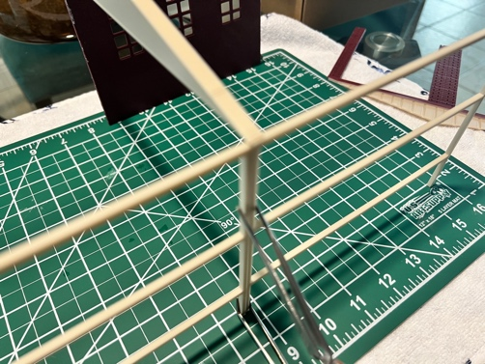 (E) 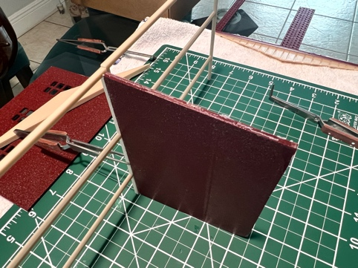 (F) 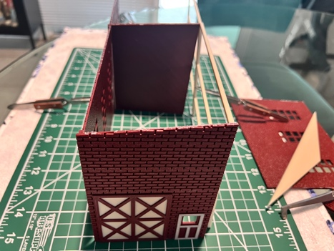

4. Glue the remaining roof support angles centered on each side. Pic (D).

5. Glue the small inner shed walls centered to the middle beams. Pic (E).

6. Glue the small fronts flush with the main building. Pic (F) & (G).

(G) 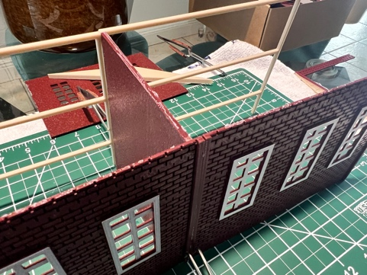 (H) 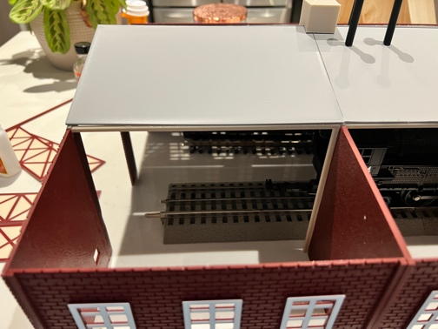 (I) 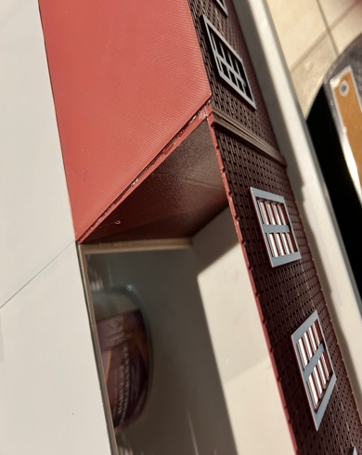

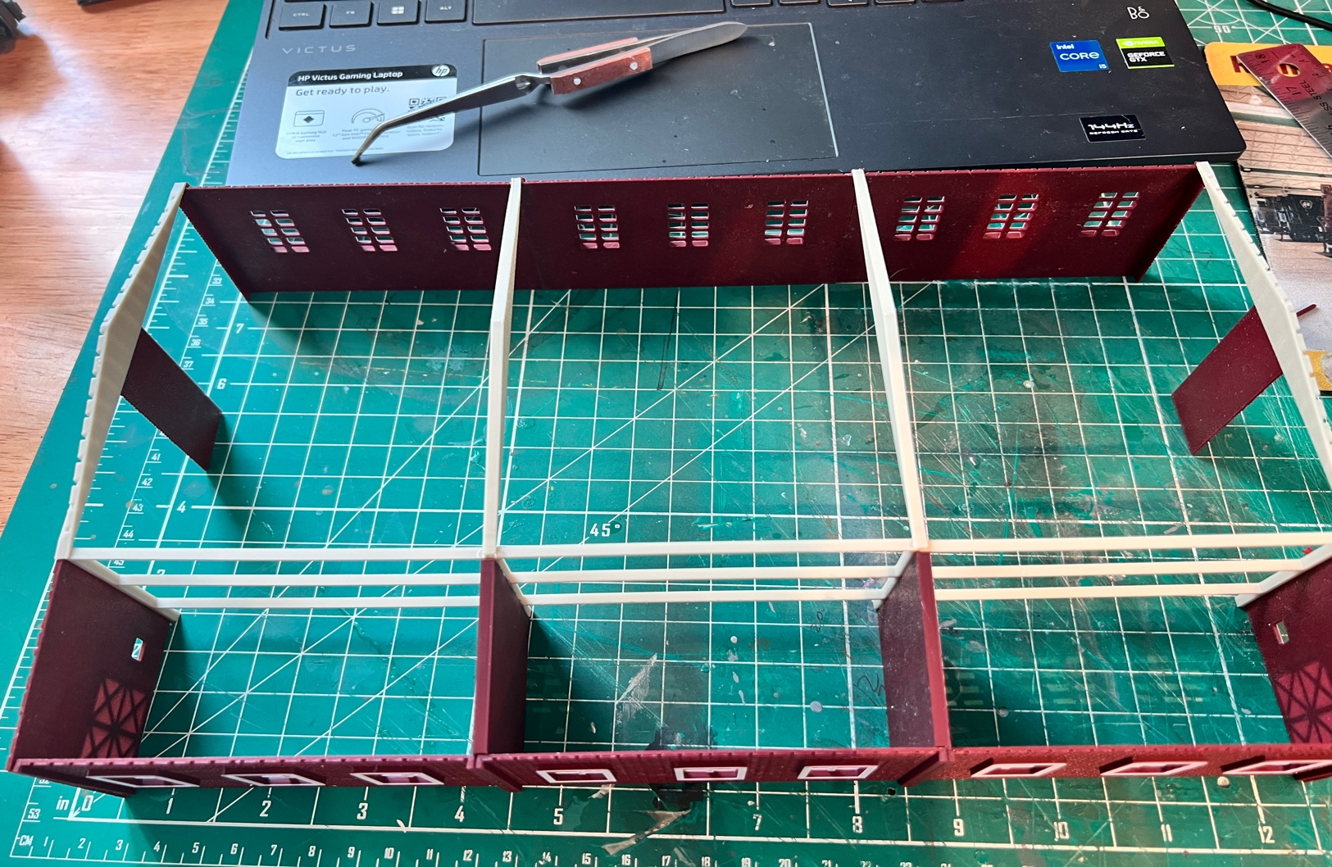

7. NOTICE that the roofs are marked Roof A-ends, Roof A-middle, etc. Looking at the front of the building with the small structure to your left. Roof A starts at the right, roof b is the center roof and roof c is the red roof. Center and glue them all to the structure.

8. Use the supplied burgundy trim pieces for the edges and to conceal the gaps if wanted.

9. Locate the copulas, trim them, and glue them to the main roof.

10. Glue the stove pipes to the roof.

11. Locate the 12 doors and glue them to the structure to your liking, either open or closed.

12. Done!

