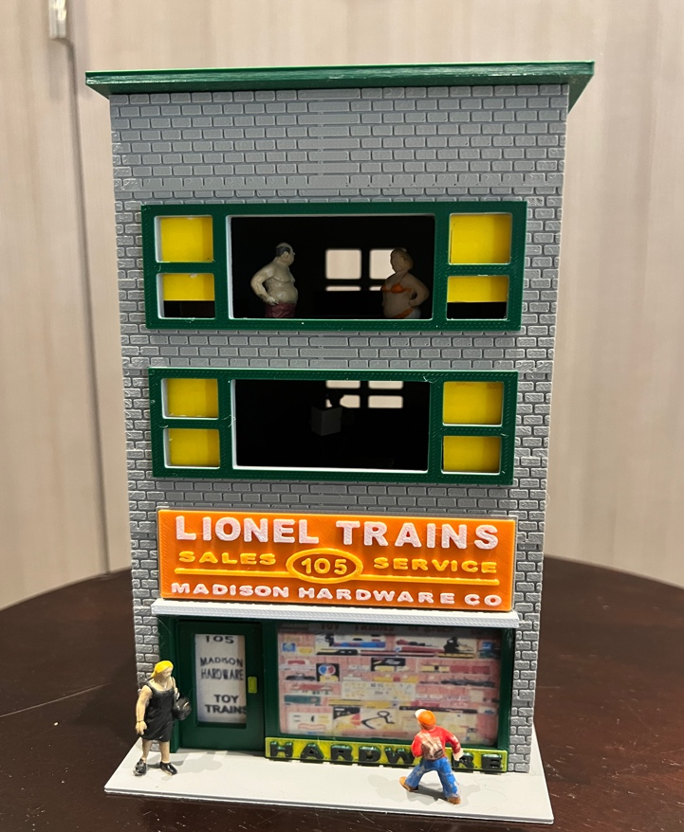

Thanks for your support!

Since these Kits are limited and hard to find, I decided to create my own and offer them for sale at a reasonable price.

You can see the cars and buildings I design and sell running on my layout on my YouTube Channel listed below, as I print and test them on my layout before I release them to the public.

Please go over the KIT, if anything arrives broken let me know and I will replace it free of charge, 100% Satisfaction and positive feedback is our goal.

Website- www.flrailroaddog.com
Youtube - @FL Railroaddog
Etsy store - https://flrailroaddog.etsy.com

1. Locate the (4) Black 1/8” support beams, and glue them to the inside of the front and back wall, just above the window openings. These pieces will support the interior floors. If you are going to use the supplied yellow paper for the window trim, cut and glue to your liking.

2. Glue the structure together, the side walls go flush and to the INSIDE of the front and rear wall.

3. Glue the entry way, notice that the door area is recessed. If you are going to use the supplied door and window trim, cut and glue prior to installing entry way.

4. Glue the large orange sign to the structure centered within the grey area.

5. Glue the interior furniture to the black floors and let dry, them lower them into position.

6. Glue the structure to the base.

7. Glue the roof to the structure.

Your Done!

