Thanks for your support!

Since these Kits are limited and hard to find, I decided to create my own and offer them for sale at a reasonable price.

You can see the cars and buildings I design and sell running on my layout on my YouTube Channel listed below, as I print and test them on my layout before I release them to the public.

Please go over the KIT, if anything arrives broken let me know and I will replace it free of charge, 100% Satisfaction and positive feedback is our goal.

Http://flrailroaddog.com
Youtube - @FL Railroaddog
Etsy store - https://flrailroaddog.etsy.com

I clean the models before I ship them out, but I recommend going through the pieces to make sure all the fillers have been removed.

As you can see, I have designed this building to be completed with ease and very little effort.
.
I use a hot glue gun to glue my models, that way they are easy to take apart and store. A small amount at each corner should be just fine. For a more permanent structure, I use Plastic Model cement or Plastruct Liquid Weld. DO NOT use crazy glue since it leaves a white residue when it dries.

If you take your time, you can create a beautiful piece.

As always, your satisfaction is of outmost important, if anything arrives broken, let me know and I will ship out a replacement free of charge.

If you have any suggestions and or ideas to improve the KIT let me know.

Happy Railroading,

Jorge

Signs

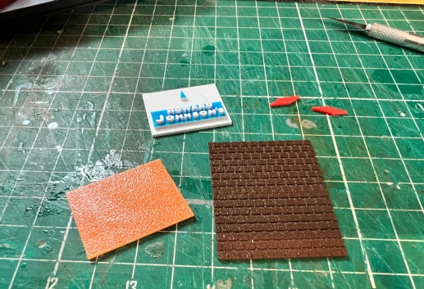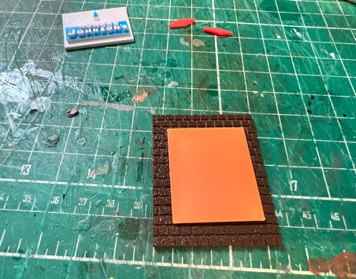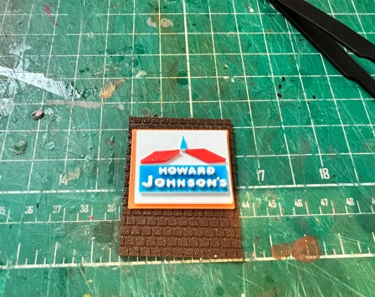

1. Start by making the signs. Locate the 2 Orange, 2 brown, 2 white, and 2 small red triangles.

2. Glue the orange squares to the brown brick walls, then glue the white squares with the Howard Johnson on to the orange square. Finally place the red triangles on either side of the blue diamond on the sign. Set aside and let dry.

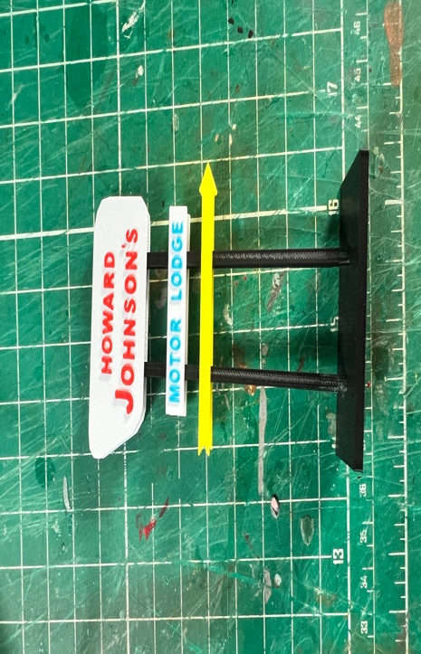

3. Locate the two black sticks, black base, 2 yellow arrows, motor lodge white and blue signs, and 2 Howard Johnson white and red signs.

4. Glue the 2 sticks to the base, if needed trim them a little so they can fit snug onto the slots in the base. Glue the white and red Howard Johnson sign to the very top, with nothing showing above it. Set aside and let dry.

Structure

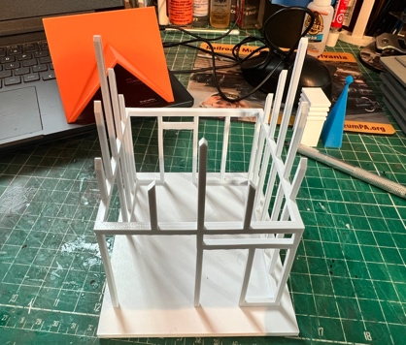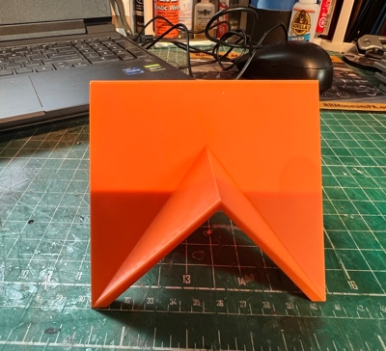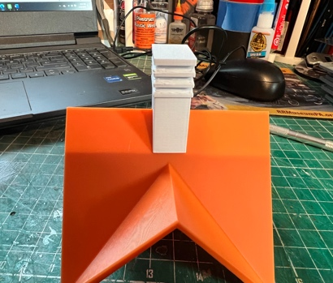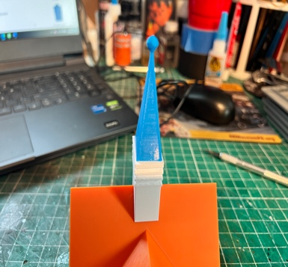

1. The structure is all one piece, so now is the time to add plastic inserts (Not Supplied) to the windows if you want.

2. Locate the Sofa, Chair, coffee table, end table and counter, glue and place them where you want them.

3. Locate the roof, white sphere base, and blue sphere. Take the white sphere base, center, and glue to the roof, look above for orientation, then center and glue the blue sphere to the white base.

4. Locate the 2 doors and glue them to the structure.

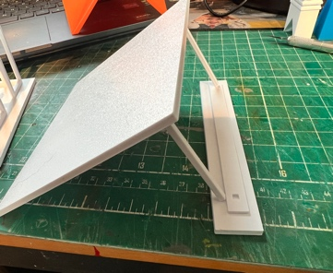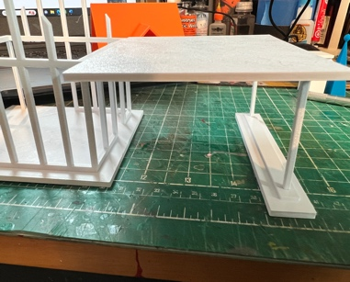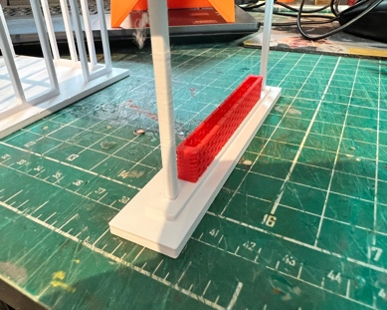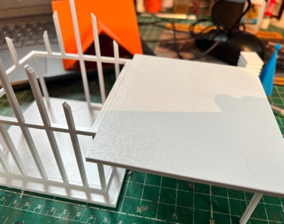

5. Notice that the structure has a small 1/8’ lip on one side with the door, this is where the carport end will be glued to if desired.

6. Locate the carport, support base, and red flower box. Glue the red flowerpot centered in the middle of the support base and glue the carport onto the support base. (trim the bottom of the beams until they fit snug).

7. Glue the carport to the structure.
Motor Lodge

1. Locate the 2 front walls, two rear walls, 4 sides, 2 grey bases, 2 black roofs, stairs, and railing.

NOTE: IF YOUR GONNA PUT THEM SIDE BY SIDE SKIP THIS AND DO NOT USE STAIRS OR RAILING.

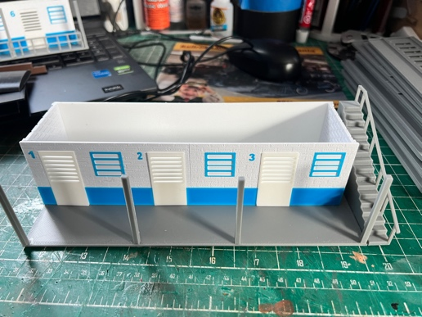

1. Take one grey base and glue the stairs on left side (looking at base), and the support beams evenly spaced.

2. Take 1 front wall, 1 rear wall, 2 side, and glue them together, making sure that the sides are on the INSIDE of the front and rear walls. Glue the completed structure to the base.

3. Repeat the process for the second level.

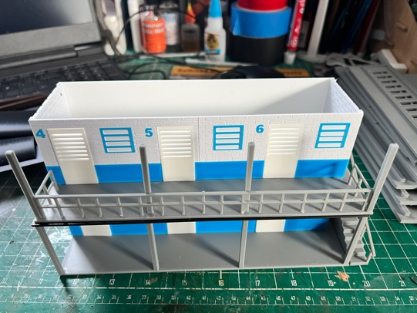

4. Locate and glue the railing.

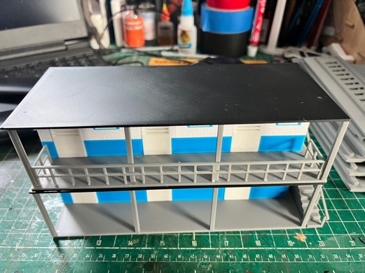

5. Locate and glue the black roof to the structure.

6. You are done!

