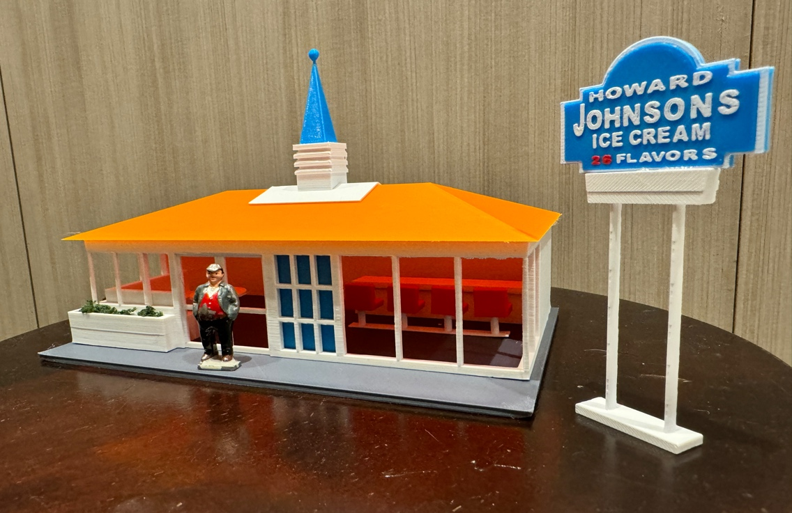

Thanks for your support!

Since these Kits are limited and hard to find, I decided to create my own and offer them for sale at a reasonable price.

You can see the cars and buildings I design and sell running on my layout on my YouTube Channel listed below, as I print and test them on my layout before I release them to the public.

Please go over the KIT, if anything arrives broken let me know and I will replace it free of charge, 100% Satisfaction and positive feedback is our goal.

Webpage – https://flrailroaddog.com
Youtube - @FL Railroaddog
Etsy store - https://flrailroaddog.etsy.com

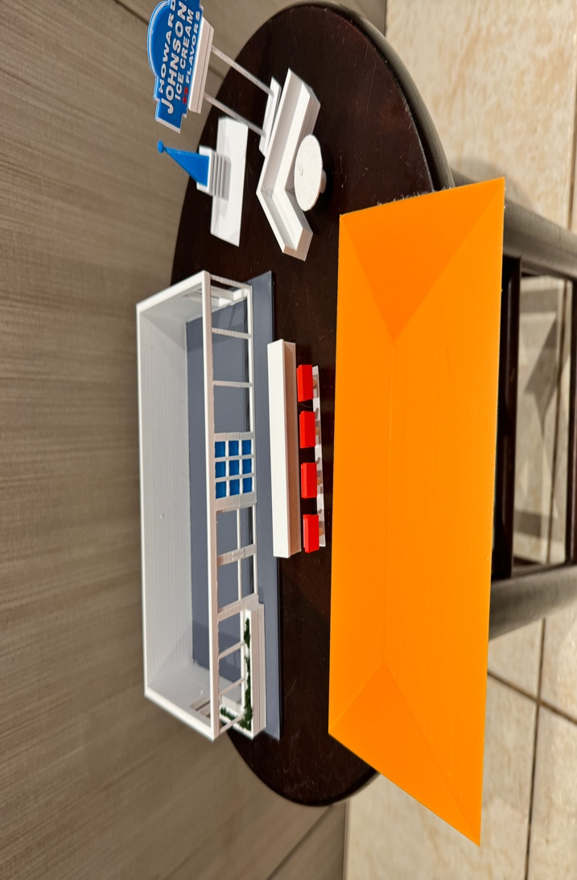

This kit is really easy to build since the structure is already built.

1. Glue the BLUE CLEAR plastic window shade to the inside of the 9 panel window.

2. Glue the Structure centered on the base.

3. GLUE the WHITE Roof centered to the Orange main roof.

4. Glue the Blue Roof Sphere centered onto the White Roof.

INTERIOR

1. Glue the counter on to the base at your desired location.

2. Glue the RED Seats to the Seat Base and glue in front of the counter.

3. Glue the WHITE Corner Booth at your desired location and then glue the WHITE round table in front of the cornered booth.

SIGN

1. Glue both signs back to back.

2. Glue the Sign centered on the white sign pole.

Finally glue the roof to the structure if desired, your done!

