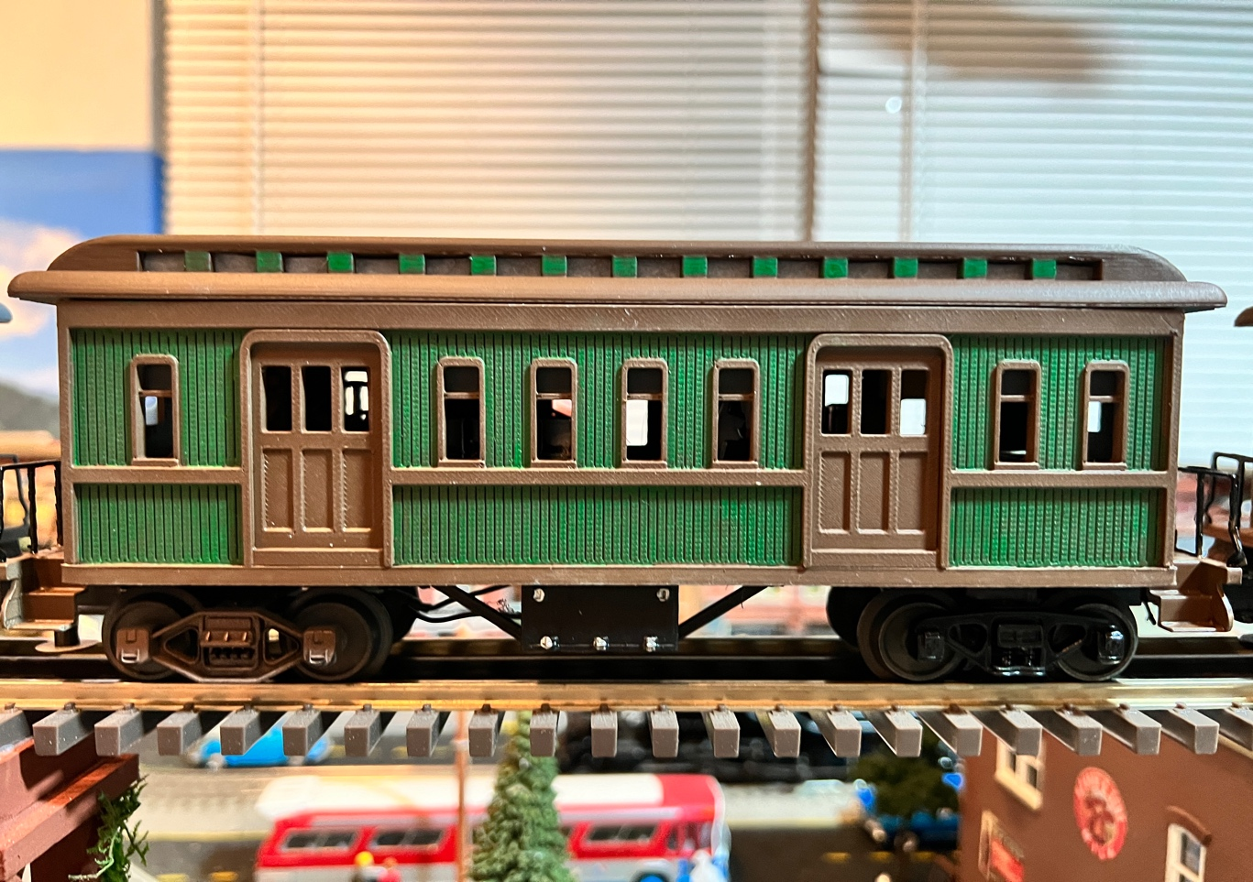

I wanted 36’ Wood Sided Coaches to match my MTH 36’ Reefer and boxcars, unfortunately they are not made and probably never will, so I decided to create my own. After searching on the Internet, I located a nice stl file on Thingyverse, created by ANDY_G1955 of these passenger cars, but they were for 50-foot coaches, so I decided to scale all the files down, and this kit is the result.

While I offer all the files for free on TinkerCad, I understand that not everyone has a 3D Printer, so I decided to print them out and sell them at a reasonable cost to cover my expenses.

Take your time putting these items together, and with a lot of attention to detail, you can create a beautiful piece of rolling stock for your model railroad.

Thanks, and Happy Railroading

Jorge

WWW.Flrailroaddog.com
YouTube Channel – FLRailroaddog
TinkerCad – FL Railroaddog
Email – flrailroaddog@gmail.com

