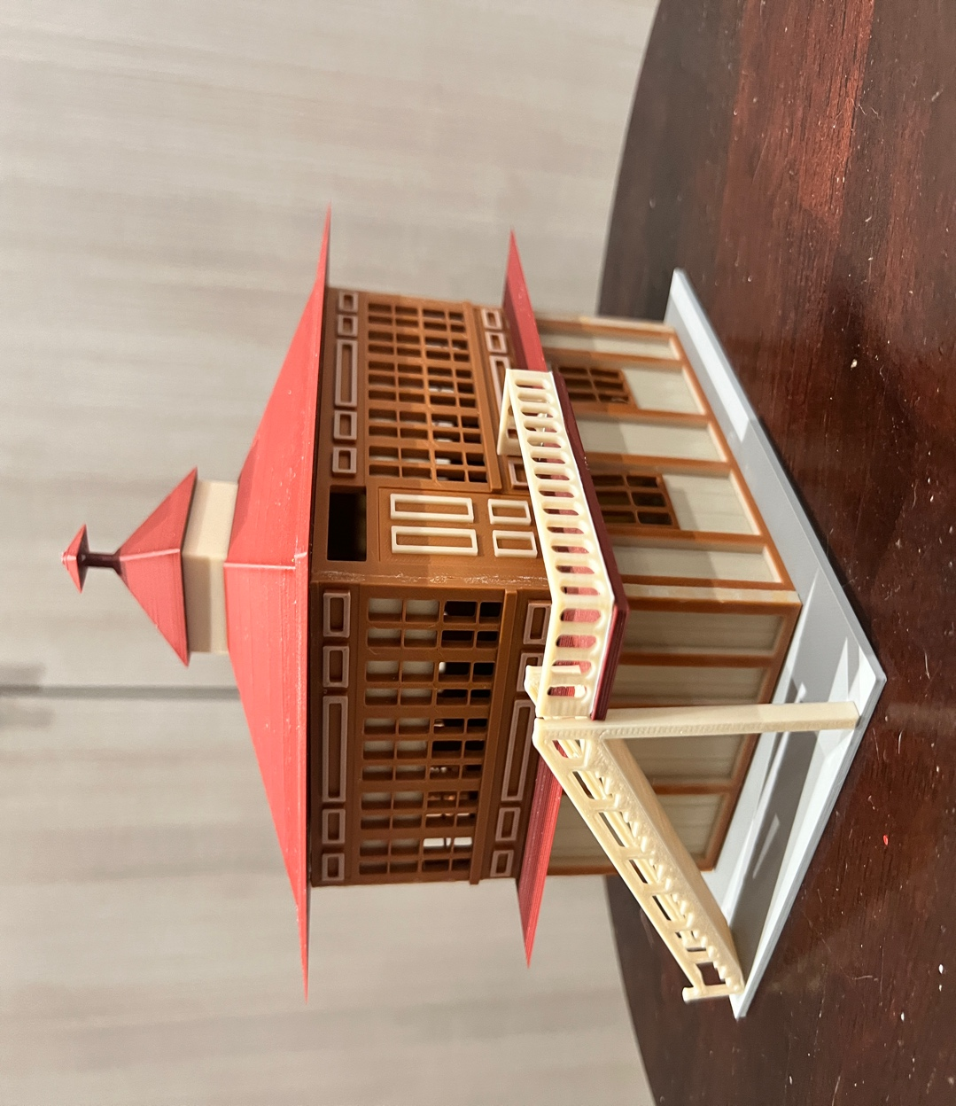

Thanks for your support!

Since these Kits are limited and hard to find, I decided to create my own and offer them for sale at a reasonable price.

You can see the cars and buildings I design and sell running on my layout on my YouTube Channel listed below, as I print and test them on my layout before I release them to the public.

Please go over the KIT, if anything arrives broken let me know and I will replace it free of charge, 100% Satisfaction and positive feedback is our goal.

www.flrailroaddog.com (Opening Jan 2024)
Youtube - @FL Railroaddog
Etsy store - https://flrailroaddog.etsy.com

I clean the models before I ship them out, but I recommend going through the pieces to make sure all the fillers have been removed.

This KIT comes pre-printed in Cream, Burgundy, Brown, White and Black, saving the time used to fine paint them.

The doors come separate and are designed to be glued / snap into place. If they are a little tough to snap it, use a knife or small file around the edges.

As you can see, I have designed this building to be completed with ease and very little effort.
.
I use a hot glue gun to glue my models, that way they are easy to take apart and store. A small amount at each corner should be just fine. For a permanent structure I use Testors Model Cement. DO NOT use super glue since it will stain the pieces once it dries.

If you take your time, you can create a beautiful piece.

As always, your satisfaction is of outmost important, if anything arrives broken, let me know and I will ship out a replacement free of charge.

If you have any suggestions and or ideas to improve the KIT let me know.

Happy Railroading,

Jorge

1. Start with the bottom walls, glue the end pieces (smaller ones) on to the outer ends of the long walls. (Make sure this is done correctly, if not the building will be too wide.

2. Glue or snap in the door.

3. Glue the 1st roof, the one with the balcony and porch on to the top of the completed bottom walls.

(Let the above completely set, before continuing)

4. Glue the top building, start with the wall with the doorway and work your way around. The END pieces are glued on to the outer edge of the end walls, as was done with the bottom building.

Note: On the balcony, the two small pieces have a flat part on one end, make sure these go towards the inside of the building.

(Let the above completely set, before continuing)

5. Glue the 2nd Roof, ensuring the balcony roof sits centered on top of the balcony.

6. Glue the 2nd roof on to the 2nd roof.

7. Glue the tower building (Small Tan block).

8. Glue the peaked roof on the tower building.

9. Glue the Peak Top to the peak roof.

10. Glue the Railing.

11. Glue the building on to the grey base, base should be hanging about 1/4” around the building, except were the staircase goes.

12. Glue the staircase.

13. Sit back and enjoy your masterpiece.

Take your time, check the pieces for proper fitment twice and glue once, and you will create a beautiful building.

