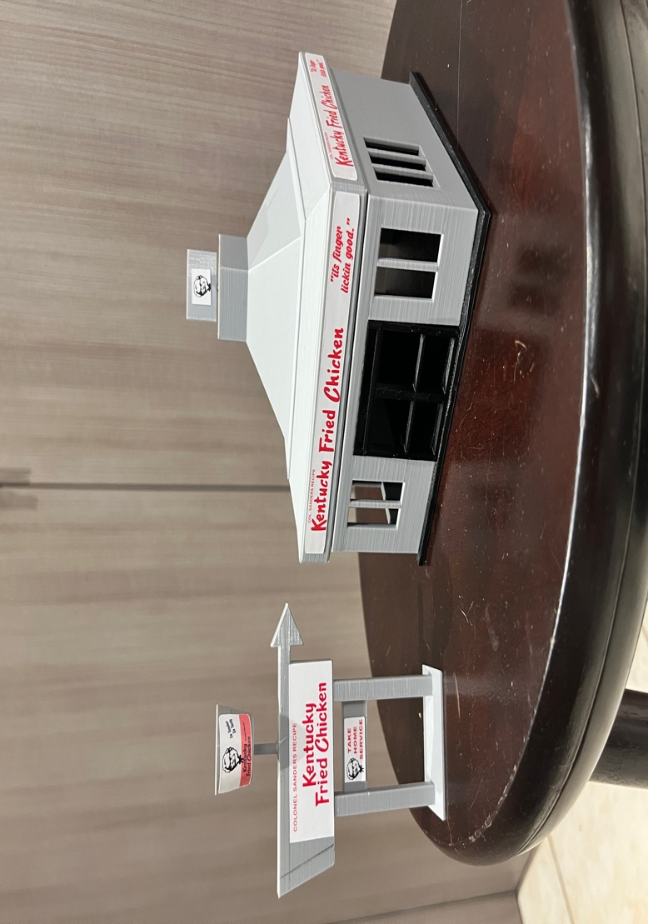

Thanks for your support!

Since these Kits have never been made or ever will, I decided to create my own and offer them for sale at a reasonable price.

You can see the cars and buildings I design and sell running on my layout on my YouTube Channel listed below, as I print and test them on my layout before I release them to the public.

Please go over the KIT, if anything arrives broken let me know and I will replace it free of charge, 100% Satisfaction and positive feedback is our goal.

www.flrailroaddog.com

Youtube - @FL Railroaddog

Etsy store - <https://flrailroaddog.etsy.com>

I clean the models before I ship them out, but I recommend going through the pieces to make sure all the fillers have been removed.

This KIT comes pre-painted in grey.

The doors and windows come separate and are designed to be glued / snap into place.

The counter can be placed or glued on to the base, keeping in mind that it is L-shaped.

I use a hot glue gun to glue my models, that way they are easy to take apart and store. A small amount at each corner should be just fine.

If you take your time, you can create a beautiful peace.

As always, your satisfaction is of outmost important, if anything arrives broken, let me know and I will ship out a replacement free of charge.

If you have any suggestions and or ideas to improve the KIT let me know.

Happy Railroading,

Jorge