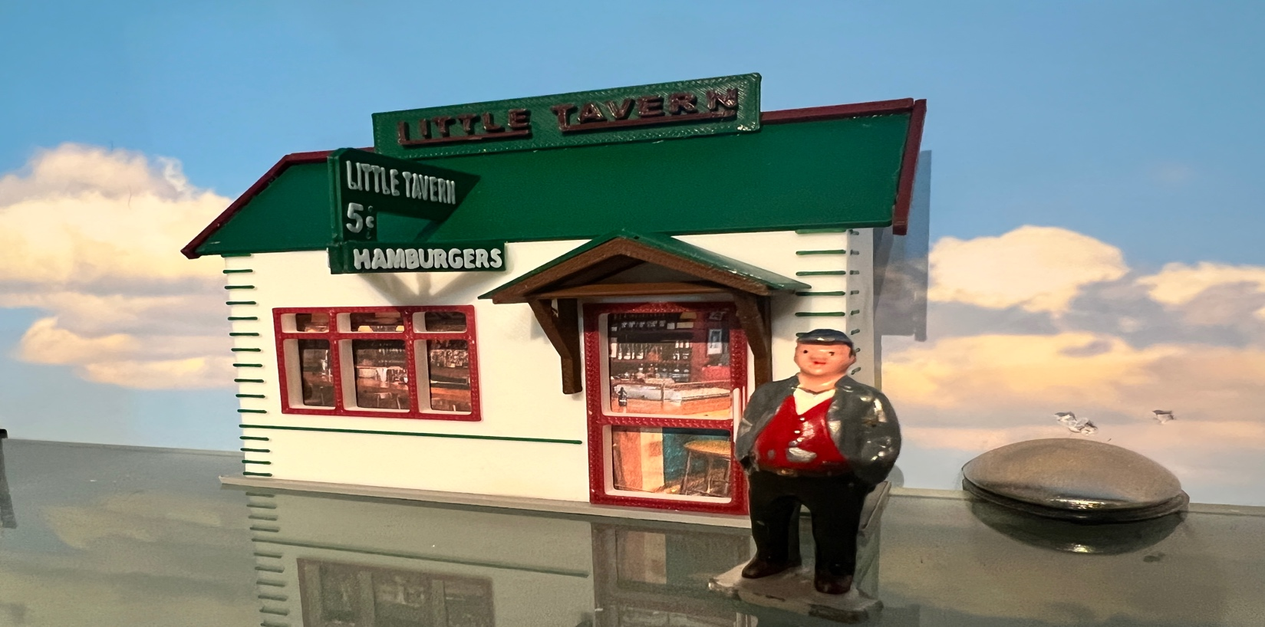
Thanks for your support!

Since these Kits are limited and hard to find, I decided to create my own and offer them for sale at a reasonable price.

You can see the cars and buildings I design and sell running on my layout on my YouTube Channel listed below, as I print and test them on my layout before I release them to the public.

Please go over the KIT, if anything arrives broken let me know and I will replace it free of charge, 100% Satisfaction and positive feedback is our goal.

Webpage – https://flrailroaddog.com
Youtube - @FL Railroaddog
Etsy store - https://flrailroaddog.etsy.com

STRUCTURE

1. I clean the models before I ship them out, but I recommend going through the pieces to make sure all the fillers have been removed.

2. Locate and glue the side walls to the INSIDE of the front wall.

3. Locate and glue the roof to the completed structure.

4. Glue the Structure to the Base, flush with the back edge of the base.

5. Glue the burgundy trim pieces around the edges of the roof.

6. Center and glue the brown porch above the door.

7. Glue the green roof on to the brown porch.

8. Center and glue the “Hamburger” Signs at a 45 degree angle together and then glue to the structure. I lay the structure down so it will be easier. (see above photo)

9. Glue the green “ Little Tavern” sign to the roof and to the “Hamburger” Signs.

10. Glue the Green & Red “Little Tavern” sign to the roof, using the top trim as backup.

Your Done!

