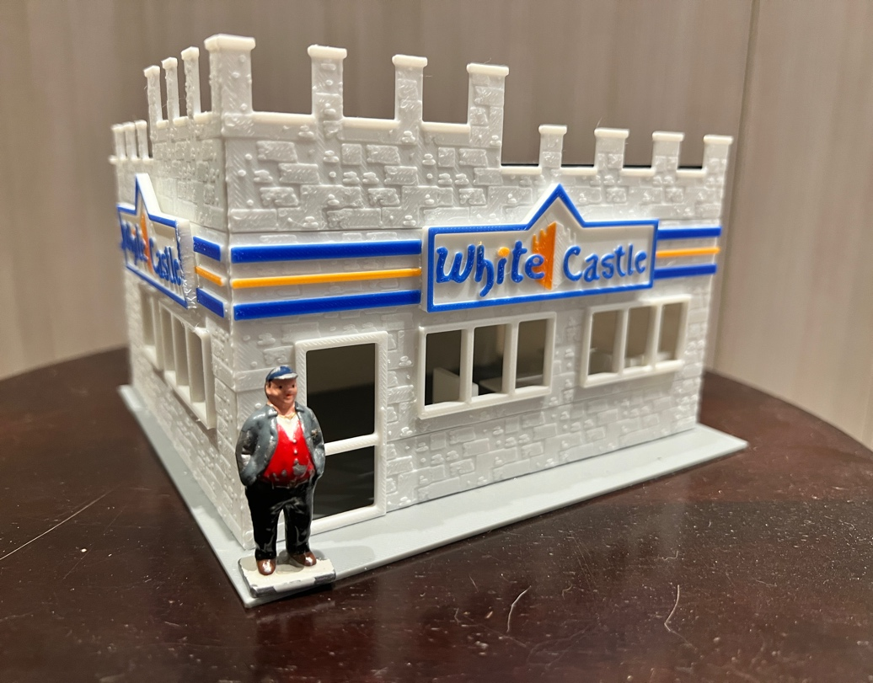

Thanks for your support!

Since these Kits are limited and hard to find, I decided to create my own and offer them for sale at a reasonable price.

You can see the cars and buildings I design and sell running on my layout on my YouTube Channel listed below, as I print and test them on my layout before I release them to the public.

Please go over the KIT, if anything arrives broken let me know and I will replace it free of charge, 100% Satisfaction and positive feedback is our goal.

Webpage – https://flrailroaddog.com
Youtube - @FL Railroaddog
Etsy store - https://flrailroaddog.etsy.com

STRUCTURE

1. I clean the models before I ship them out, but I recommend going through the pieces to make sure all the fillers have been removed. I use Testors Model Cement in the red tube on all my kits.

2. Glue both sides with the castle tops together and let dry.

3. Glue the back walls to the front walls, with the back walls flush and to the inside of the front walls.

3. Glue the structure to the base.

4. I added 2 strips that can be glued to the inside of the front walls, but they are not needed since the roof will be sturdy when glued to the lips on the back walls. You have the option to use them if wanted.

5. Glue the roof. You will notice that the roof overhangs a little bit, I did that so that the rear of the building has coverage.

6. Glue the roof signs in the gaps on the front walls, one sign is a little smaller than the other one, ensure that each fit before gluing.

Your Done!

Let me know if I need to change or add anything to make the building better!!

