O Scale Cass Railroad Passenger
Coach & Handicap Coach
EXTRA PIECES

You will notice that I sent extra pieces, the reason for this is as follows.

If you are going to build this car and place it on a Lionel 6411 or 2411 Flatcar, or any other type of Flatcar, Do NOT USE the included base and stairs. Simply glue the cab pieces directly onto the Flatcar.

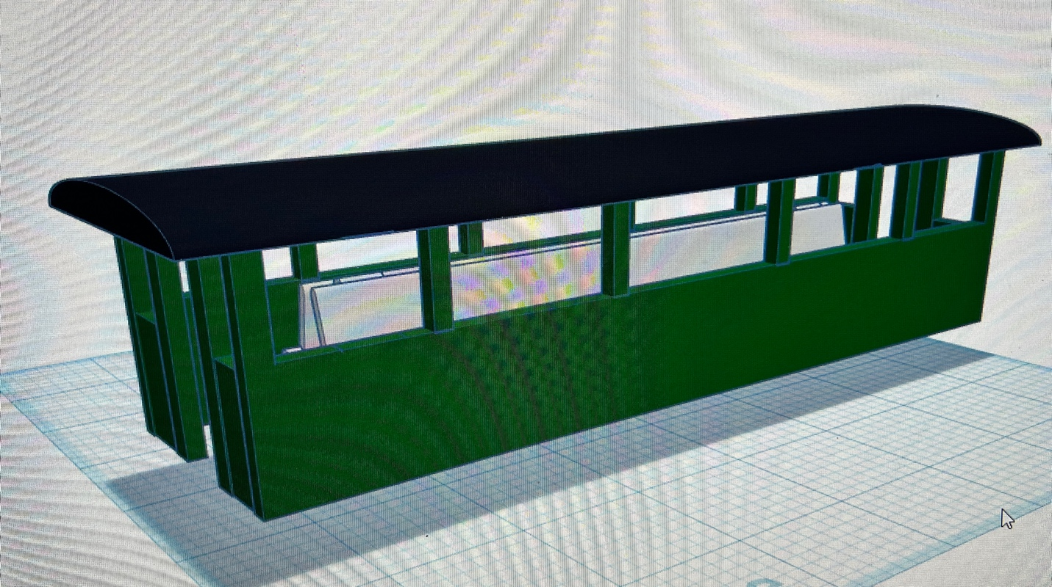

Completed and glued on to Flatcar

If you are going to add your own Trucks and Wheels, then use the base and included stairs.

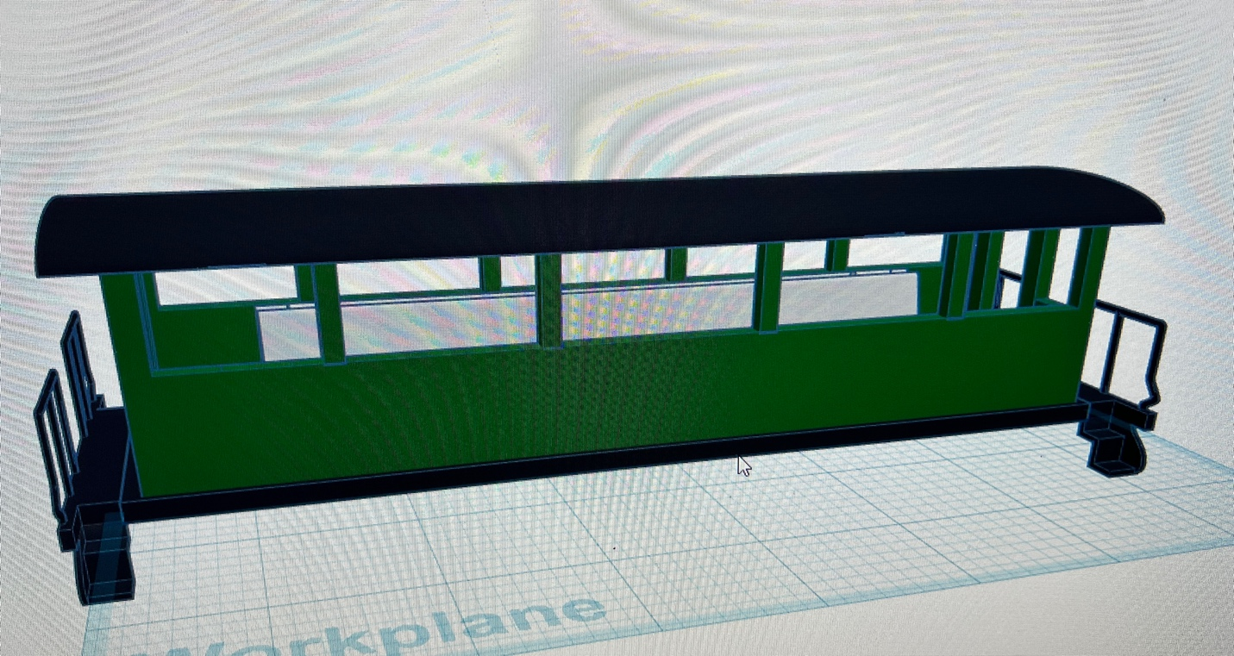

Completed Car with Trucks and Wheels

If you have any questions let me know!

Jorge

