O (Petticoat Junction) Stand
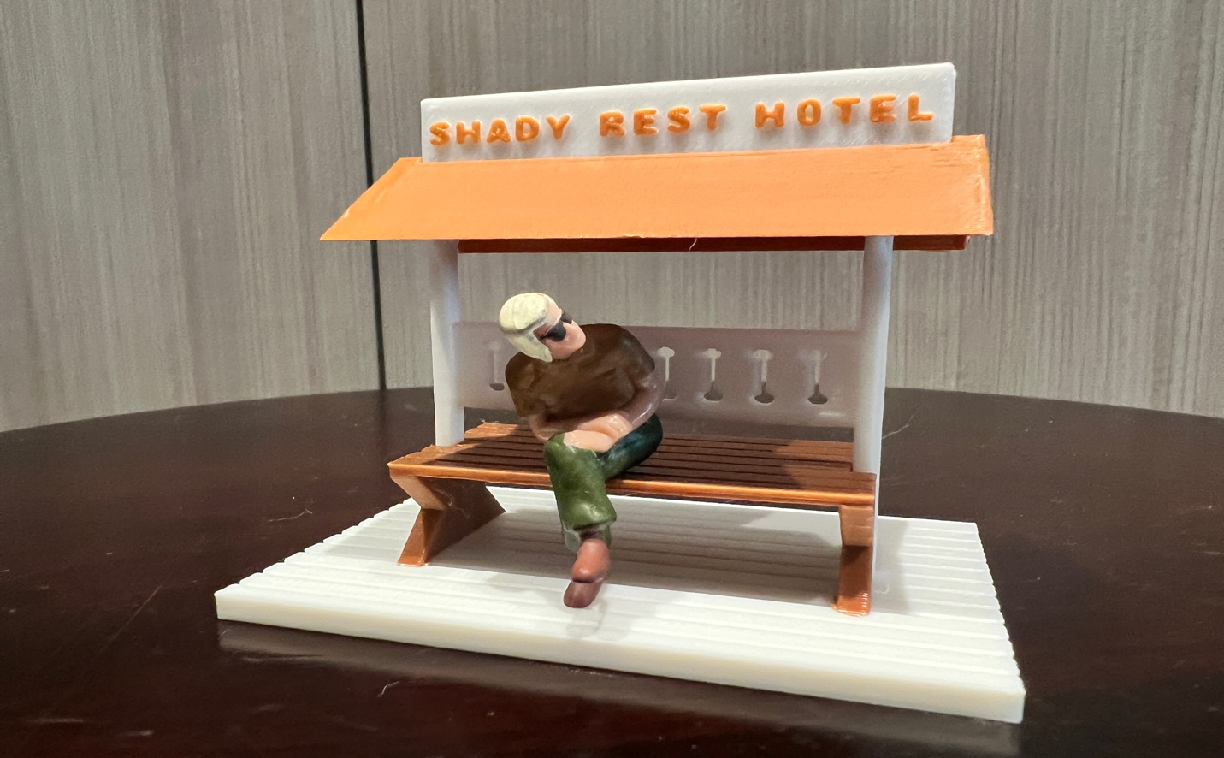

Thanks for your support!

Since this Passenger Stand is impossible to find for sale, I decided to create my own and offer it to the community at a reasonable price.

You can see all my designs that I sell running on my layout on my YouTube Channel listed below, as I print and test them on my layout before I release them to the public.

Please go over the kit, if anything arrives broken let me know and I will replace it free of charge. 100% Satisfaction and positive feedback is our goal.

WWW.FLRailroaddog.com
Youtube - @FL Railroaddog

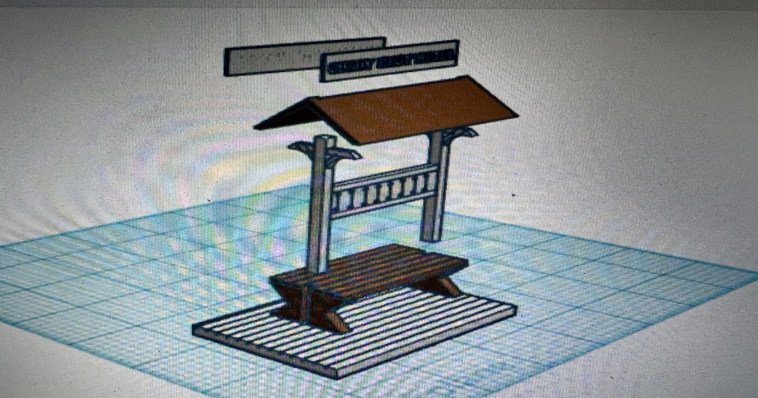

I clean the models before I ship them out, but I recommend going through the pieces to make sure all the fillers have been removed.

If you’re going to repaint the item, paint all the pieces separately, I recommend a coat of GREY AUTOMOTIVE FILLER PRIMER, this will ensure the paint catches better and small imperfections are filled.

I then paint all the pieces to the colors I need.

This Passenger Stand is simple to build, I use a hot glue gun to be able to take it apart a store, but you can use super glue for a more permanent structure.

1. Glue the bench to the platform (centered).

2. The roof support comes in 2 parts, one already together and 1 part loose, this is so it’s easier to put together. Glue and slide one part into the bench slot, then slide and glue the other pole in to the other side of the bench and then glue and snap it in to the pole.

3. Glue the signs together back to back and glue in to the slot on the roof.

4. glue to roof centered on the support poles.

Take your time and you can create a beautiful piece for your layout.

Happy Railroading, Jorge

