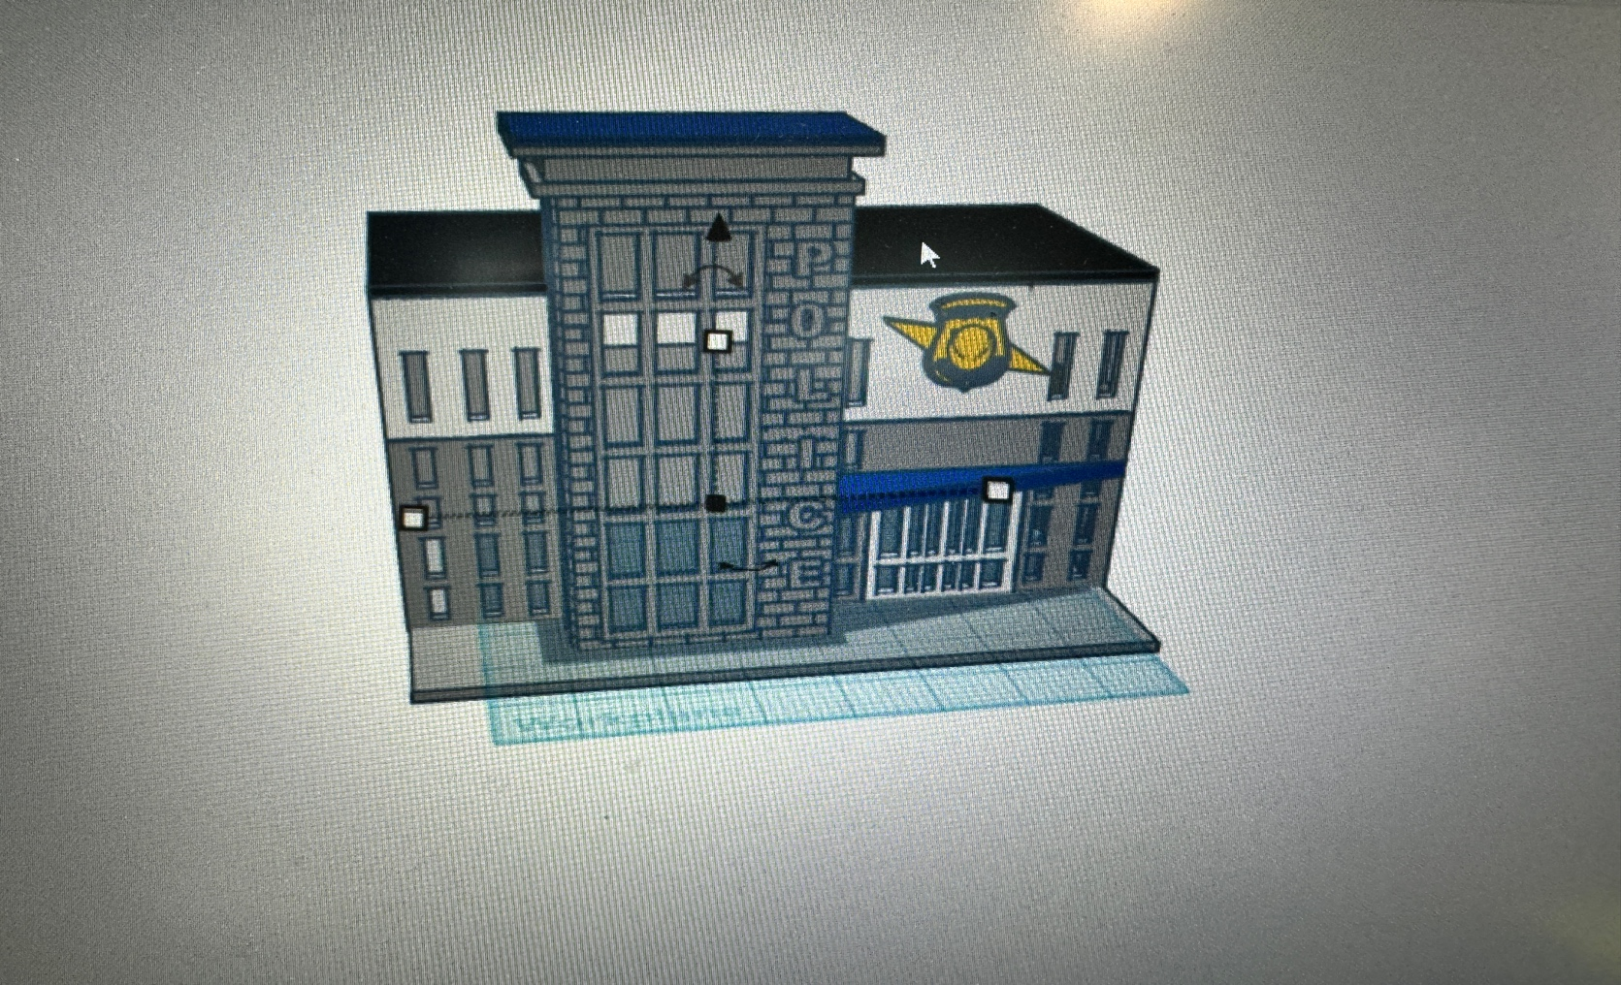
Thanks for your support!

Since these Kits are limited and hard to find, I decided to create my own and offer them for sale at a reasonable price.

You can see the cars and buildings I design and sell running on my layout on my YouTube Channel listed below, as I print and test them on my layout before I release them to the public.

Please go over the KIT, if anything arrives broken let me know and I will replace it free of charge, 100% Satisfaction and positive feedback is our goal.

Webpage – https://flrailroaddog.com
Youtube - @FL Railroaddog
Etsy store - https://flrailroaddog.etsy.com

1. 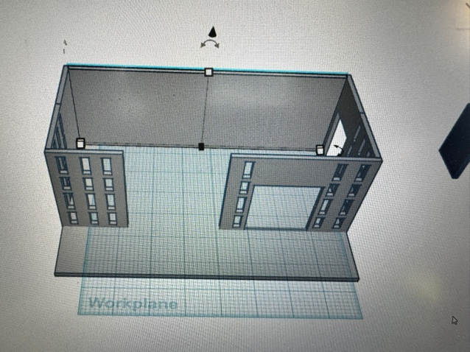 2. 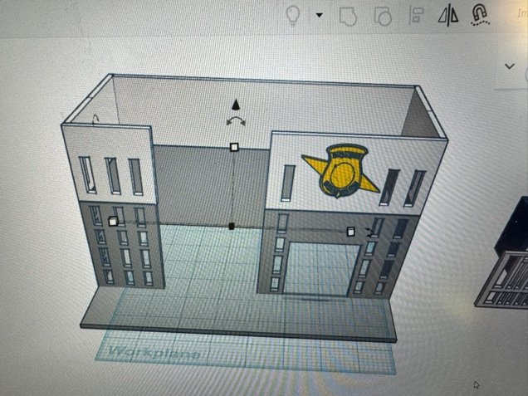

1. Glue the lower (grey) Walls as shown to the base.

2. Glue the upper white walls to the lower grey walls.

3. 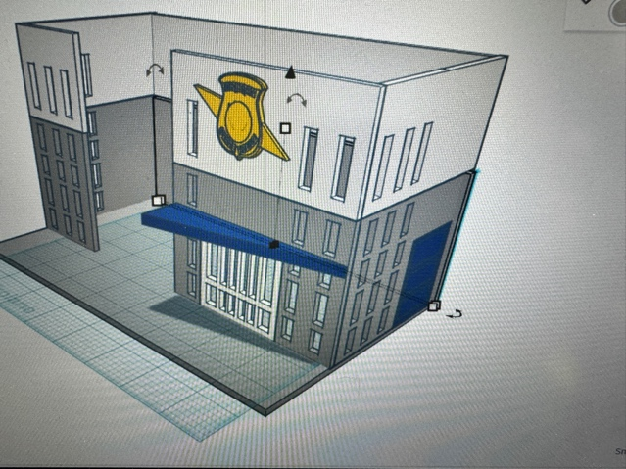 4. 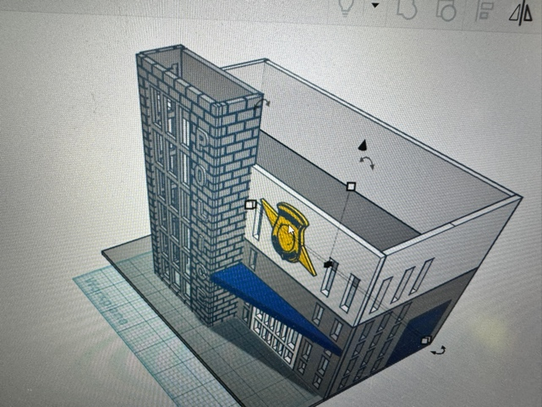

3. Glue white door to opening and then glue the blue overhang porch roof to the grey wall flush with the top of the door opening. Glue the garage door.

4. Glue the see through plastic to the inside of the front grey brick wall if desired. Then glue the 2 side brick walls and small grey wall together. When dry glue this to the structure.

5. 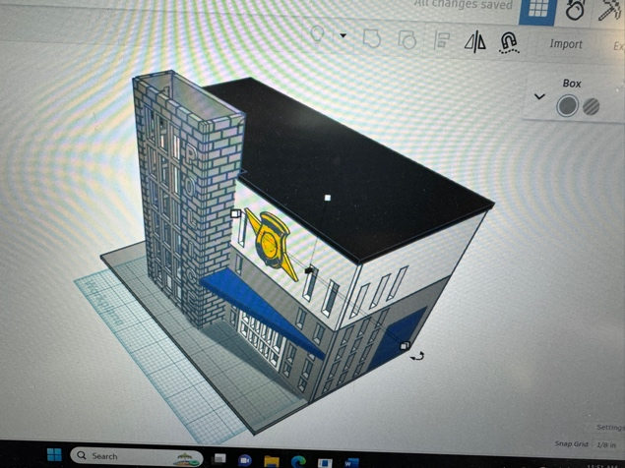 6. 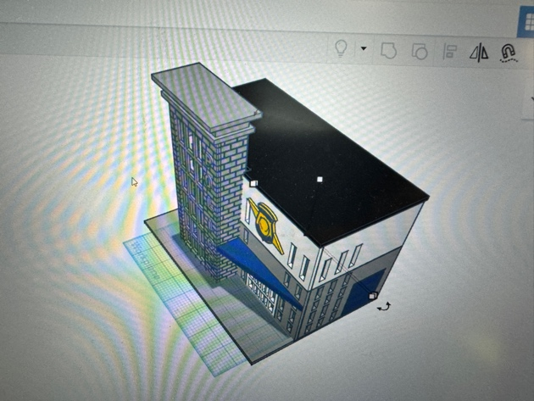

5. Glue the black roof.

6. Glue the Grey roof centered to the brick building.

7. 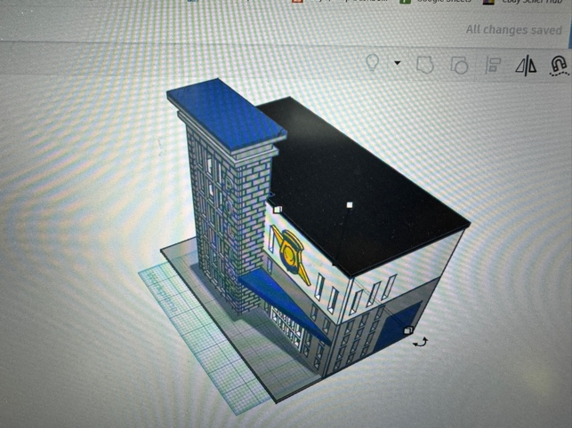

7. Glue the blue roof to the grey roof.

You are done!

