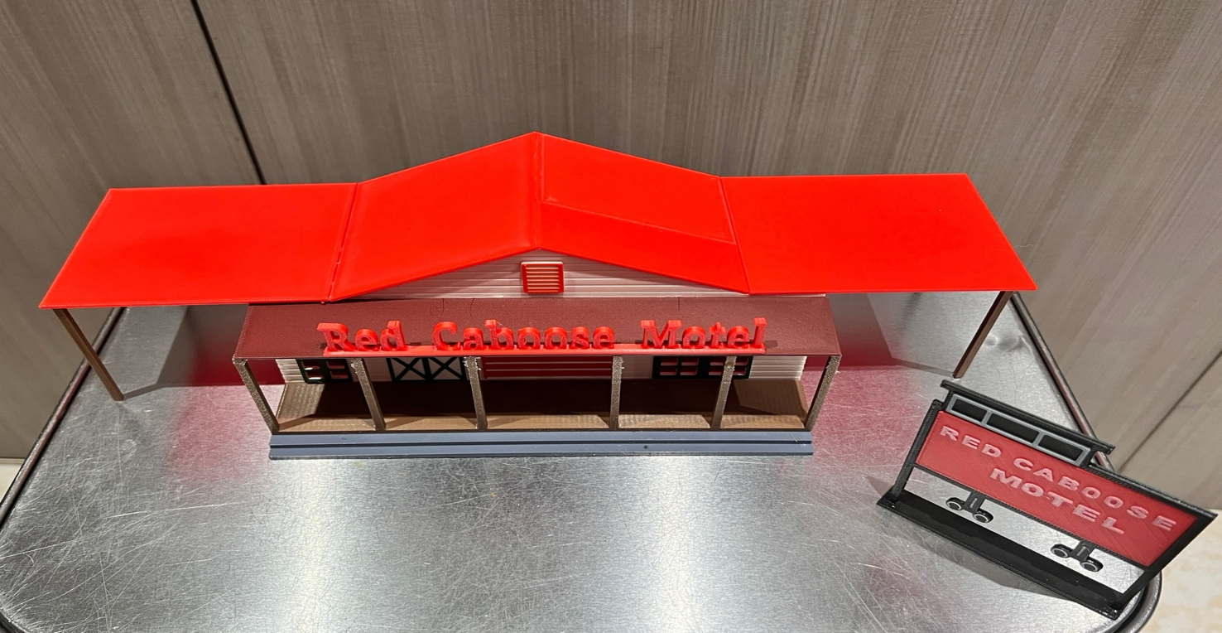

Thanks for your support!

Since these Kits are limited and hard to find, I decided to create my own and offer them for sale at a reasonable price.

You can see the cars and buildings I design and sell running on my layout on my YouTube Channel listed below, as I print and test them on my layout before I release them to the public.

Please go over the KIT, if anything arrives broken let me know and I will replace it free of charge, 100% Satisfaction and positive feedback is our goal.

www.flrailroaddog.com
Youtube - @FL Railroaddog
Etsy store - https://flrailroaddog.etsy.com

I clean the models before I ship them out, but I recommend going through the pieces to make sure all the fillers have been removed.

As you can see, I have designed this building to be completed with ease and very little effort.
.
I use a hot glue gun to glue my models, that way they are easy to take apart and store. A small amount at each corner should be just fine. For a more permanent structure, I use Plastic Model cement or Plastruct Liquid Weld. DO NOT use crazy glue since it leaves a white residue when it dries.

If you take your time, you can create a beautiful piece.

As always, your satisfaction is of outmost important, if anything arrives broken, let me know and I will ship out a replacement free of charge.

If you have any suggestions and or ideas to improve the KIT let me know.

Happy Railroading,

Jorge

1. Start by gluing the side walls to the front walls, the side walls will be on the inside of the front walls.

2. Glue the structure to the base, with the front wall flush to the elevated porch.

3. Glue the porch to the base.

4. Glue the porch roof (Burgundy) to the front wall, ensuring it is flush to the lip on the front wall, and even on both sides.

5. Glue the red overhang roofs to the structure, ensure that they are flush to where the pitch of the roof begins, do both sides.

You will notice I supplied two different sizes of support beams for the overhang roofs. IF you plan on parking a passenger or other car underneath the overhang roof, you need to elevate the structure with foamboard, etc. then use the longer beams, cutting them to the correct size to be flush with the ground.

If you will not be parking anything underneath the overhangs, then use the shorter beams.

5a. Glue the beams to the outer corners of the overhang roofs.

6. Glue the top roof to the structure, ensuring they are flush to the overhang roofs.

7. Glue the Red Caboose Hotel Sign to the Porch roof, you will notice the there is an indentation on the roof where the sign sits a little tilted to compensate for the roofs pitch.

Road Sign

1. Glue both sides of the black caboose sign holder together back to back.

2. Glue the sign to the base.

3. Snap in or glue the Red Caboose sign to each side of the sign structure.

