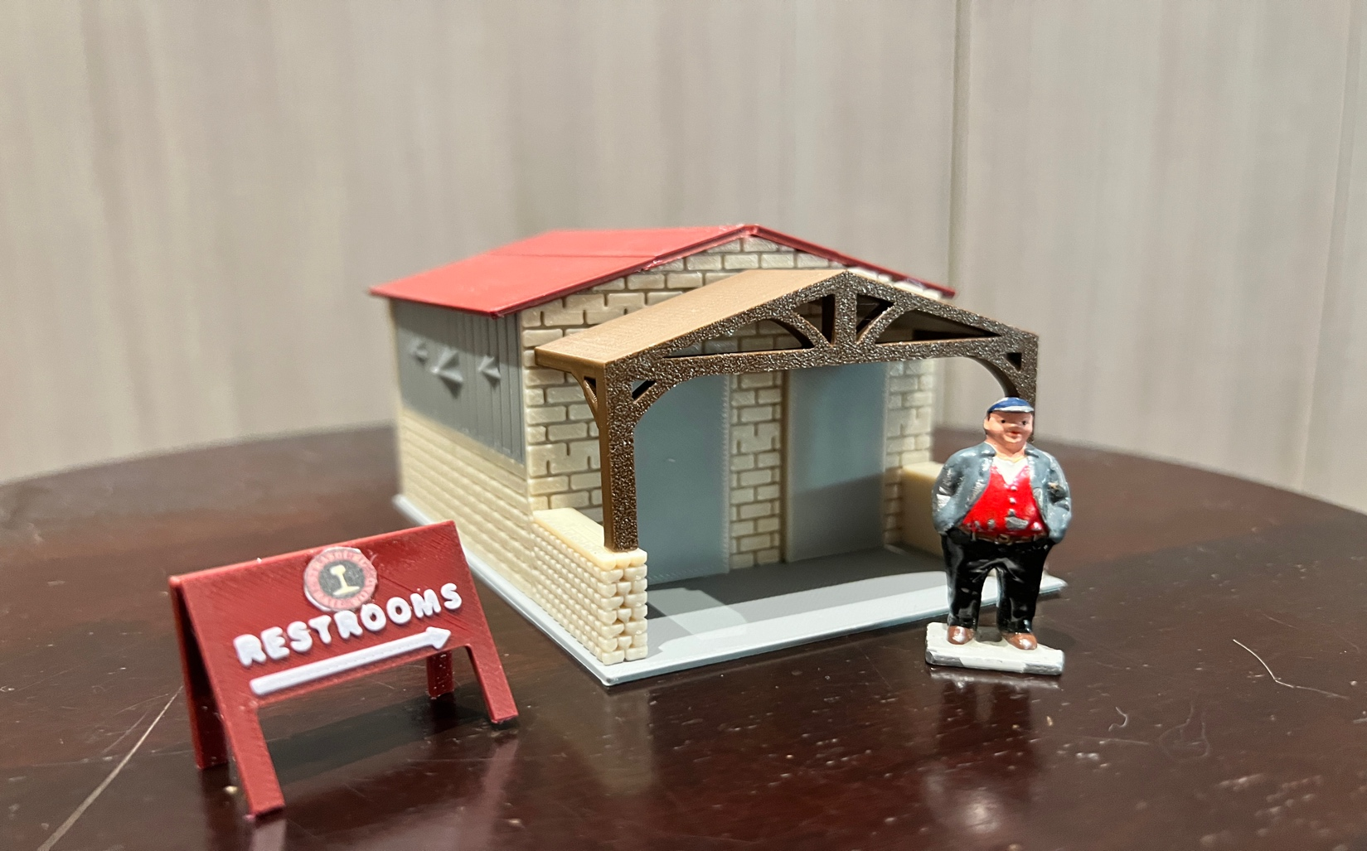

Thanks for your support!

Since these Kits are limited and hard to find, I decided to create my own and offer them for sale at a reasonable price.

You can see the cars and buildings I design and sell running on my layout on my YouTube Channel listed below, as I print and test them on my layout before I release them to the public.

Please go over the KIT, if anything arrives broken let me know and I will replace it free of charge, 100% Satisfaction and positive feedback is our goal.

Webpage – https://flrailroaddog.com
Youtube - @FL Railroaddog
Etsy store - https://flrailroaddog.etsy.com

STRUCTURE

1. I clean the models before I ship them out, but I recommend going through the pieces to make sure all the fillers have been removed.

2. Start by gluing the Grey Wall with the stars to the Tan walls and let dry.

3. Glue The Front and Rear walls to the completed side walls, the side walls go on the INSIDE of the front and rear walls.

4. Glue the Porch to the tan support walls.

5. Glue the completed porch to the from wall.

6. Glue the roofs to the completed structure.

7. Glue the completed structure to the base.

8. Glue the restroom sign at a slight angle. (I downloaded from the internet the Strasburg Logo, scaled it down and glued it to my sign.

Your Done!

