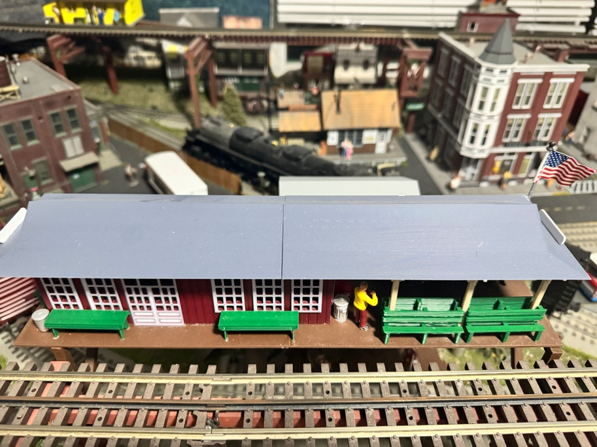

Thanks for your support!

Since these Kits are limited and hard to find, I decided to create my own and offer them for sale at a reasonable price.

You can see the cars and buildings I design and sell running on my layout on my YouTube Channel listed below, as I print and test them on my layout before I release them to the public.

Please go over the KIT, if anything arrives broken let me know and I will replace it free of charge, 100% Satisfaction and positive feedback is our goal.

Webpage – https://flrailroaddog.com
Youtube - @FL Railroaddog
Etsy store - https://flrailroaddog.etsy.com

STRUCTURE

1. Start of by locating both brown base pieces and gluing them together. The separation will mostly be inside the building so it will not be too noticeable.

2. Locate all the walls and glue the end walls flush and to the inside of the side walls. (see pic 1.)

3. Once the structure is dry, place it on the base (Do NOT Glue) it, since once structure is complete all you need to do is raise it off the base to install interior lights, figures etc.

1. 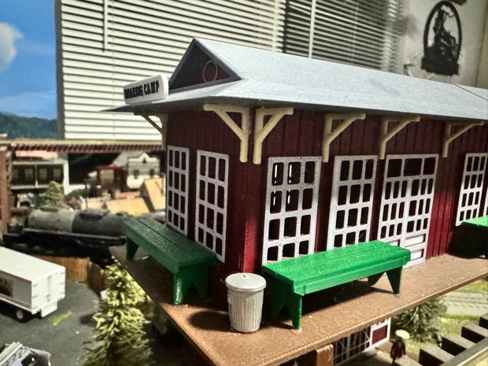 2. 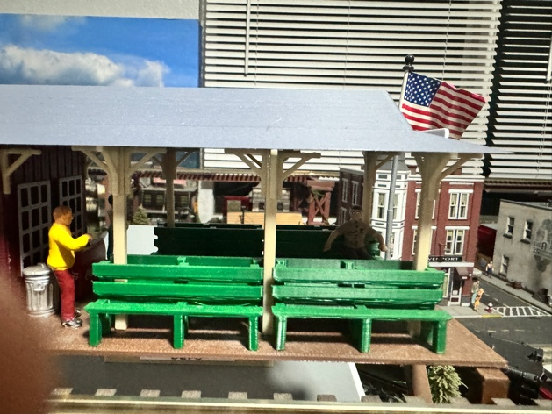

4. Glue the 2 halves of the roof together and once dry turn it upside down to install the supports and angles on the patio end.

5. Glue 3 angles flush to the support beams and let dry. Assemble (6) of these. Once they are dry, starting on the far end, glue the support beam with the tip of the angle flush to the outside corner of the roof. Evenly space and glue the other support beams. (See Pic 2.)

6. Once the support beams are dry, turn the roof over, align it evenly around the structure and glue it down. (DO NOT) glue the bottom of the support beams.

7. Once the structure and patio section are dry, go around and install the other roof angles around the building to your preference, I supplied you with enough angles to space them however you want.

8. Place the roof back on the structure and glue the roof signs and benches to your preference.

9. Glue the roof triangle facias to the inside openings at the ends of the roof. (See Pic 3)
3. 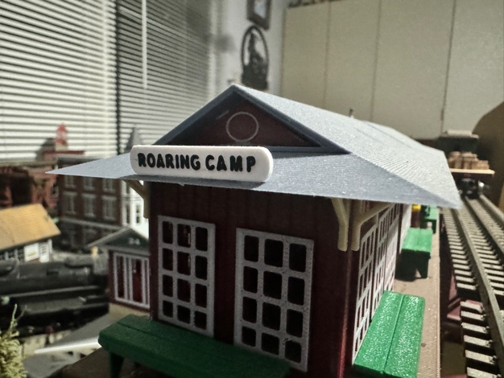 4. 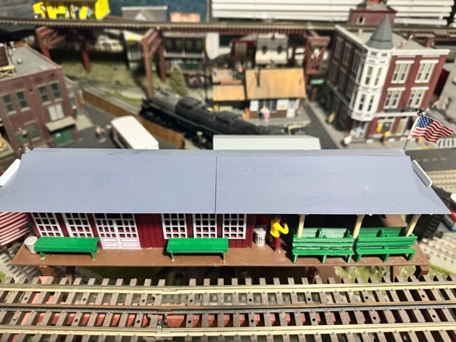

10. Place the long benches around the structure to your preference.

11. Your Done!

