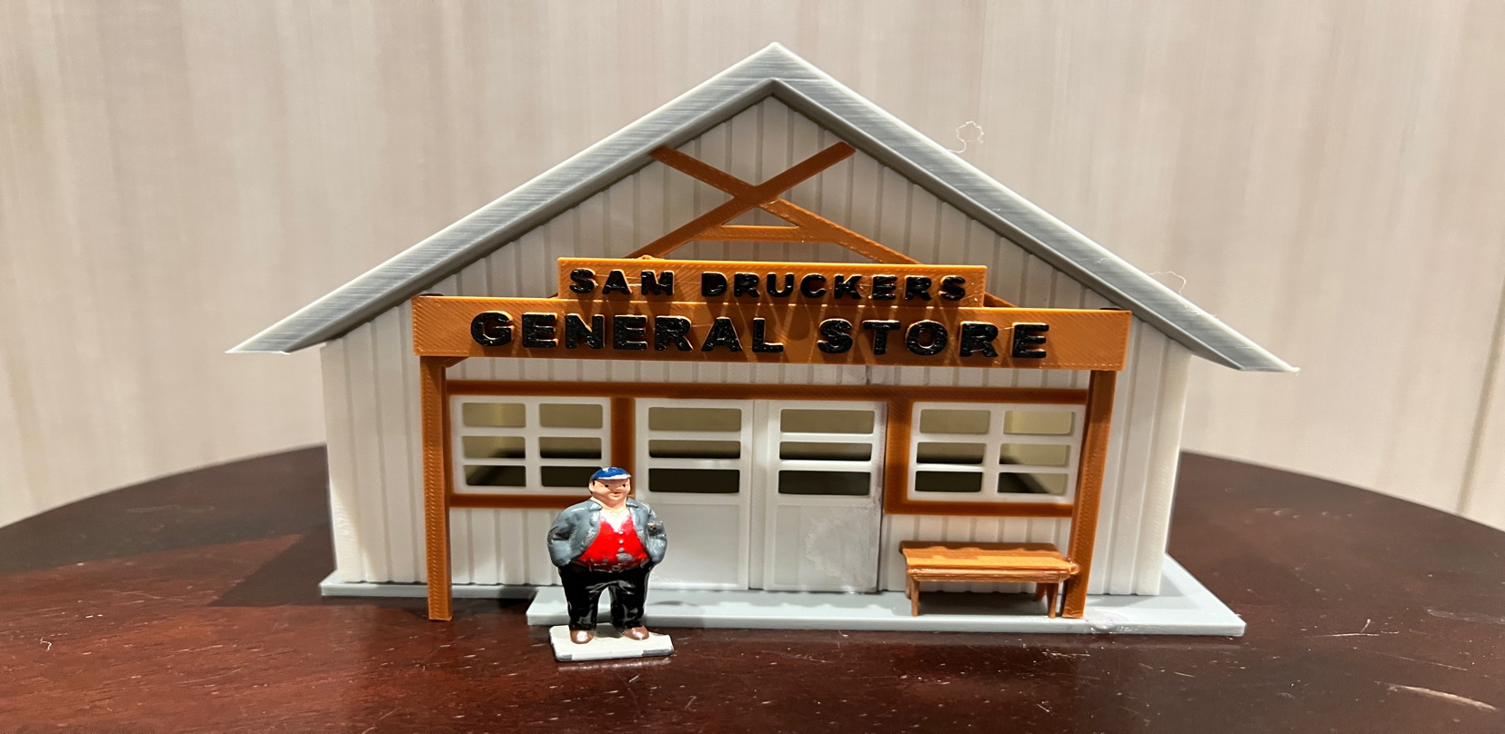
Thanks for your support!

Since these Kits are limited and hard to find, I decided to create my own and offer them for sale at a reasonable price.

You can see the cars and buildings I design and sell running on my layout on my YouTube Channel listed below, as I print and test them on my layout before I release them to the public.

Please go over the KIT, if anything arrives broken let me know and I will replace it free of charge, 100% Satisfaction and positive feedback is our goal.

Ebay – www.flrailroaddog.com
Youtube - @FL Railroaddog
Etsy store - https://flrailroaddog.etsy.com

I clean the models before I ship them out, but I recommend going through the pieces to make sure all the fillers have been removed.

1. Glue the back wall and front wall to the side walls, with the back and front walls flush to the outside of the side walls.

2. Glue the structure to the base.

3. PLEASE NOTE that the one of the roof pieces has a small grove, were the other half of the roof fits nicely into. Glue both of these together and then glue on to the structure.

4. Glue the Rear Sign to the Rear Wall Centered.

5. Glue the front beams with the sign centered on to the base.

Your Done!

