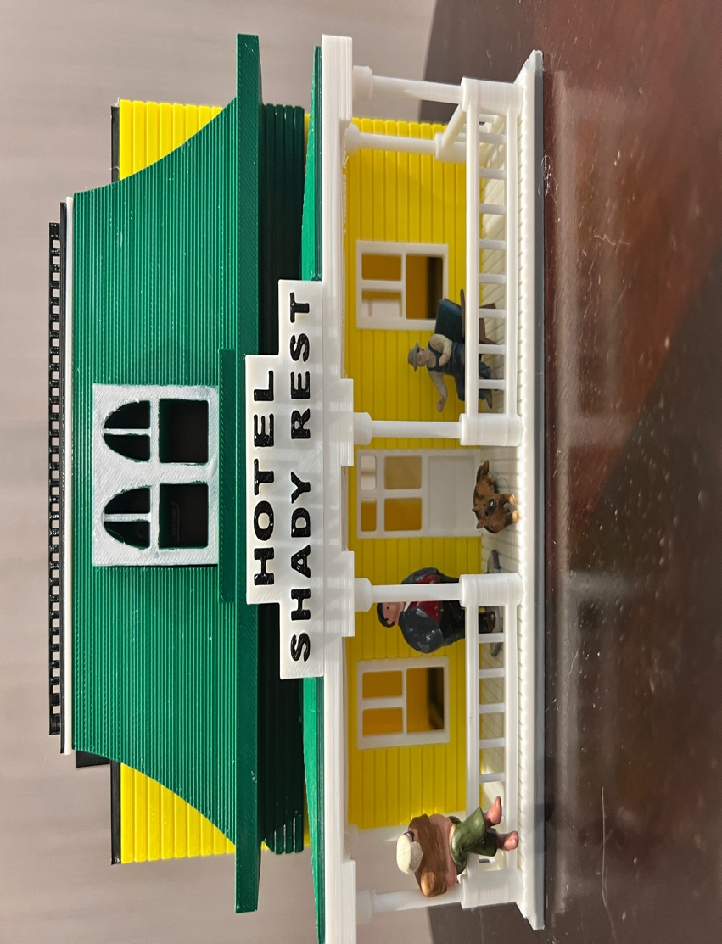

INSTRUCTIONS

1. Glue the 4 walls to the base, ensuring that they are square. The side walls go on the INSIDE of the front and rear walls and on the outside of the lip on the base. The lip around the base will keep the walls square and level.

2. The windows and doors are designed to snap in, if they are too tight, use a file to lightly sand the edges. You can glue them on if you wish.

3. IMPORTANT Follow steps as described.

a. Glue the Black top roof with the railing on to the white roof.

b. Glue this on to the main roof and let dry.

C. Glue this to the top of the green fascia and let dry. (One this is completed the completed roof will sit on the building without the necessity to glue it, that way you can remove to add interior and lights if desired.

4. Glue the roof of the porch (white) on to the beams of porch.

5. Glue the green porch roof on top of the white porch roof.

6. Glue the sign on to the slot on the green fascia.

7. Glue the chimneys on to the top of the roof.

ALL Done…take your time and you can build a beautiful building for your layout.

Let me know if you have any questions, 100% satisfaction and positive feedback is our goal.

Happy railroading!

Jorge

