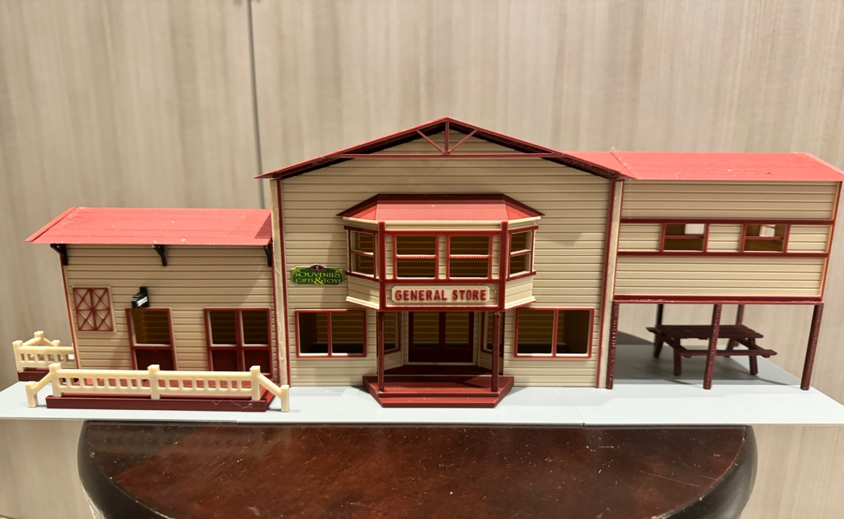

Thanks for your support!

Since these Kits are limited and hard to find, I decided to create my own and offer them for sale at a reasonable price.

You can see the cars and buildings I design and sell running on my layout on my YouTube Channel listed below, as I print and test them on my layout before I release them to the public.

Please go over the KIT, if anything arrives broken let me know and I will replace it free of charge, 100% Satisfaction and positive feedback is our goal.

Webpage – https://flrailroaddog.com
Youtube - @FL Railroaddog
Etsy store - https://flrailroaddog.etsy.com

A. 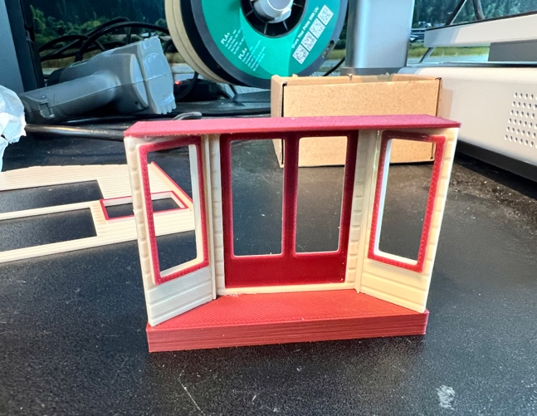 B.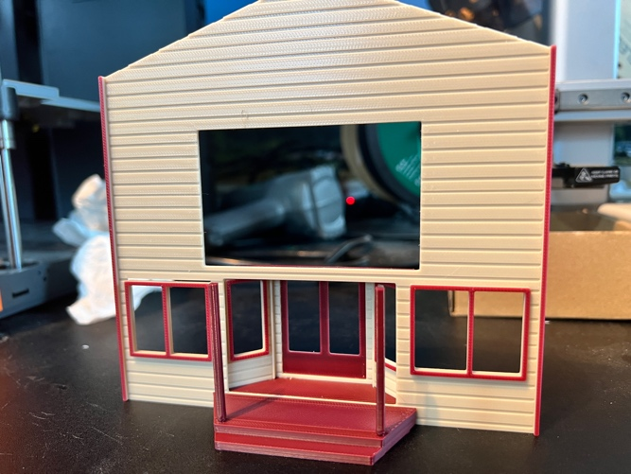

MAIN STRUCTURE

1. I clean the models before I ship them out, but I recommend going through the pieces to make sure all the fillers have been removed.

2. Assemble the entry way, which will sit back from the front wall. Notice that the smaller pieces go at a 45 degree angle. Glue to the inside of the front wall. SEE PIC A.

3. Glue the front porch to the front wall, SEE PIC B.

C. 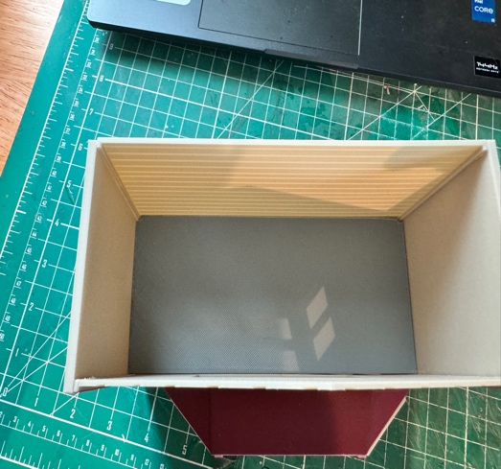

4. Glue the main building side walls to the front and back walls. The side walls go on the OUTSIDE of the front walls. You can now insert the grey floor, gluing it to the top of the entrance way. SEE PIC C.

PATIO STRUCTURE

D. 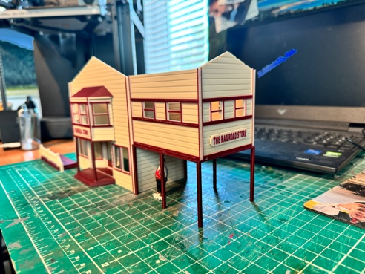 E. 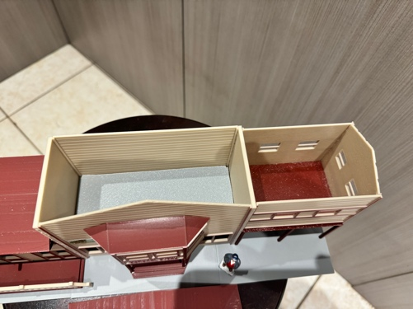 F.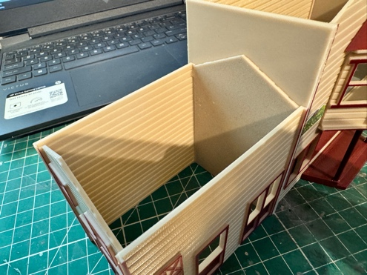

5. Glue the front, back and side walls together, with the Side Wall on the INSIDE of the Front and Back walls, then glue this to the patio deck. There is no end wall on this structure since it will be glued to the main structure. SEE PIC D and PIC E.

6. Locate the front balcony and glue centered to the front wall and on to the front porch. Glue the balcony roof and the front sign. SEE PIC D.

OFFICE STRUCTURE

7. Glue the Front, Back and side walls together, with the Side Wall on the INSIDE of the Front and Back walls, there is also no end wall on this structure since it will be glued to the main structure. DISREGARD THE END PIECE IN THE PICTURE IT WAS REMOVED AS IT WAS NOT NEEDED. SEE PIC F.

G. 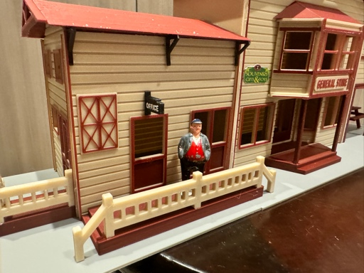

8. Glue the railings to the front and side porches, glue the office signs together back to back and glue just above the doorway.

9. Locate the larger of the 2 small roofs and glue the DECORATED Trim Piece to the end and set on structure, then glue the 3 black roof supports to the structure, just below the roof. SEE PIC G.

10. Locate the smaller of the 2 small roofs (Patio Structure) and glue the Decorated Trim to the end.

F. 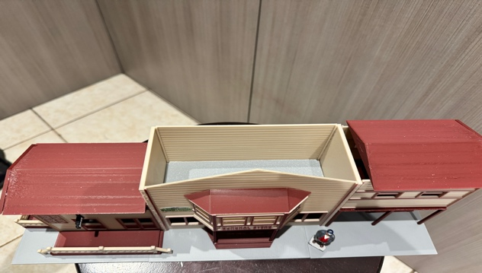

11. Notice that the grey base comes in 3 sections, make sure the fit in to their respective slots and glue, you can now glue the structure on to the base, ensuring that it is even on all sides. SEE PIC F.

12. Glue the DECORATED Trim piece to the main roof and sit on structure and then place the other roofs on to the structure ensuring flush and even on all sides. I left mine unglued.

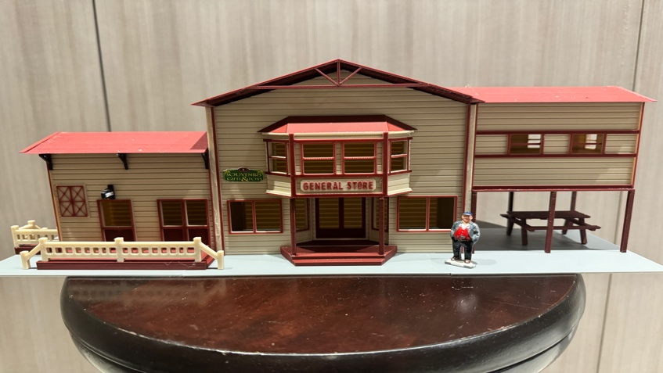

13. Locate the picnic table (Trim the legs to the height you desire) and place included sticker on to the front wall. SEE Above Pic.

14. You are done! Take your time and you can create a really nice piece, let me know if you encounter any issues or if I need to fix or replace something.

Jorge

