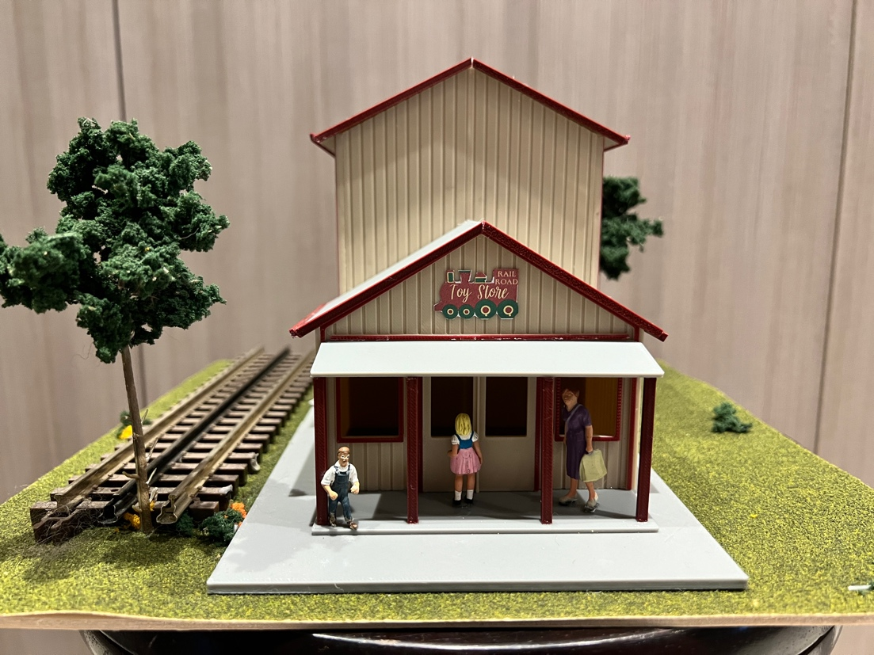
Thanks for your support!

Since these Kits are limited and hard to find, I decided to create my own and offer them for sale at a reasonable price.

You can see the cars and buildings I design and sell running on my layout on my YouTube Channel listed below, as I print and test them on my layout before I release them to the public.

Please go over the KIT, if anything arrives broken let me know and I will replace it free of charge, 100% Satisfaction and positive feedback is our goal.

Webpage – https://flrailroaddog.com
Youtube - @FL Railroaddog
Etsy store - https://flrailroaddog.etsy.com

STRUCTURE

1. I clean the models before I ship them out, but I recommend going through the pieces to make sure all the fillers have been removed.

2. Assemble the Back wall, Tall side walls and the Center divider wall, together. The center divider wall will support the short section roof.

3. Assemble the entry building and glue to the larger structure.

4. Glue this structure to the base, then glue the porch base to the structure base.

5. Glue the porch beams evenly spaced to the porch roof and glue this to the entry building just below the lip in the front building.

6. Glue the roofs to the large roof and glue the smaller roofs to the entry structure.

7. Use the supplied trim pieces to cover the gaps in the roof and trim around the roof edges, cut and glue.

8. Attached the supplied sticker.

Your Done!

