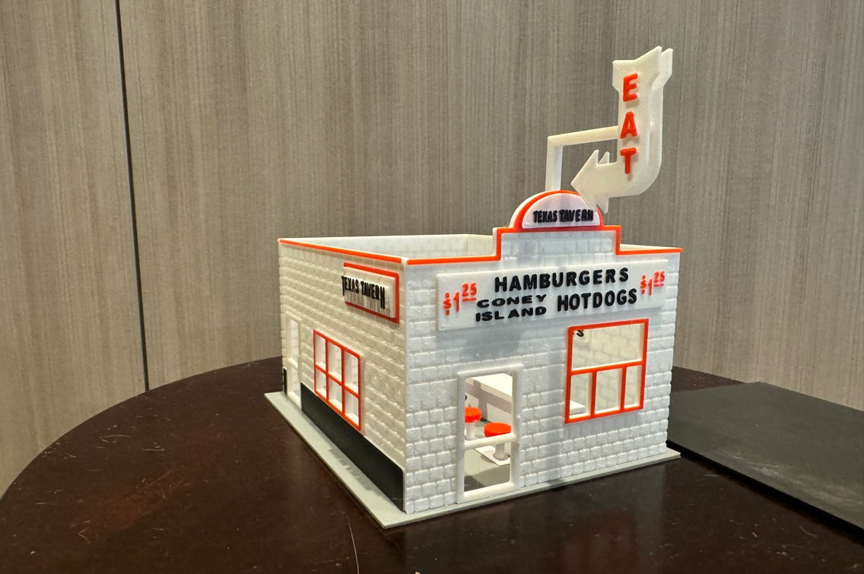
Thanks for your support!

Since these Kits are limited and hard to find, I decided to create my own and offer them for sale at a reasonable price.

You can see the cars and buildings I design and sell running on my layout on my YouTube Channel listed below, as I print and test them on my layout before I release them to the public.

Please go over the KIT, if anything arrives broken let me know and I will replace it free of charge, 100% Satisfaction and positive feedback is our goal.

Webpage – https://flrailroaddog.com
Youtube - @FL Railroaddog
Etsy store - https://flrailroaddog.etsy.com

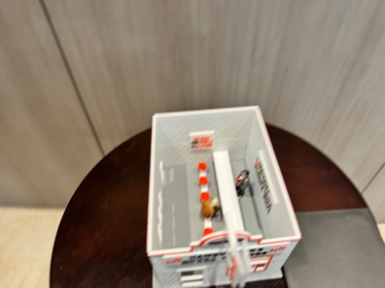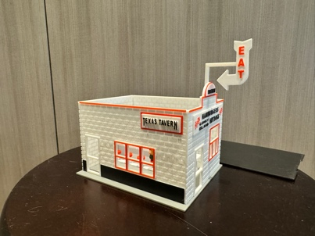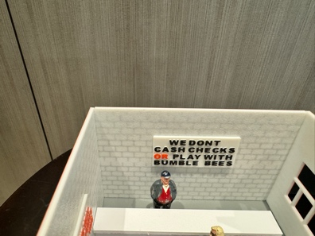

STRUCTURE

1. I clean the models before I ship them out, but I recommend going through the pieces to make sure all the fillers have been removed.

2. Glue the back wall and front wall to the side walls, with the back and front walls flush to the outside of the side walls.

3. Glue the structure to the base.

4. Glue the Front sign centered to the front wall.

5. Glue the small “Texas Tavern” half moon sign centered to the roof area.

6. Glue the Red bar stool tops centered to the bar stool base and glue inside structure.

7. Glue Counter

8. Glue both signs to the interior at preferred location.

9. Glue roof if wanted.

10. Glue both arrow signs to the support beam and glue to the rear of the top sign. I left a small gap so I could remove the roof. I left the L beam long enough so you can place it at your preferred distance from the building, just cut with a sharp knife.

11. Your Done!

