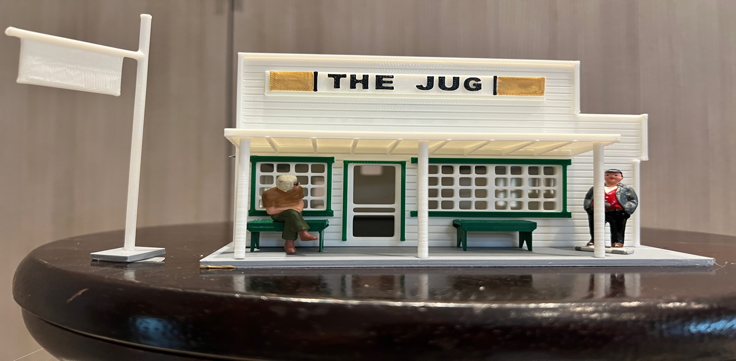
Thanks for your support!

Since these Kits are limited and hard to find, I decided to create my own and offer them for sale at a reasonable price.

You can see the cars and buildings I design and sell running on my layout on my YouTube Channel listed below, as I print and test them on my layout before I release them to the public.

Please go over the KIT, if anything arrives broken let me know and I will replace it free of charge, 100% Satisfaction and positive feedback is our goal.

Webpage – https://flrailroaddog.com
Youtube - @FL Railroaddog
Etsy store - https://flrailroaddog.etsy.com

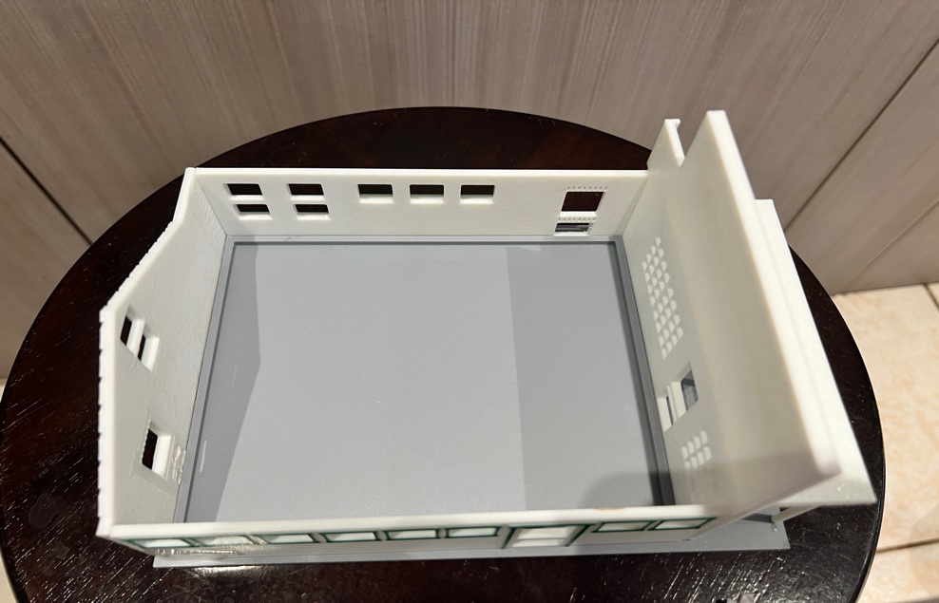

STRUCTURE

1. I clean the models before I ship them out, but I recommend going through the pieces to make sure all the fillers have been removed.

2. Locate the base, you will see that the base has a lip around it to ensure that the building is square.

3. Glue the side walls to the INSIDE of the front and rear wall and let dry.

4. Glue the porch to the front wall and to the base.

5. Locate the roofs and glue them to the structure.

6. Glue the included benches to the porch area.

7. Glue the Sign to the Structure

POLE SIGN

1. You will need to trim the bottom of the pole so it will fit snug on the base.

2. You are done!

