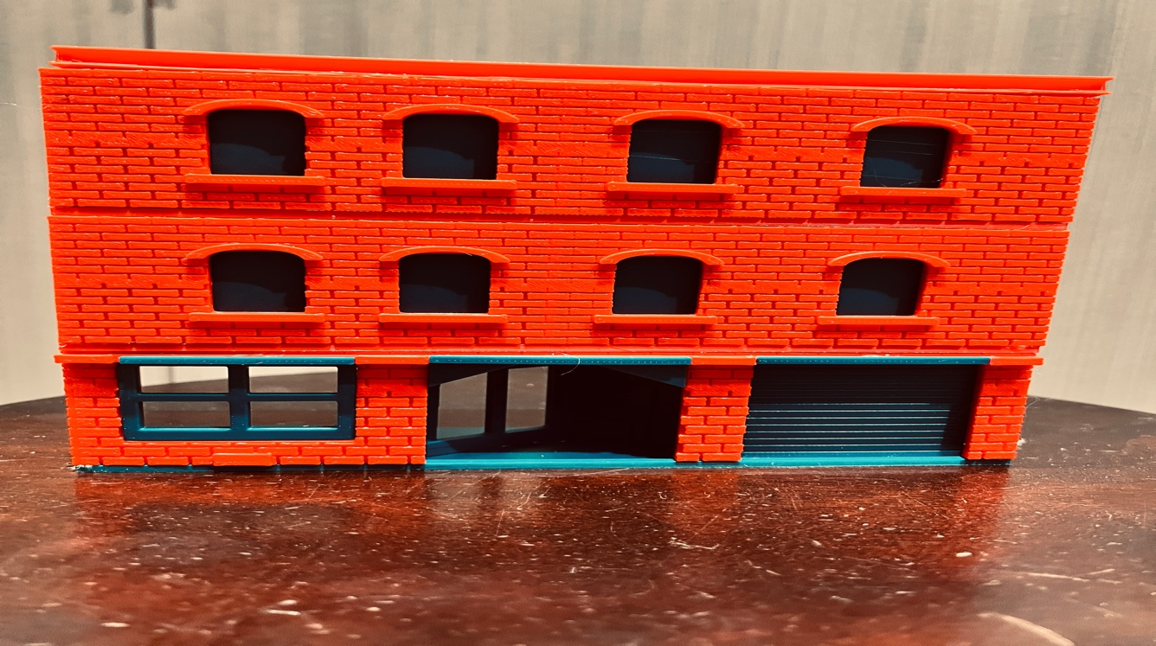

Thanks for your support!

Since these historic buildings have never been made or ever will, I decided to create my own and offer them for sale at a reasonable price.

You can see all items that I design and sell running on my layout on my YouTube Channel listed below, as I print and test them on my layout before I release them to the public.

Youtube - @FL Railroaddog
Etsy store - https://flrailroaddog.etsy.com
www.flrailroaddog.com

1. Glue the storefront, sides, and rear wall to the base.

2. Glue the interior entry way and use the Triangles and sticks to trim the entry way.

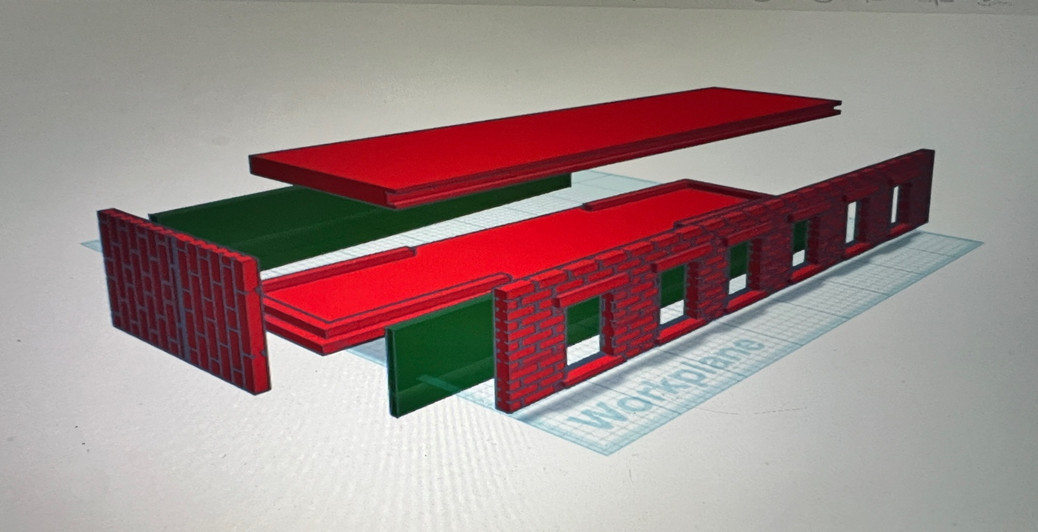

3. The top levels are built the same way, except you have the option to glue the thin green window covering on to the front.

4. Glue the roof to the top.

I clean the models before I ship them out, but I recommend going through the pieces to make sure all the fillers have been removed.

If you’re going to paint the kit, I recommend painting all the pieces separately, I recommend a coat of GREY AUTOMOTIVE FILLER PRIMER, this will ensure the paint catches better and small imperfections are filled.

If you take your time, you can create a beautiful piece.

I appreciate positive feedback and would love to see your completed kits.

Happy Railroading, Jorge

