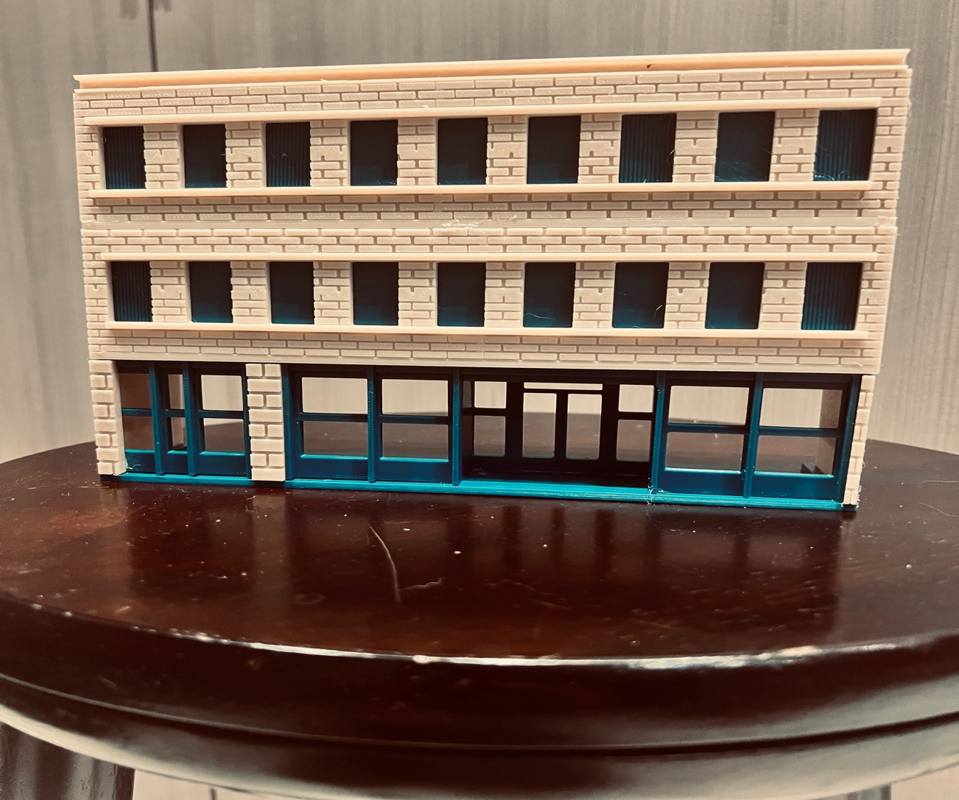

Thanks for your support!

Since these historic buildings have never been made or ever will, I decided to create my own and offer them for sale at a reasonable price.

You can see all that I design and sell running on my layout on my YouTube Channel listed below, as I print and test them on my layout before I release them to the public.

Youtube - @FL Railroaddog
Etsy store - https://flrailroaddog.etsy.com
www.flrailroaddog.com

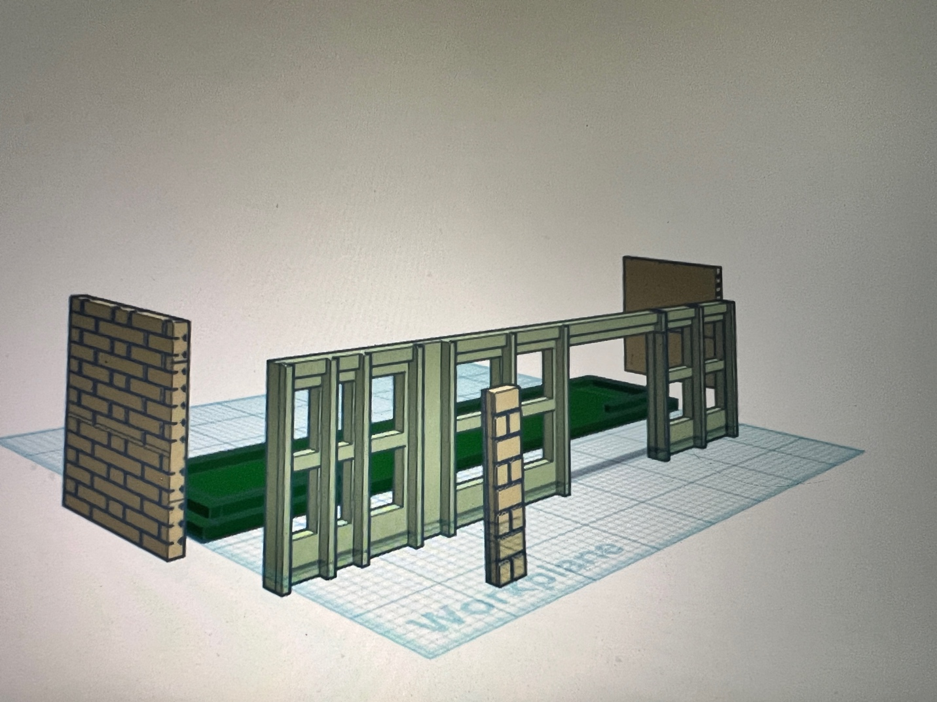

1. Start with the bottom base (Green), glue the front facia (small brick section) on to the store front.

2. Glue the storefront to the base and glue the bottom sides to the base. The bottom sides and the top-level sides are different sizes so check first, and make sure you have the longer ones.

3. The sides extend out past the storefront to give it a brick ending and match the facia.
.

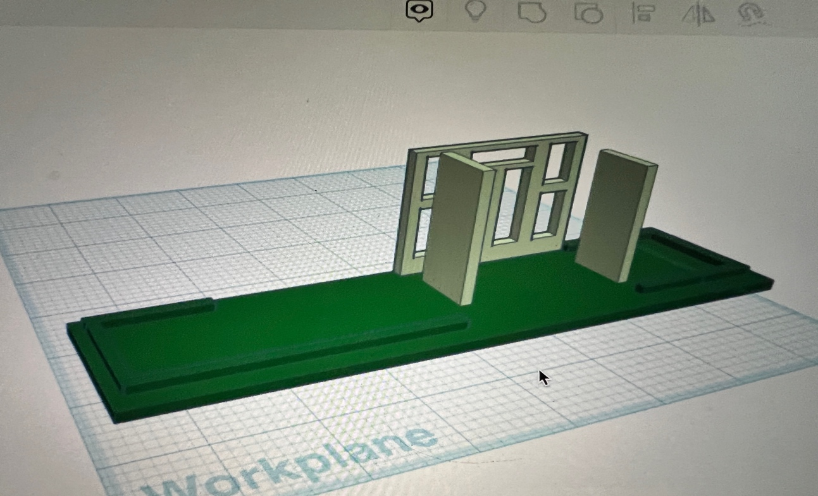

4. Build the door way section and glue on to the store front section.

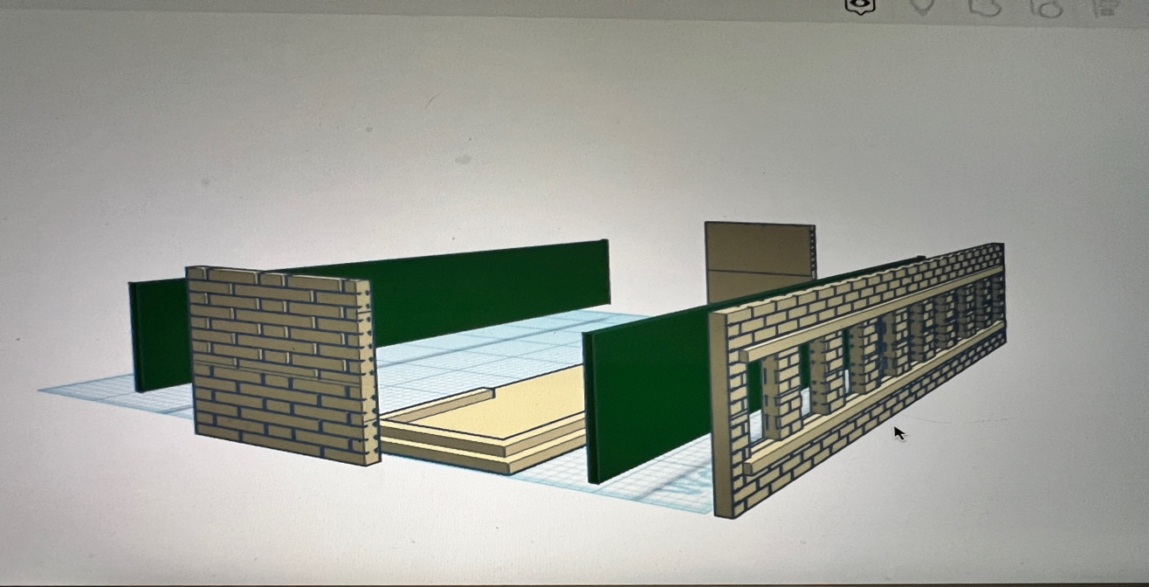

5. The top levels are built the same way, except you have the option to glue the thin green window covering on to the front.

6. Glue the back wall.

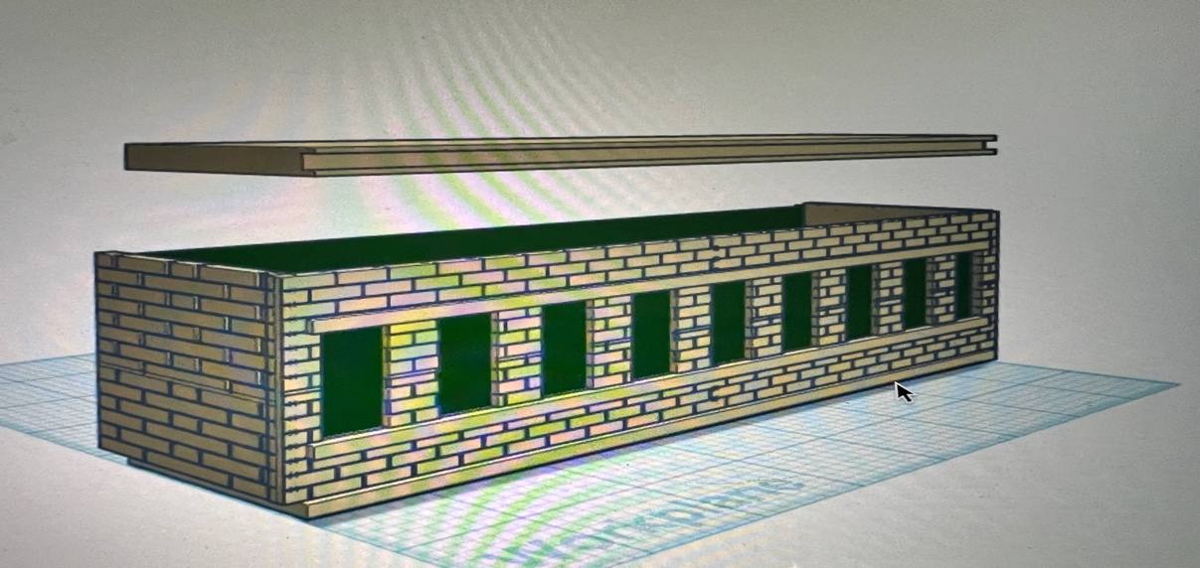

7. Glue the roof to the top.
I clean the models before I ship them out, but I recommend going through the pieces to make sure all the fillers have been removed.

If you’re going to paint the kit, I recommend painting all the pieces separately, I recommend a coat of GREY AUTOMOTIVE FILLER PRIMER, this will ensure the paint catches better and small imperfections are filled.

If you take your time, you can create a beautiful piece.

I appreciate positive feedback and would love to see your completed kits.

Happy Railroading,

Jorge

