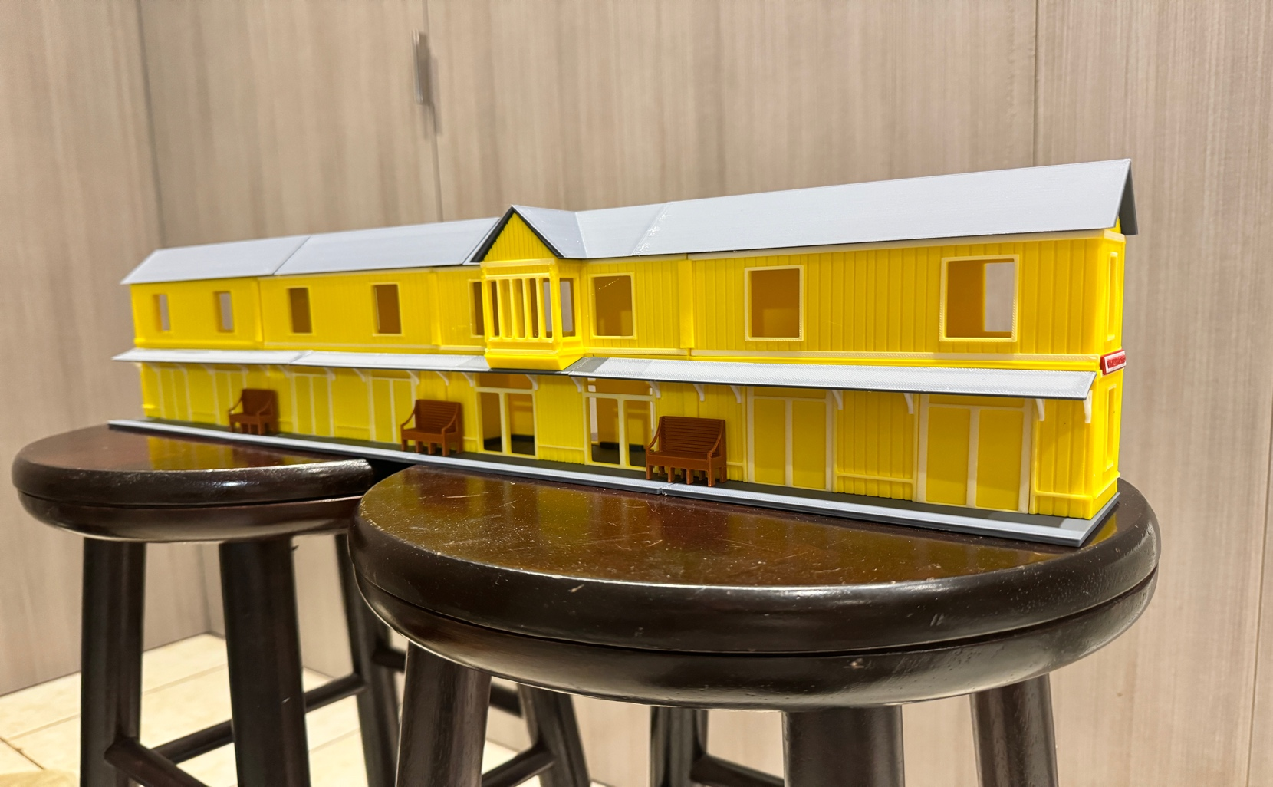
Thanks for your support!

Since these Kits are limited and hard to find, I decided to create my own and offer them for sale at a reasonable price.

You can see the cars and buildings I design and sell running on my layout on my YouTube Channel listed below, as I print and test them on my layout before I release them to the public.

Please go over the KIT, if anything arrives broken let me know and I will replace it free of charge, 100% Satisfaction and positive feedback is our goal.

Webpage – https://flrailroaddog.com
Youtube - @FL Railroaddog
Etsy store - https://flrailroaddog.etsy.com

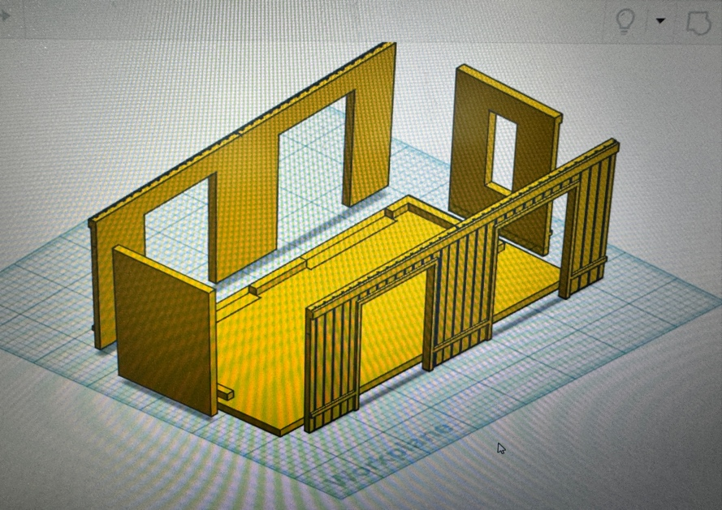
Outer Buildings (2)

1. Start building the four lower sections, remember that the window pieces go on the two end buildings. I glue the back and sides then glue the front. The sides go on the INSIDE of the front and back pieces.

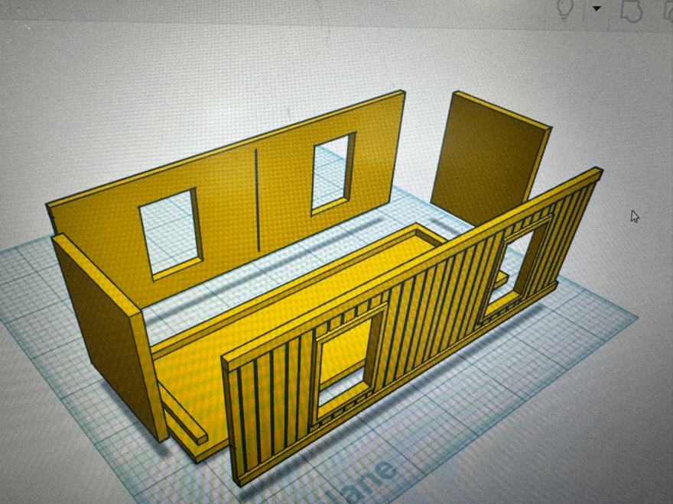
Inner Buildings (2)

2. Built the inner buildings, the building with the office on top has the doors already molded in, but it is built same as above.
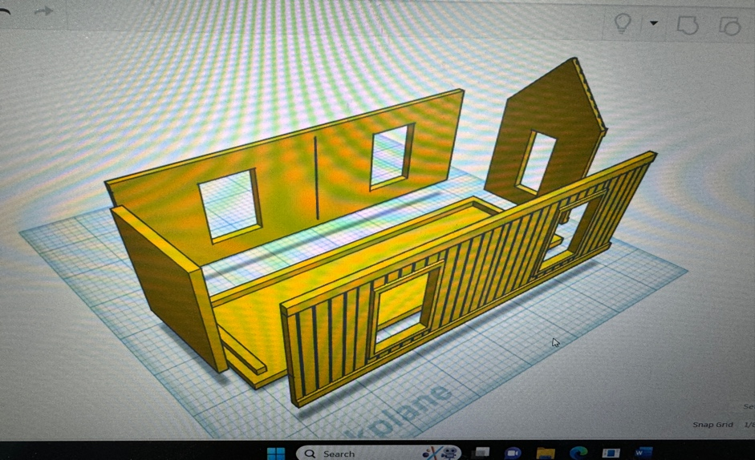

3. Build the top buildings the same as you did the bottoms, remembering that the 2 end buildings have the windows. You can leave the solid pieces off if you want a continuous building on the inside.

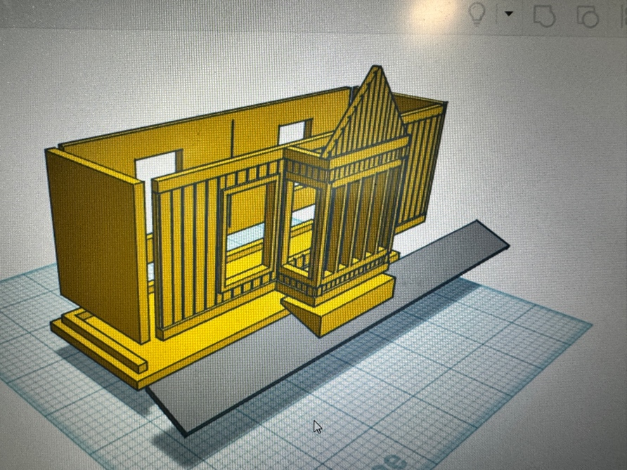

4. The office structure is built the same, then glue the yellow triangle under the overhang office, this triangle will give the overhang roof the correct angle. Once the buildings are placed together you can glue the other overhang roofs flush and level with the office roof to give you correct angle across the whole structure. Trim any excess roof before gluing.
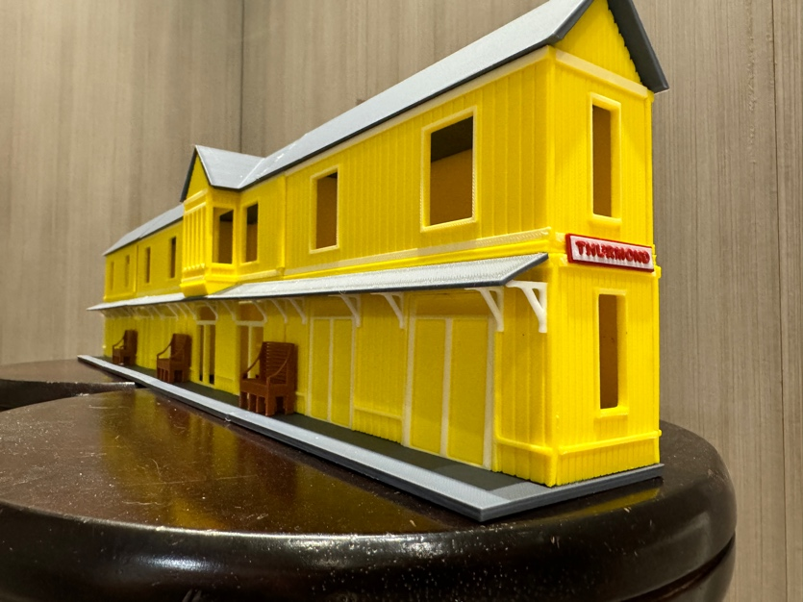

5. Glue the white overhang roof supports, I provided more than enough so you can place them however and how many you want.

6. Glue the Thurmond sign to the center of both ends.

7. Insert and glue the doors.

8. I provided yellow pieces of planks which can be used to cover up the gaps that are present when the building is glued side by side. (see the picture above by the top office)

9. Set and glue the roofs.

10. I added 3 benches that can be placed in front of the building to cover the gaps in the grey base.

11. I decided to try and design a baggage cart and this is the final product.

Your Done! I hope you enjoy building this kit and please let me know if I need to add or change anything to make it easier or better.

Jorge

