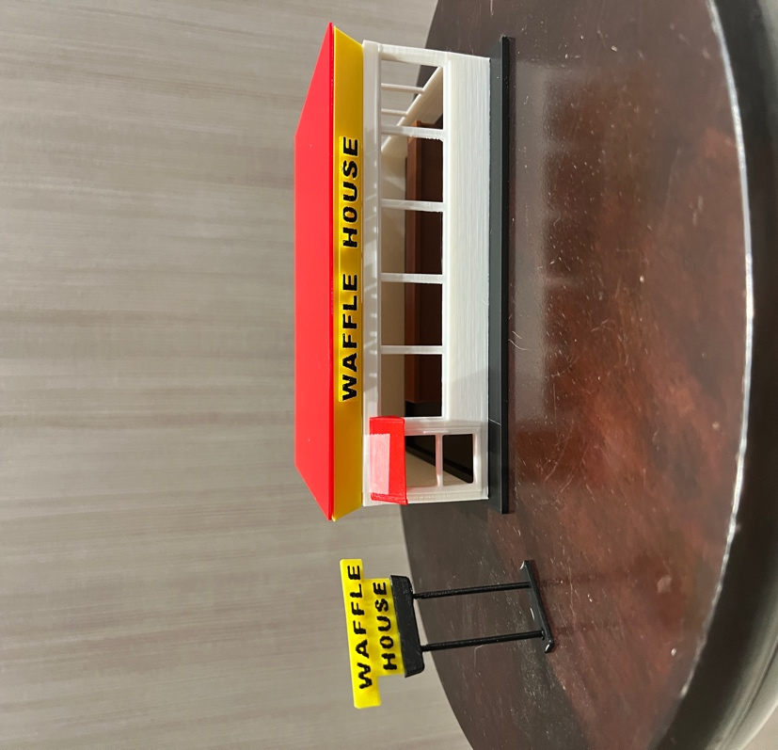

Thanks for your support!

Since these Kits have never been made or ever will, I decided to create my own and offer them for sale at a reasonable price.

You can see the cars and buildings I design and sell running on my layout on my YouTube Channel listed below, as I print and test them on my layout before I release them to the public.

Please go over the KIT, if anything arrives broken let me know and I will replace it free of charge, 100% Satisfaction and positive feedback is our goal.

www.flrailroaddog.com
Youtube - @FL Railroaddog
Etsy store - https://flrailroaddog.etsy.com

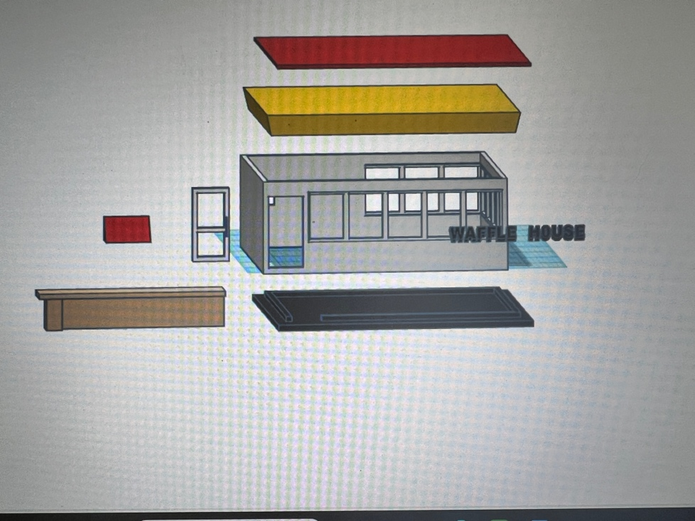

I clean the models before I ship them out, but I recommend going through the pieces to make sure all the fillers have been removed.

This KIT comes pre-printed in White, Yellow, Red, Brown, and Black, with the Waffle House Logos already painted in black and yellow, saving the time used to fine paint them.

The door comes separate and is designed to be glued / snap into place. I printed them in white if a different color is wanted. I recommend primer first, then paint. IF the door is a little tight, use a fine file to get them to snap in.

As you can see, I have designed this building to be completed with ease and very little effort. The structure is one piece, which keeps the building square and level, and sits perfectly on the designed base.

The counter can be placed or glued on to the base, keeping in mind that it is L-shaped.

The Yellow roof sits on top of the structure and then the red roof sits on top of the yellow roof, these can be glued together ensuring that its even on all sides.

.

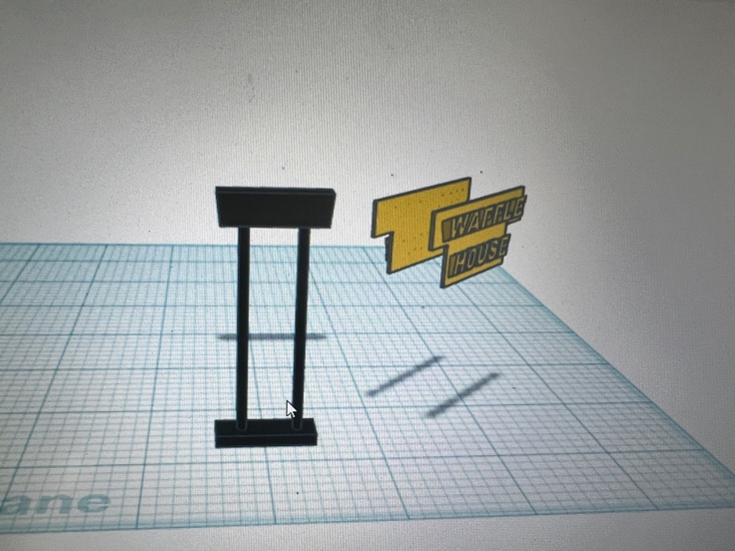

As you can see, I added a completed sign with backing for the yellow roof, you can center these and glue them on.

Finally glue both sides of the Pole sign together, let dry and then carefully glue it centered on top of the pole.

I use a hot glue gun to glue my models, that way they are easy to take apart and store. A small amount at each corner should be just fine. For a permanent structure I use Gorilla Super Glue liquid not gel.

If you take your time, you can create a beautiful piece.

As always, your satisfaction is of outmost important, if anything arrives broken, let me know and I will ship out a replacement free of charge.

If you have any suggestions and or ideas to improve the KIT let me know.

Happy Railroading,

Jorge

